# Final Deliverable

## Group details

|  |  |
| --- | --- |
| Group number | 5 |
| Member names and UPIs | 1. Christoper Ham-sham708 2. Christynn Sim-schy192 3. Darren Wong-wwon158 4. Vincelia Wong-vwon786 5. Xinning Gong-xgon780 |
| Group name | Group 5 |
| System name | X2C2D Job-Portal |

**System Architecture**

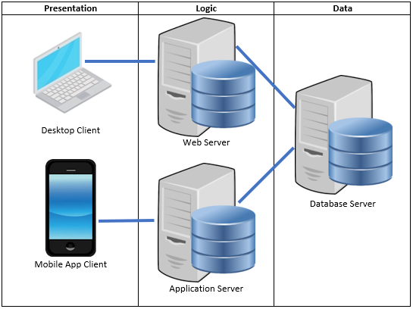

# Prototype Documentation

## Instructions/links to access prototype(s):

Open the Adobe XD file named “Infosys220 group5.xd” on canvas that was sent along with this word document. (Note: Due to complications in publishing a link, Adobe XD file was submitted instead.)

# UC#1

UC#1 name: Manage Personal Dashboard

## UC#1 Functionality

### F#1 Create Dashboard

Enables applicants to change their dashboard from predefined categories. Users can select a theme and a few features that they want to display on their personal dashboard. The Create Dashboard function also come up in a mobile version

**GUI 1: Desktop**

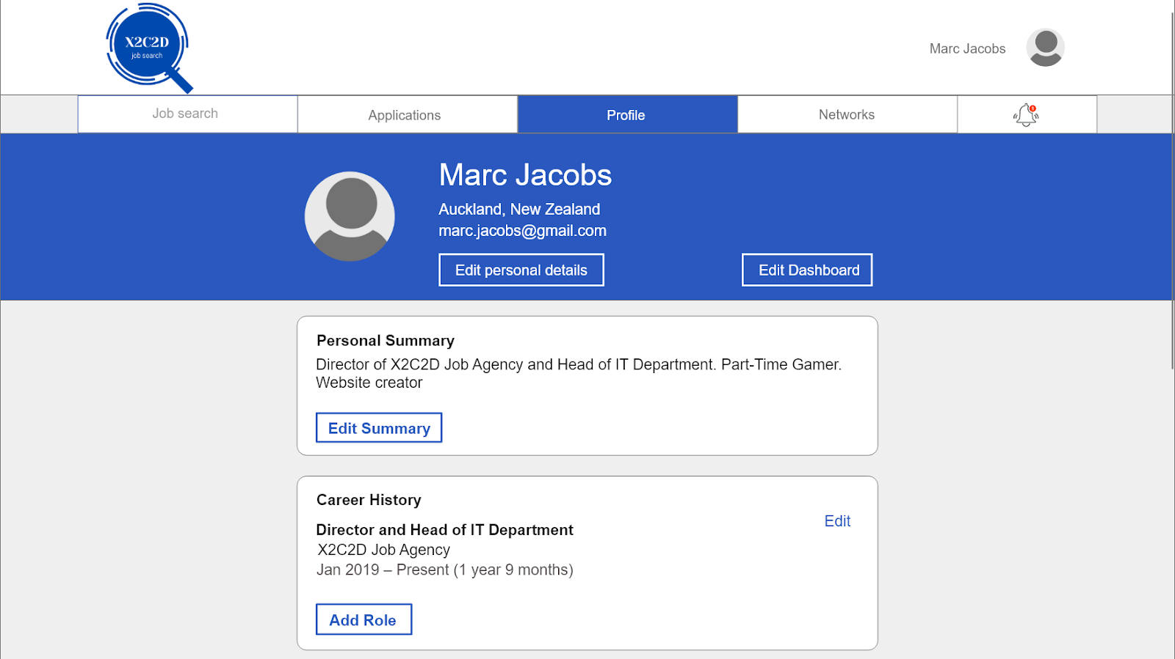

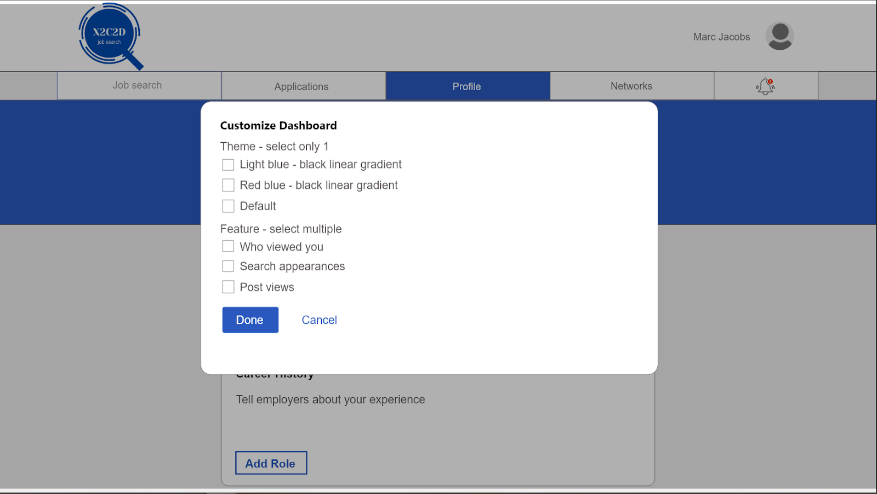

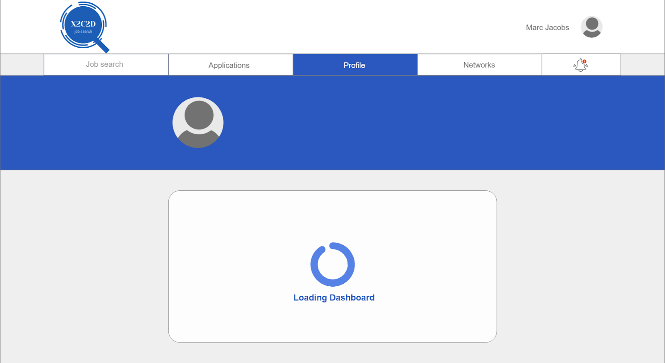

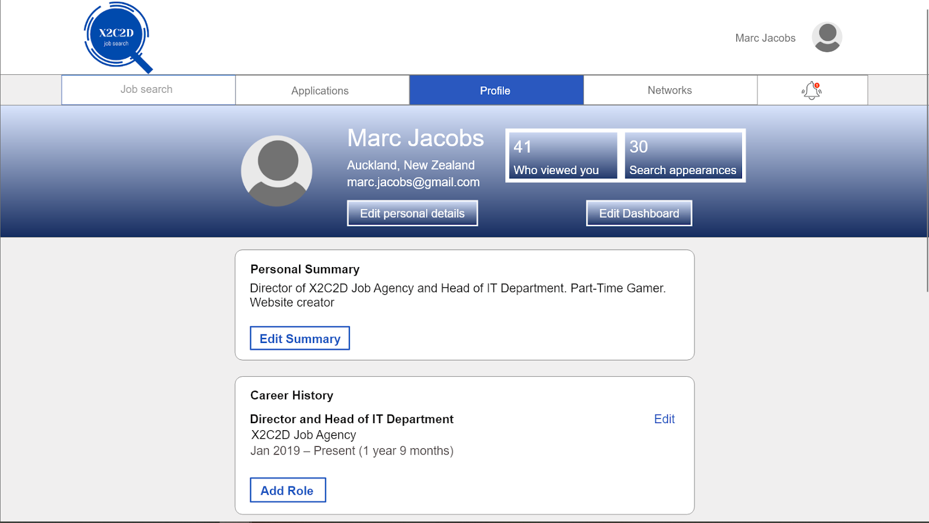

**GUI 2: Mobile**

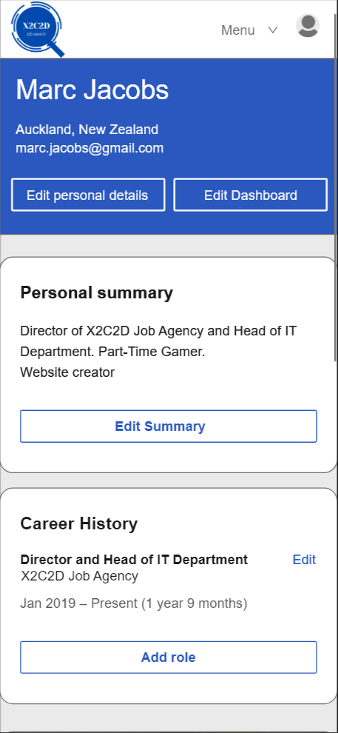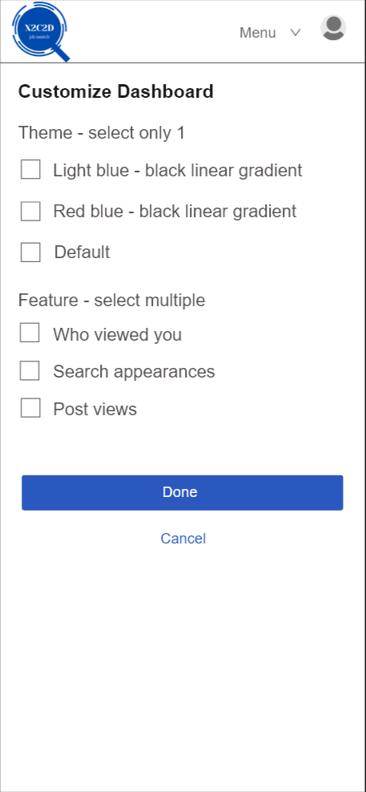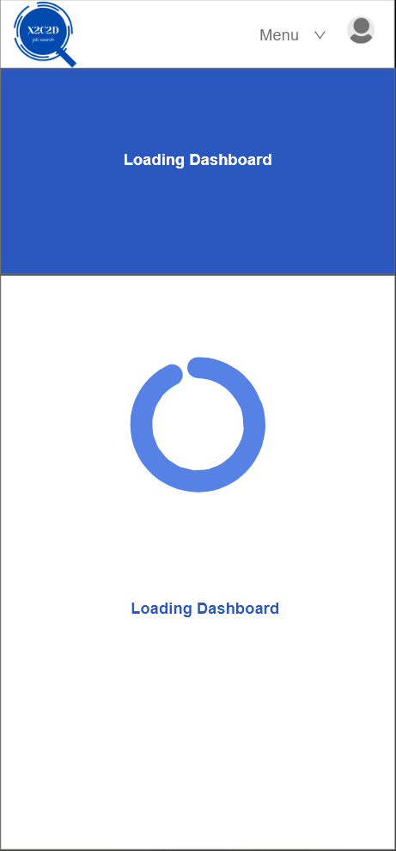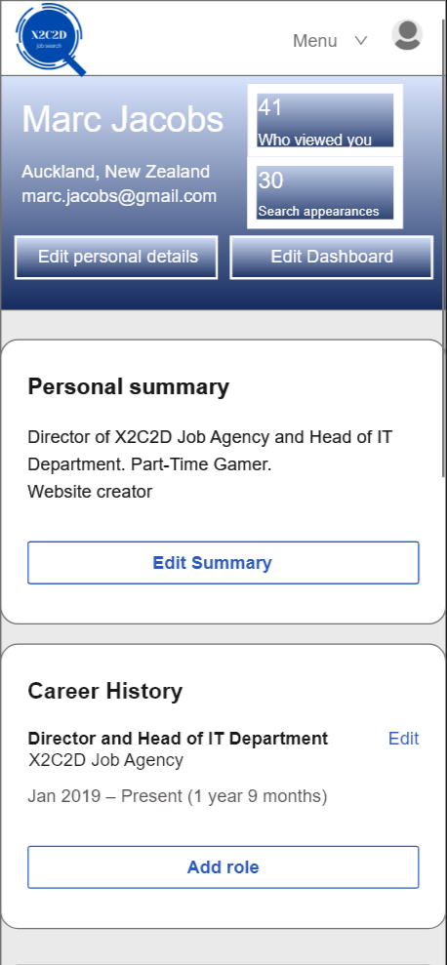

### F#2 Upload Document

Upload document will allow users to upload and store documents like resumes on their profile. Upload document will have two versions: Desktop and Mobile

GUI 1: Desktop

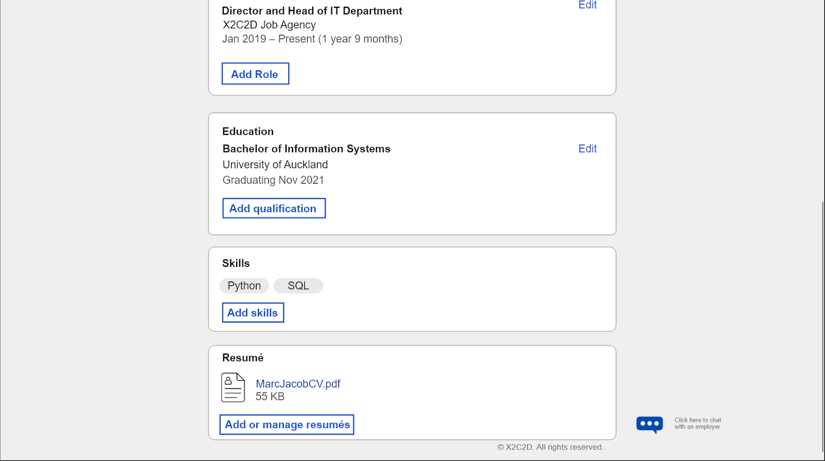

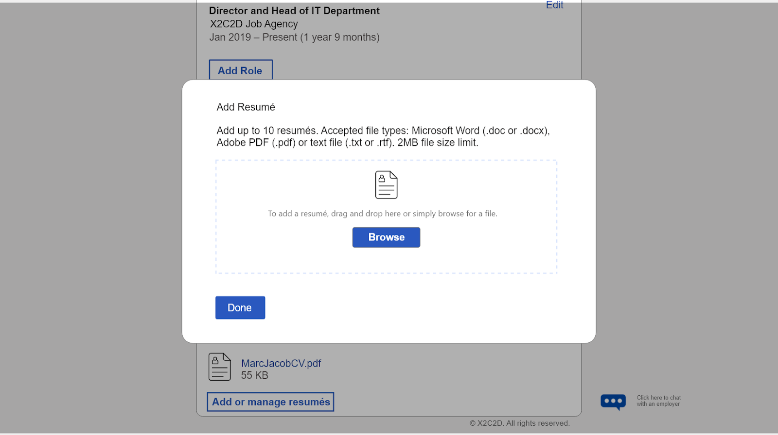

**GUI 2: Mobile**

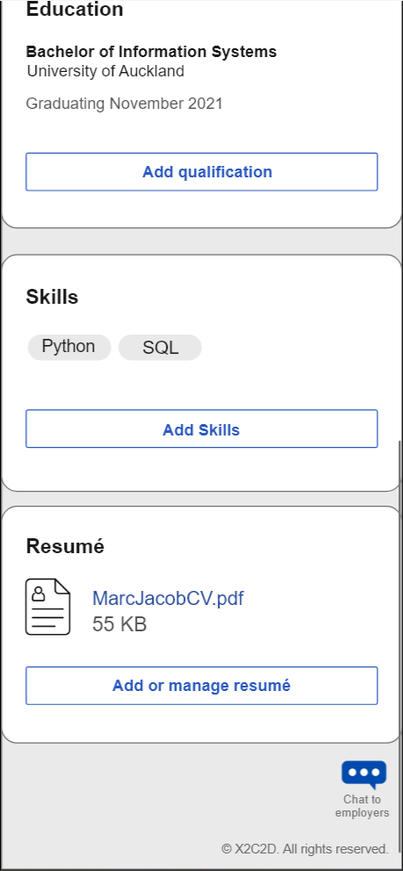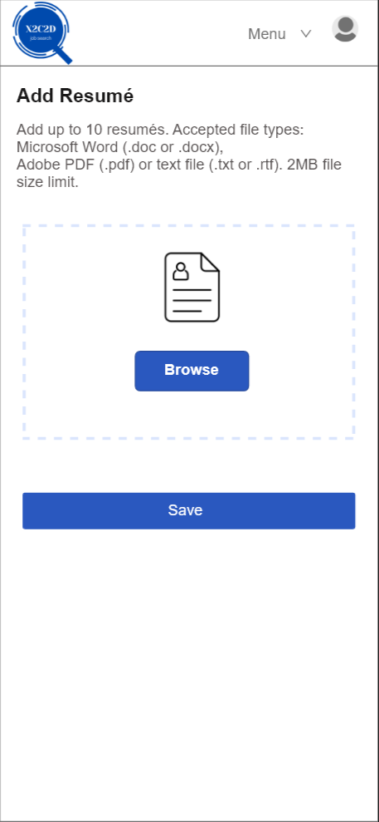

### F#3 Edit Information

Allow users to change personal information whenever necessary. Information such as job experience, skills and education can be edited or deleted.

**GUI 1: Desktop**

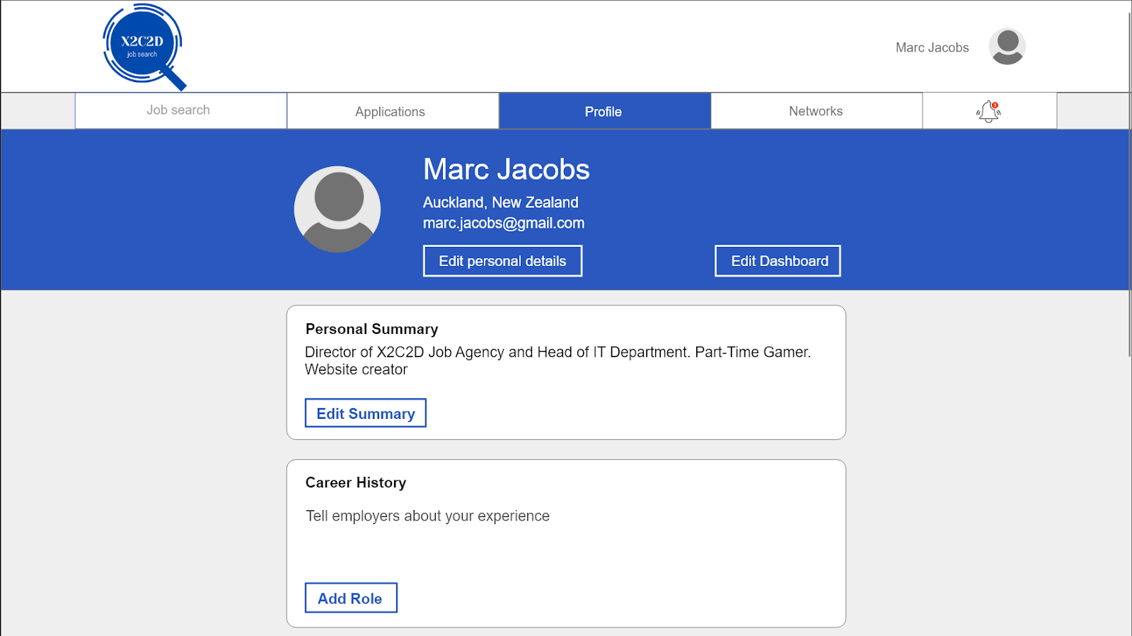

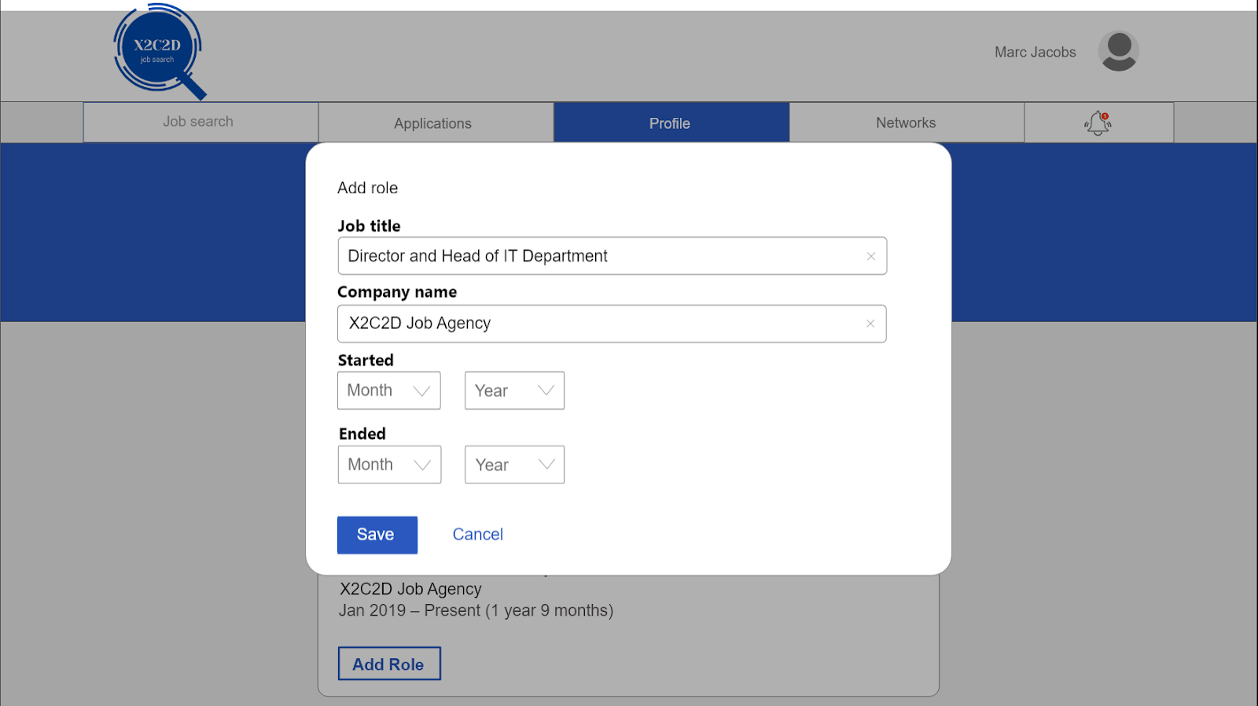

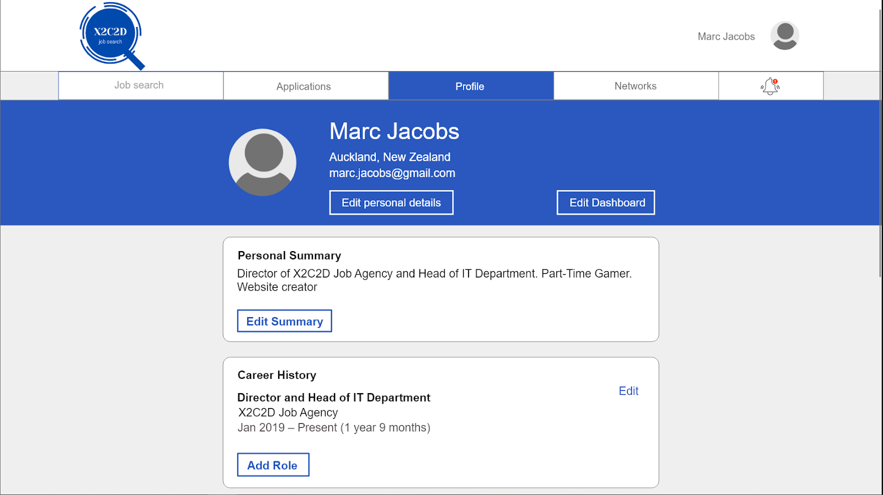

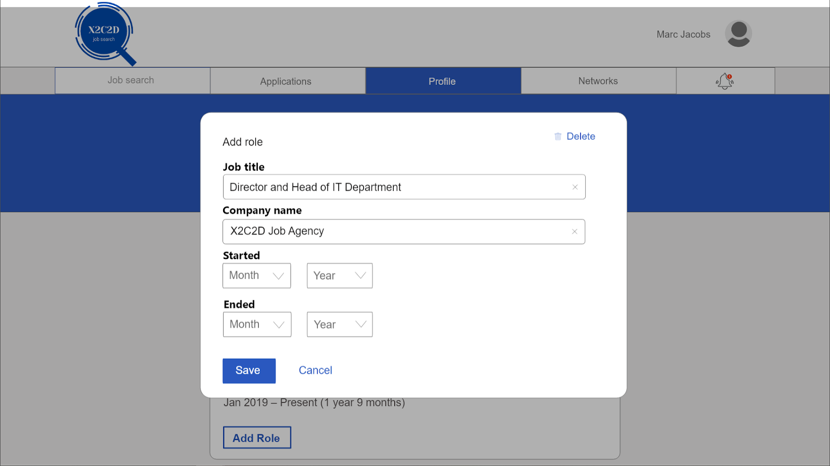

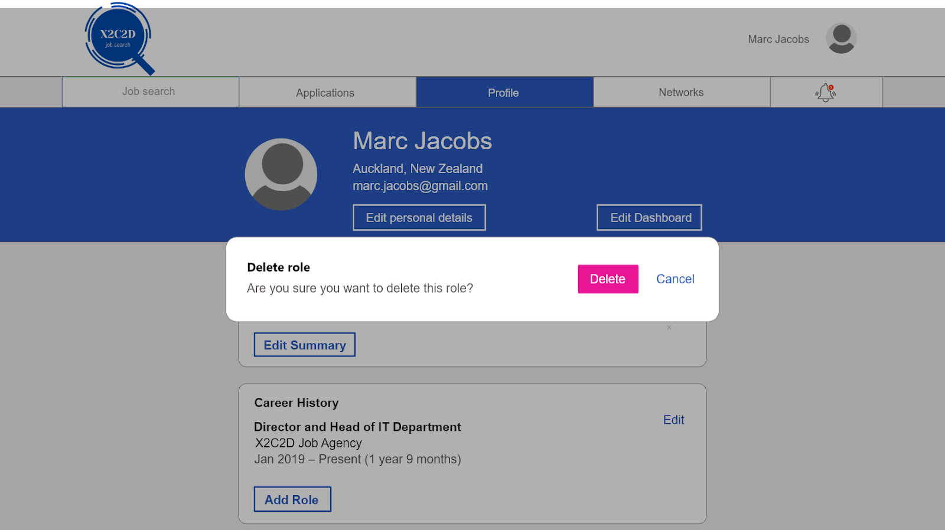

**GUI 2: Mobile**

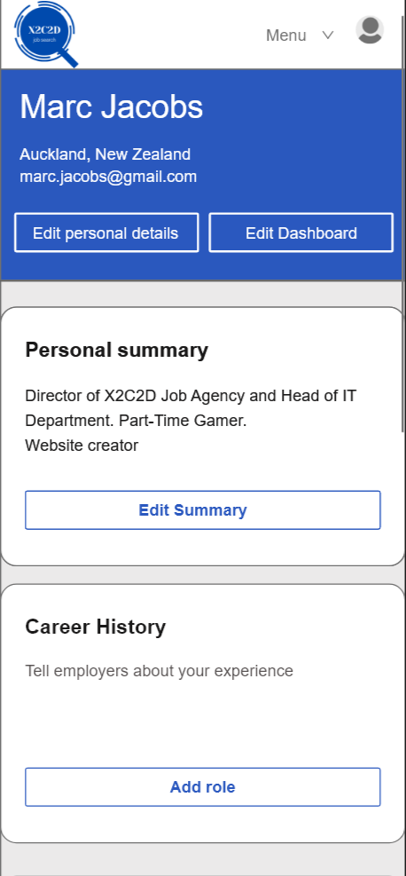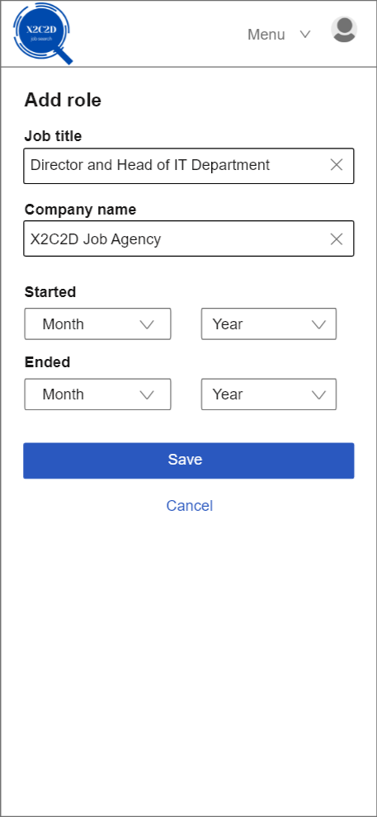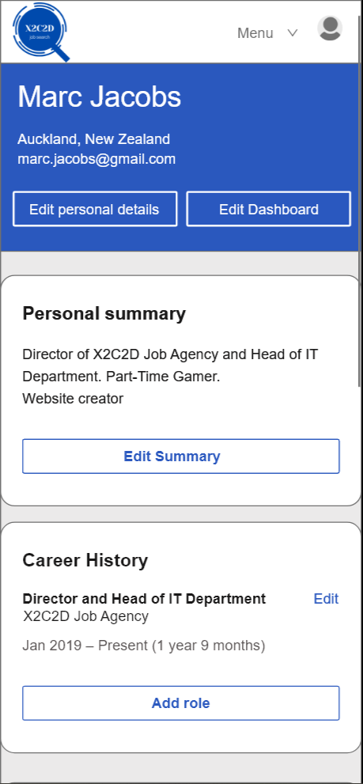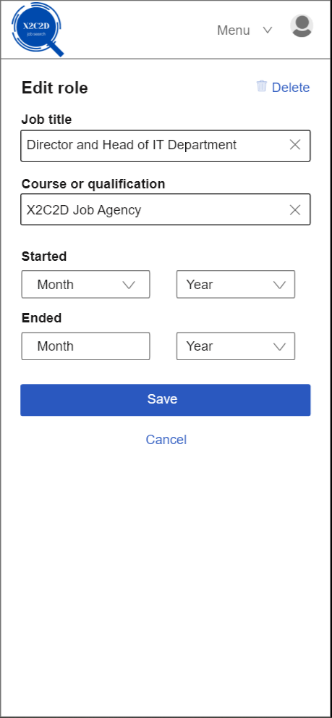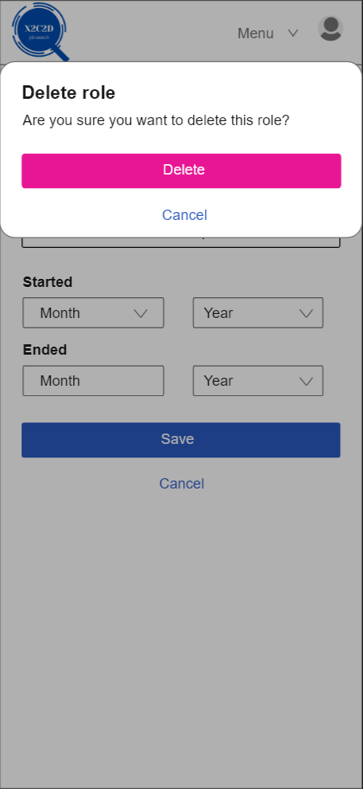

## UC#1 Data

|  |  |  |
| --- | --- | --- |
| Entity name: CareerHistory | Entity name: Feature | Entity name: Education |
| Attributes:   * CompanyName * JobTitle * StartDate * EndDate | Attributes:   * NumberView * NumberSearchAppereance | Attributes:   * University * Qualification * DateGraduate |

|  |
| --- |
| Entity name: Profile |
| Attributes:   * Name * Email * Location |

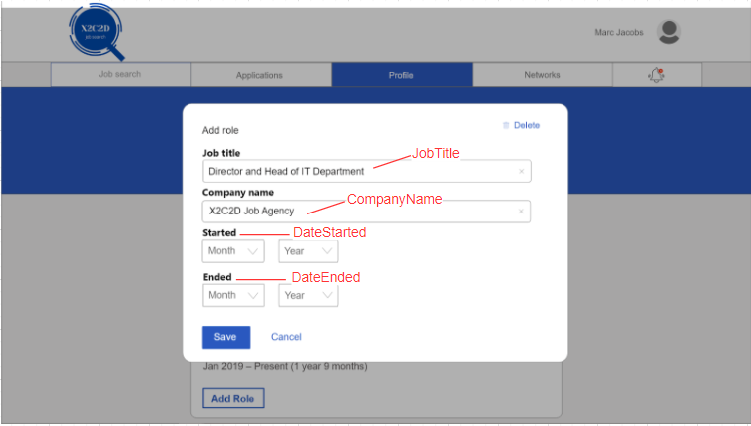



Email

Location

Name

NumberSearchAppereance

NumberView

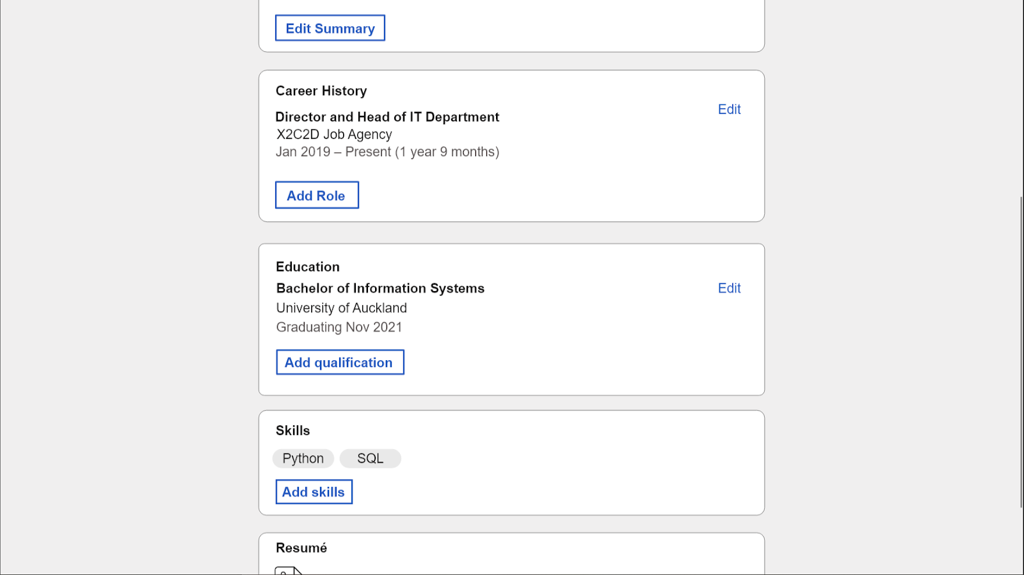

DateGraduate

University

Qualification

## UC#1 Demonstration/simulation

Chosen function number: F#1

Chosen function name: Create Dashboard

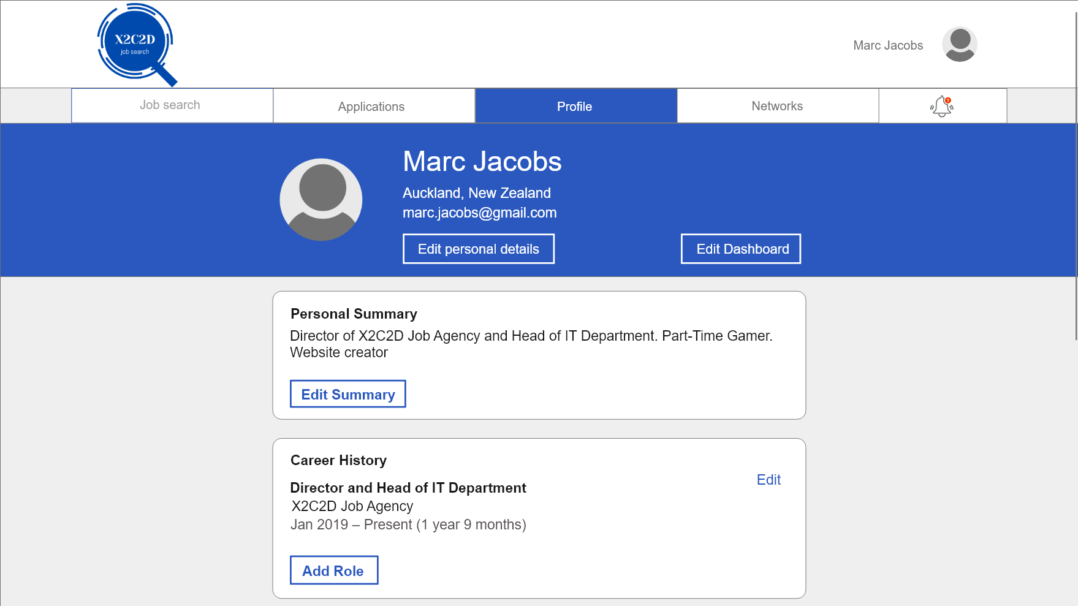

**Step 1.** On the profile page. Click Edit Dashboard

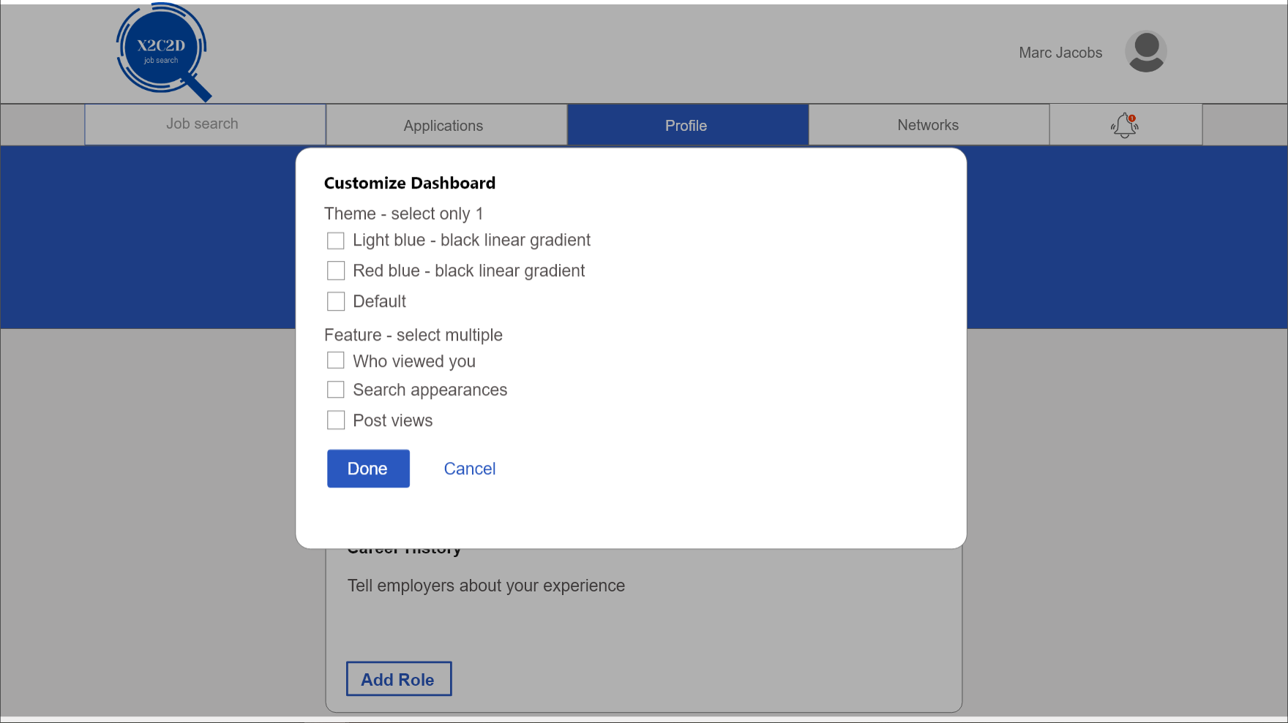

**Step 2.** Select one theme only, select to tick the box.

For demonstration purposes, select “Light blue-black linear gradient”.

**Step 3.** Select feature, multiple selection of features are allowed.

For demonstration purposes, select only “Who viewed you” and “Search appearances”.

## 

**Step 4.** After ticking the boxes. Click Done.

## 

**Step 5.** Wait for dashboard to load.

A circular loading bar will load to a full circle to indicate the loading of the new dashboard

## 

**Step 6.** New dashboard is loaded, the new colour theme is as shown. Features selected are displayed as well, users can now see the number of people who viewed their profile and number of search appearances.

End of demonstration for UC#5, F#1.

## Video Demonstration

## 

## F#1 Test plan

|  |  |
| --- | --- |
| Goal/Description of test plan | Allows applicants to personalise their dashboard by selecting predefined themes and display certain features that shows applicants how attractive their profile is to employers or other applicants, like profile views and search appearances. |
| Testing method | 1. Select Edit Dashboard on the profile page 2. A pop up will show up enabling the user to customise dashboard via selection of themes and features. 3. The user can choose only one preferred theme that is available.    * 1. A tick will be shown upon clicking on the empty box.      2. Deselecting will untick the box.      3. In the real system, when a user tries to select more than one box. The previous ticked box will untick itself and the latest selected box will be ticked.      4. For purposes of this simulation, only the “Light blue - black linear gradient” can be selected.      5. More themes are to be added in the real system. 4. The user can then choose multiple features that they want to display on their dashboard.    * 1. A tick will be shown upon clicking on the empty box as well.      2. Deselecting will untick the box.      3. For demonstration purposes, only "Who viewed you” and “Search appearances” can be selected 5. After the user finishes selecting the option for their personalised dashboard. Click onto the “Done” button below. 6. A circular loading bar will load to a full circle. Indicating the loading of the new dashboard. 7. Once the loading bar loads to a full circle, a new page is shown with a new dashboard. 8. The user can now see the new dashboard with its chosen theme and feature.    * 1. User can also see selected features displayed on the personalized dashboard      2. This allows user to know how many people viewed their profile      3. Also allows the user to know how many times their profile has been in search appearances. |
| Expected successful result | A personalised dashboard that allows the user to know how many people viewed their profile and how many times their profile has been in search appearances. As well as themes that allow the user to choose what they want and not feel restricted on a single boring dashboard. |
| Other notes (optional) | At step 3 to 5, a user can click “Cancel” anytime between these steps instead of “Done”. This is aligned to the concept of forgiveness, should a user accidentally mis-click into Edit Dashboard.  For demonstration purposes the customized dashboard does not stay as you click into another page. This is due to the limitations Adobe XD could offer. |

# UC#2

UC#2 name: Manage Job Search

## UC#2 Functionality

### F#1 Search Job

Allow users to search for available jobs using free text. Users can click inside the search button, type in text and then press the go button to proceed.

**GUI 1: Desktop**

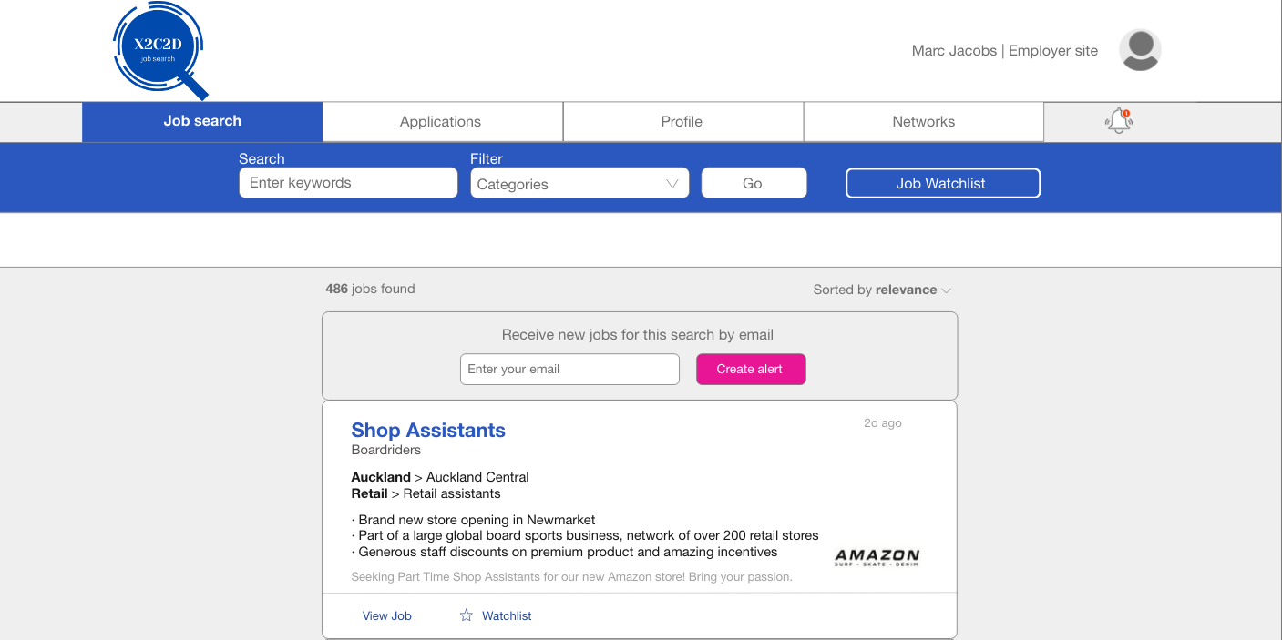

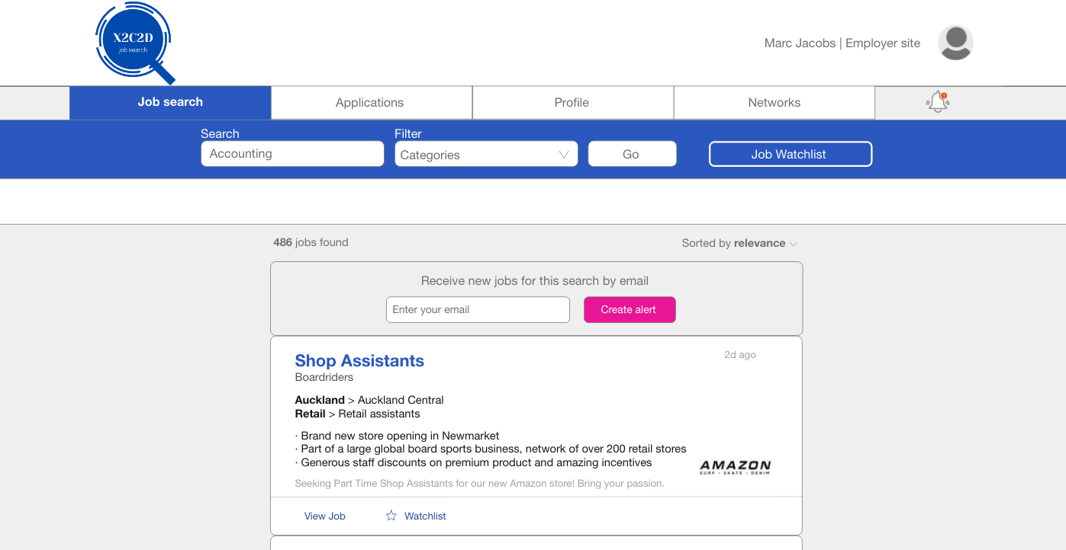

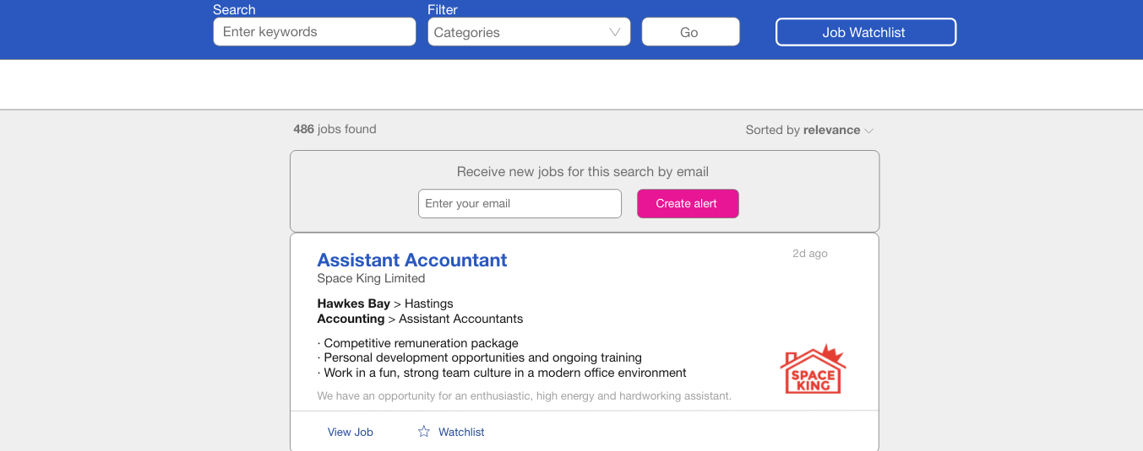

**GUI 2: Mobile**

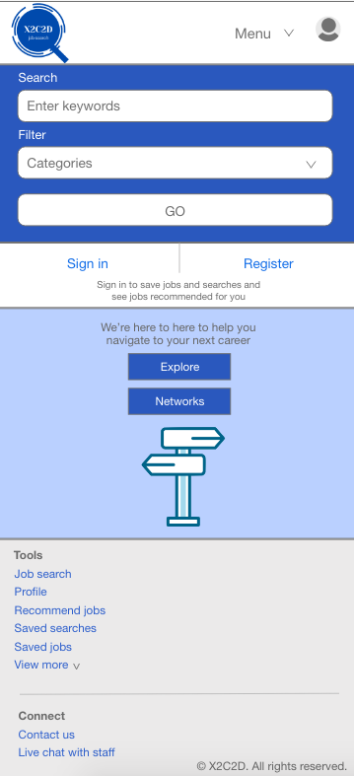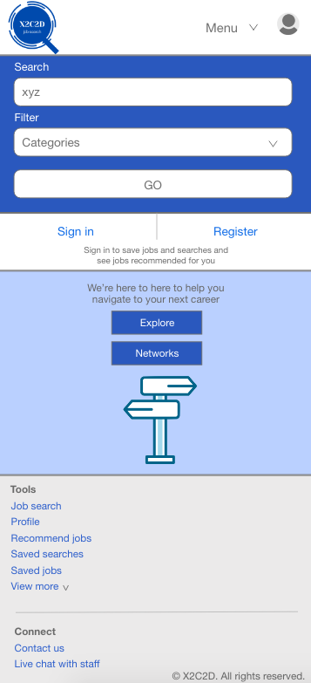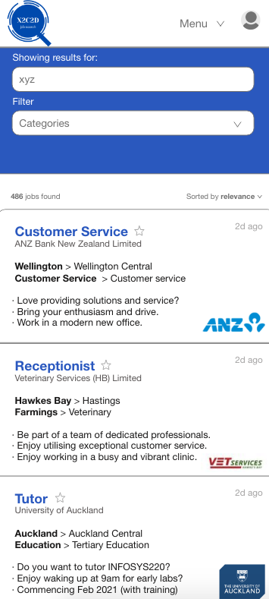

### F#2 Filter Search

Allows users to filter their job searches using predefined categories such as location, work type and job classifications. By clicking on categories, a drop down of the categories will appear with the 3 options.

**GUI 1: Desktop**

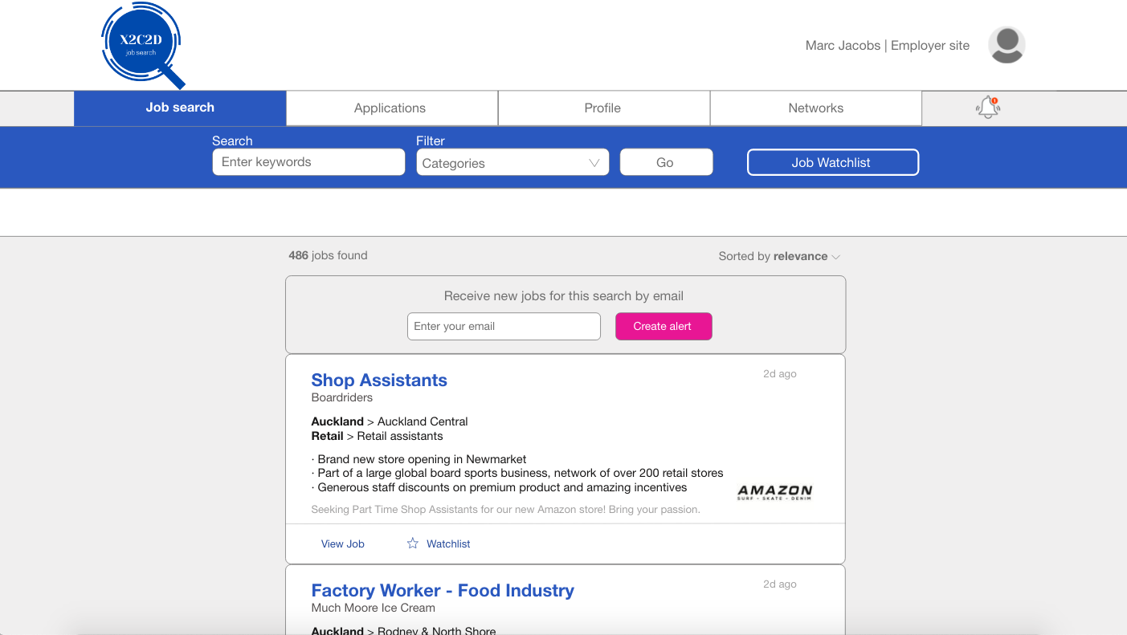

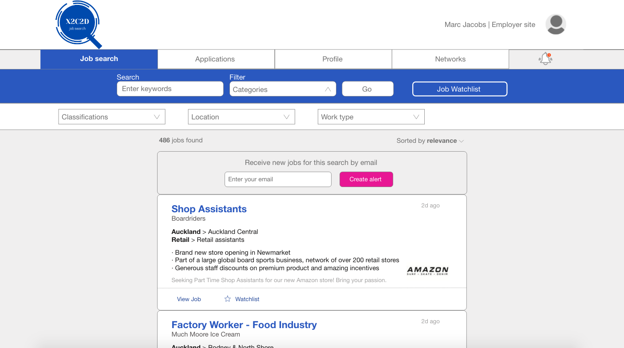

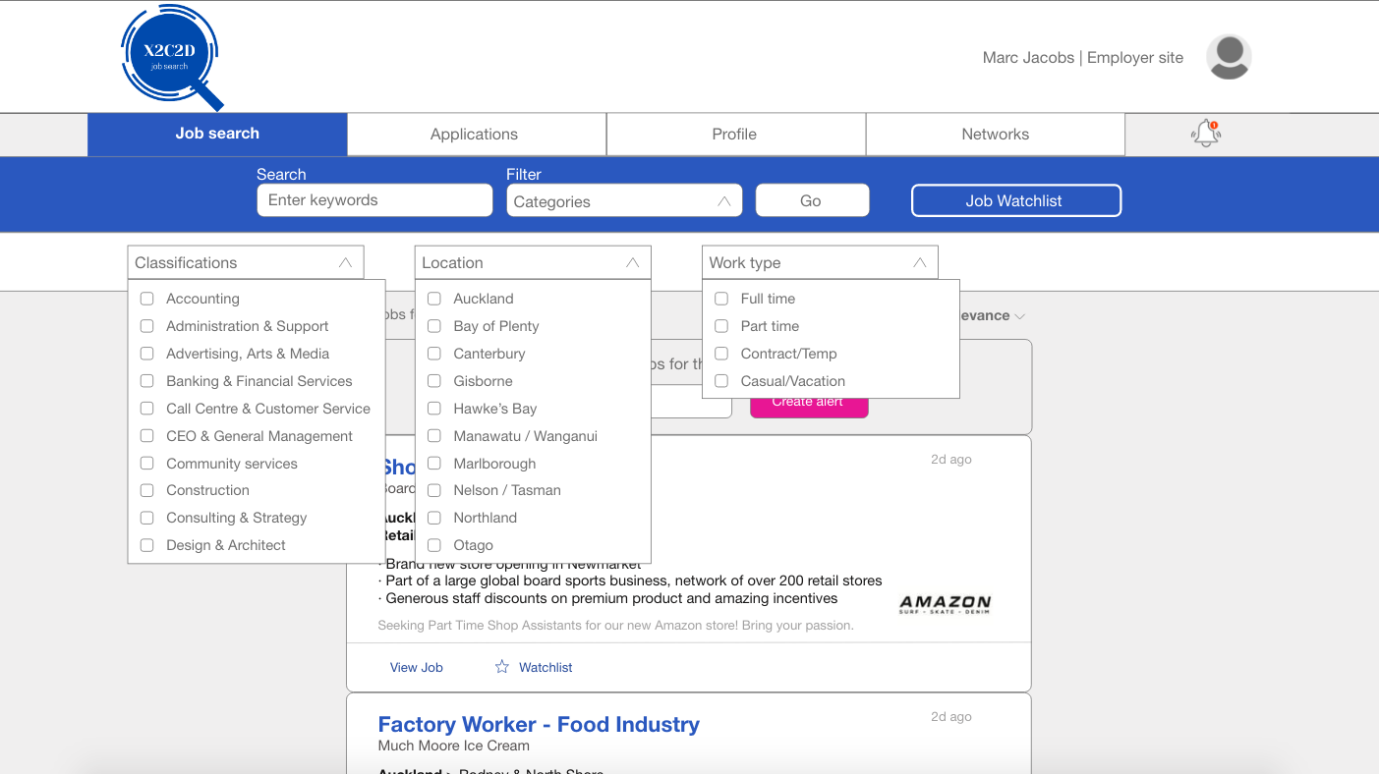

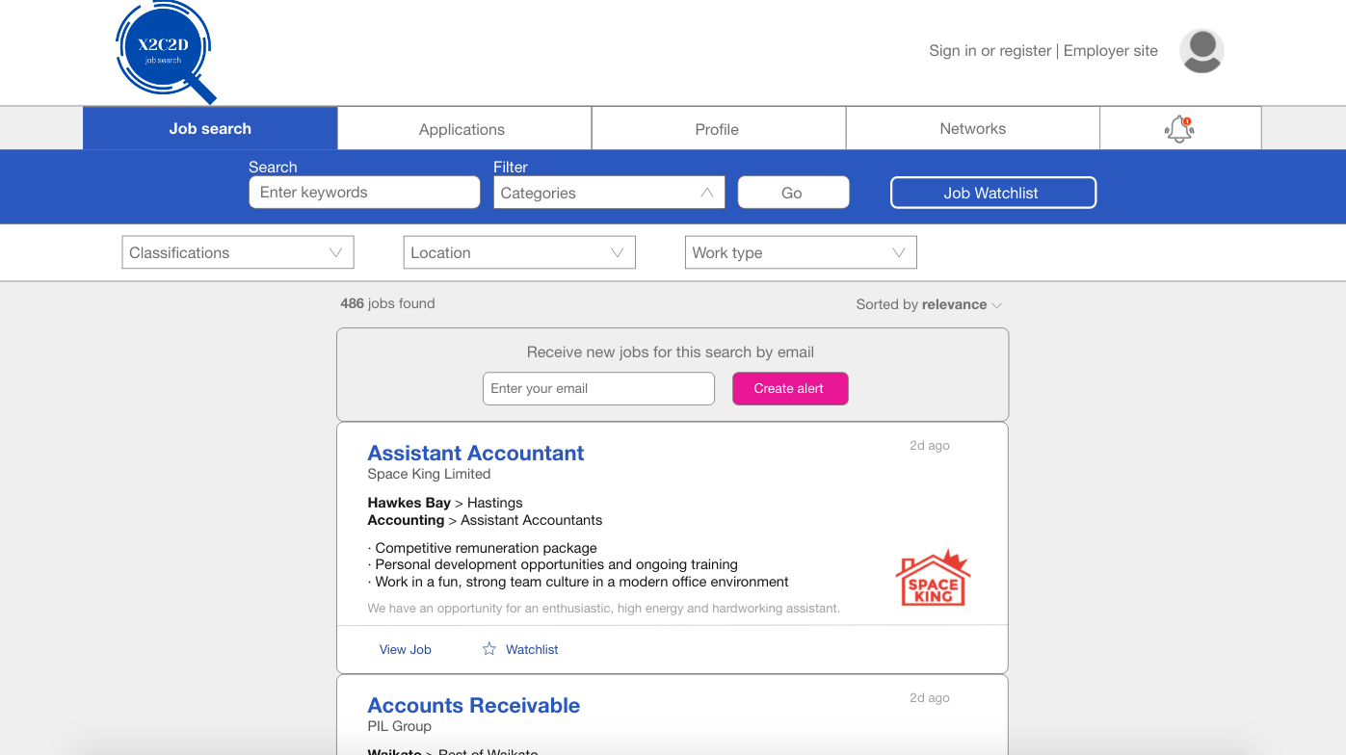

**GUI 2: Mobile**

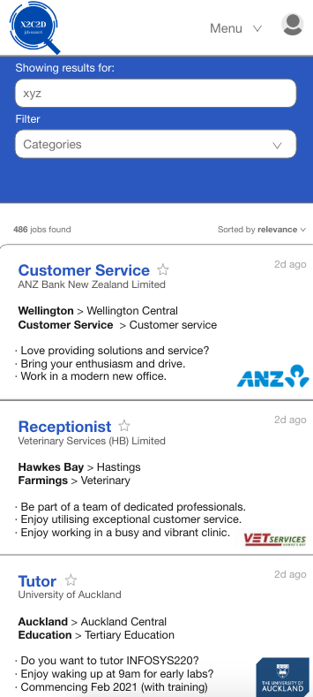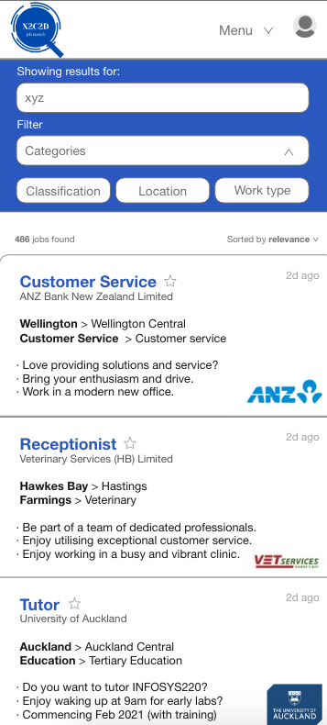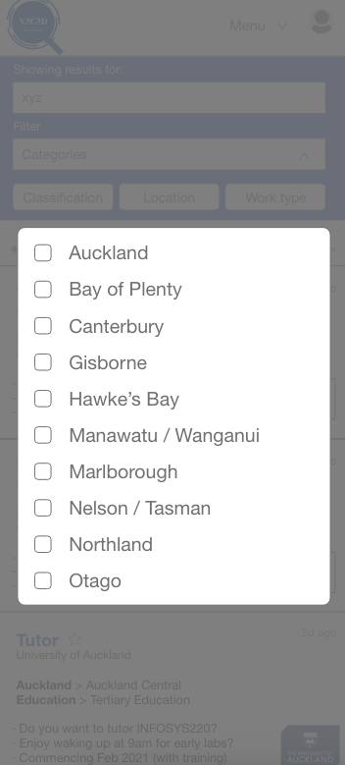

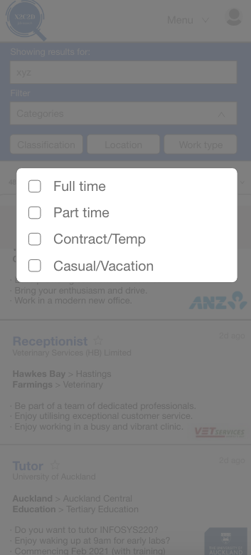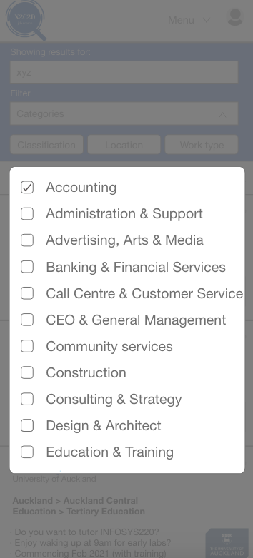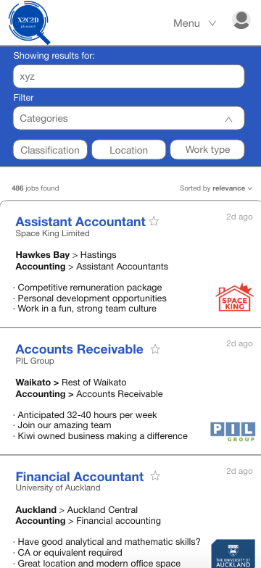

### F#3 Add to Watchlist

Allows users to save jobs they are interested in and view them later through the watch list page. A star is used to signify ‘save’ or ‘favourites’.

**GUI 1: Desktop**

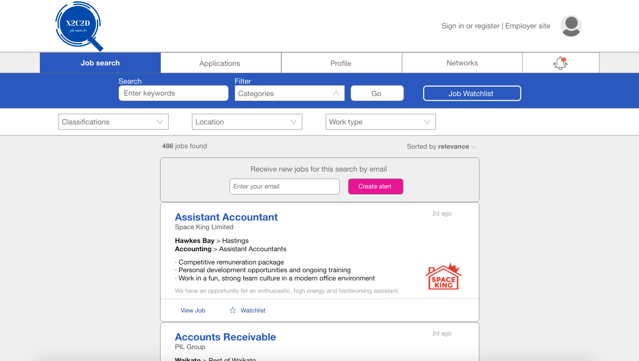

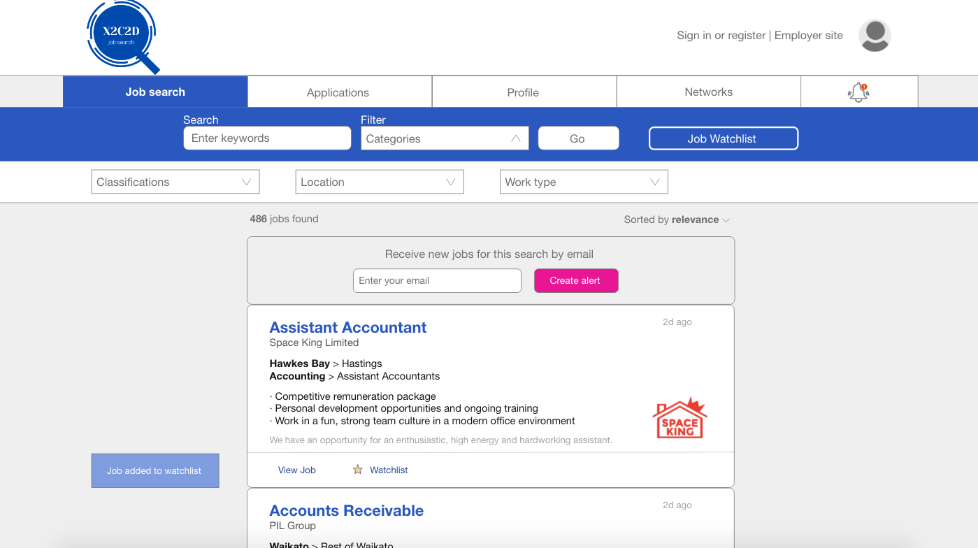

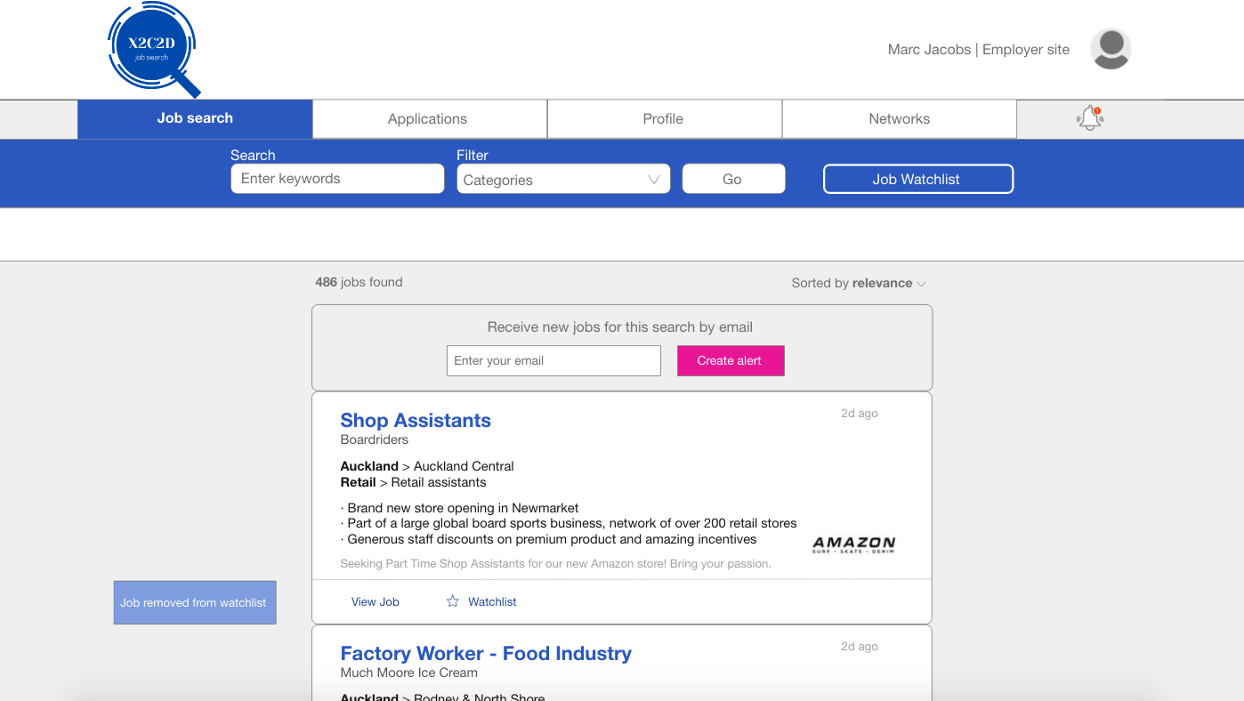

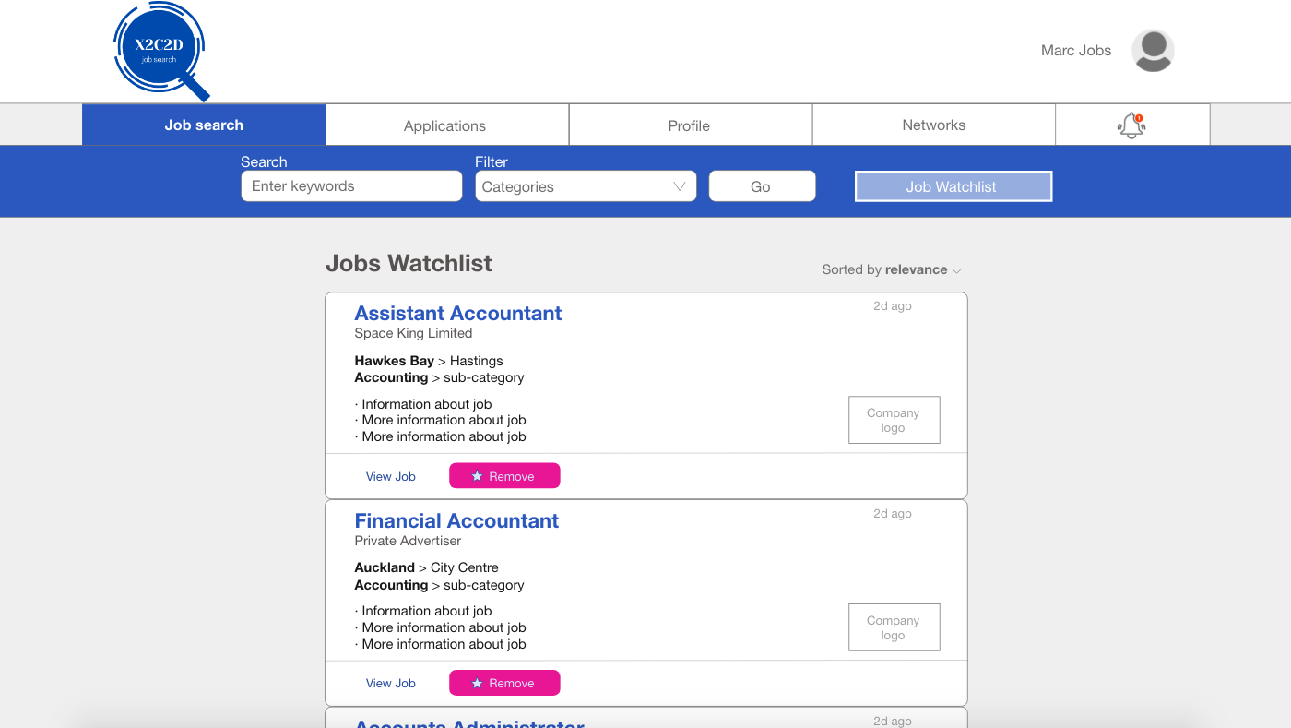

**GUI 2: Mobile**

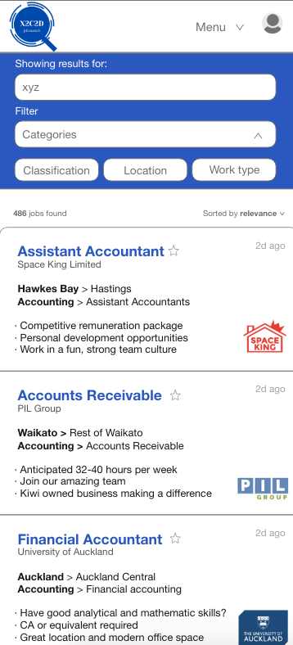 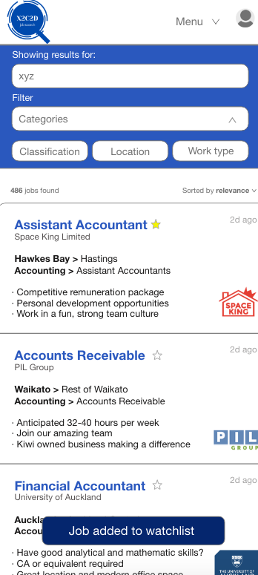 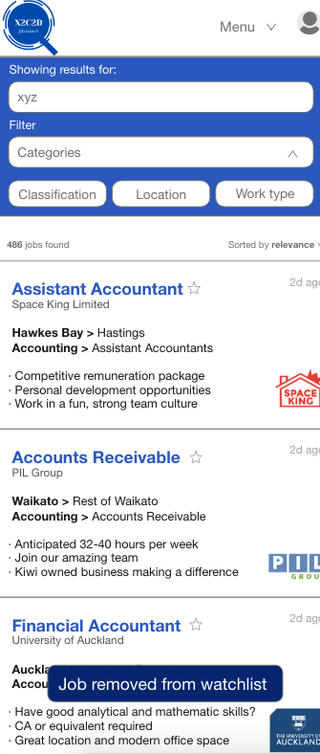

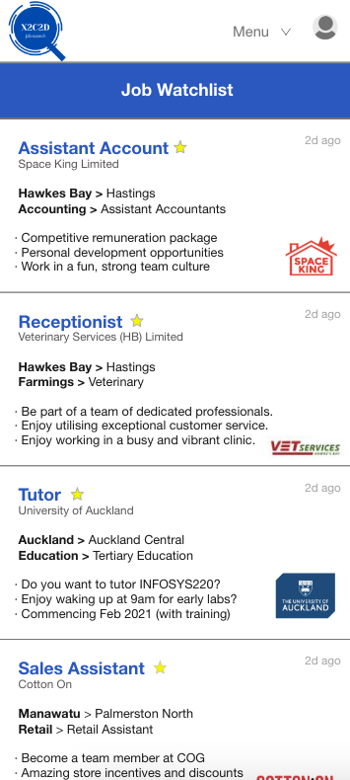

## UC#2 Data

|  |  |  |
| --- | --- | --- |
| Entity name: Search | Entity name: Filter | Entity name: Watchlist |
| Attributes:   * SearchText * NumberOfJobs * Sort * JobID | Attributes:   * Classification * Location * WorkType | Attributes:   * JobID * AddWatchlist * JobName * CompanyName * Location * CompanyLogo |

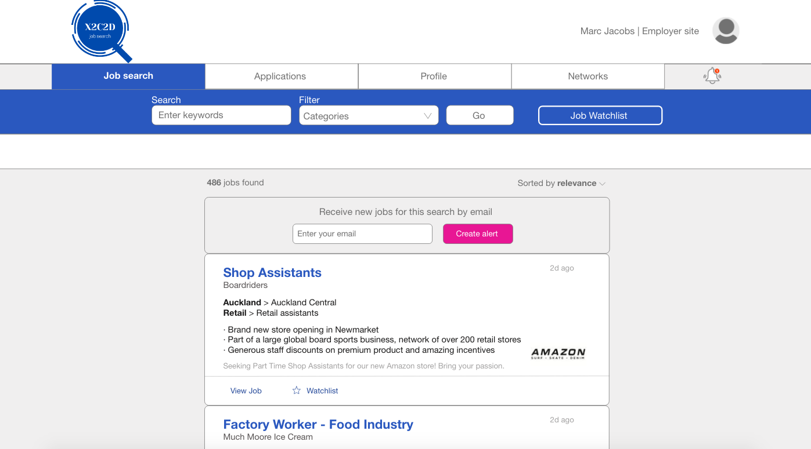

JobID

Sort

NumberOfJobs

SearchText

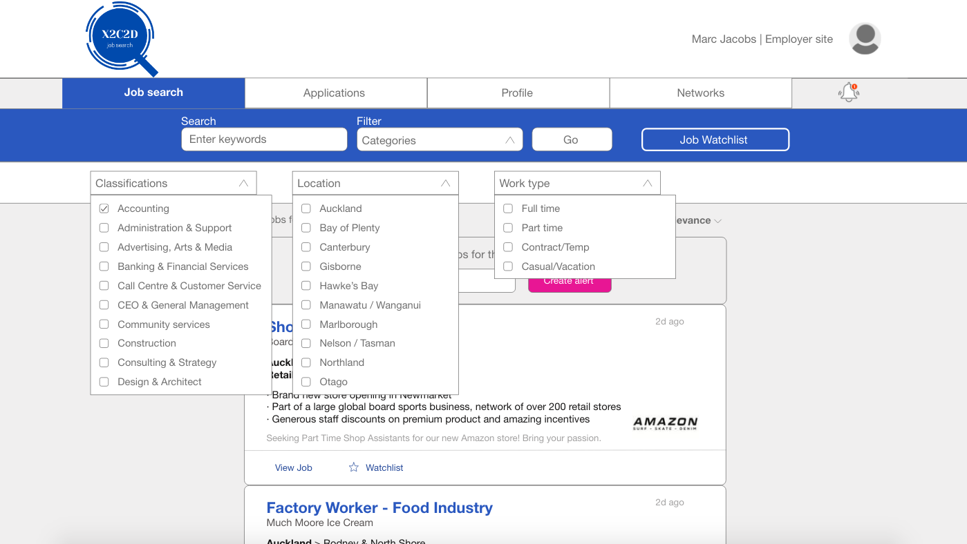

Location

Classification

WorkType

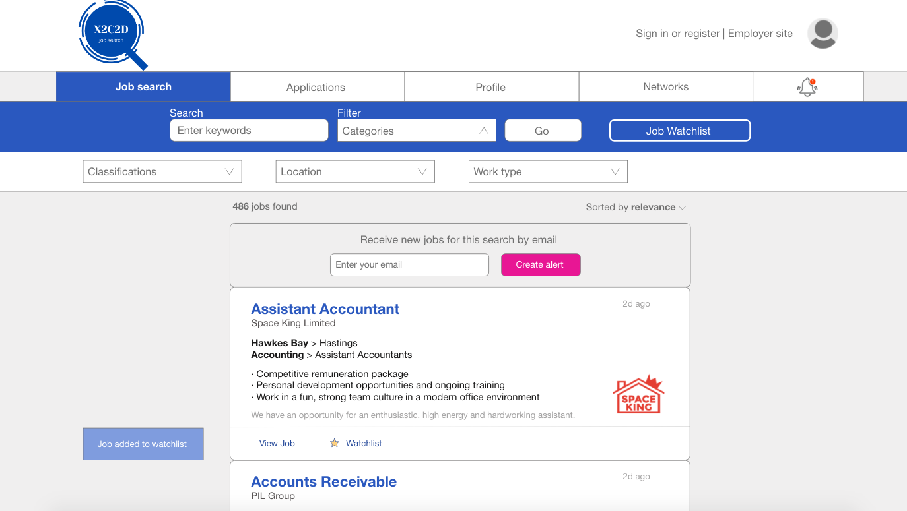

Location

CompanyLogo

CompanyName

JobName

AddWathclist

JobID

## UC#2 Demonstration/simulation

Chosen function number: F#3

Chosen function name: Add to Watchlist

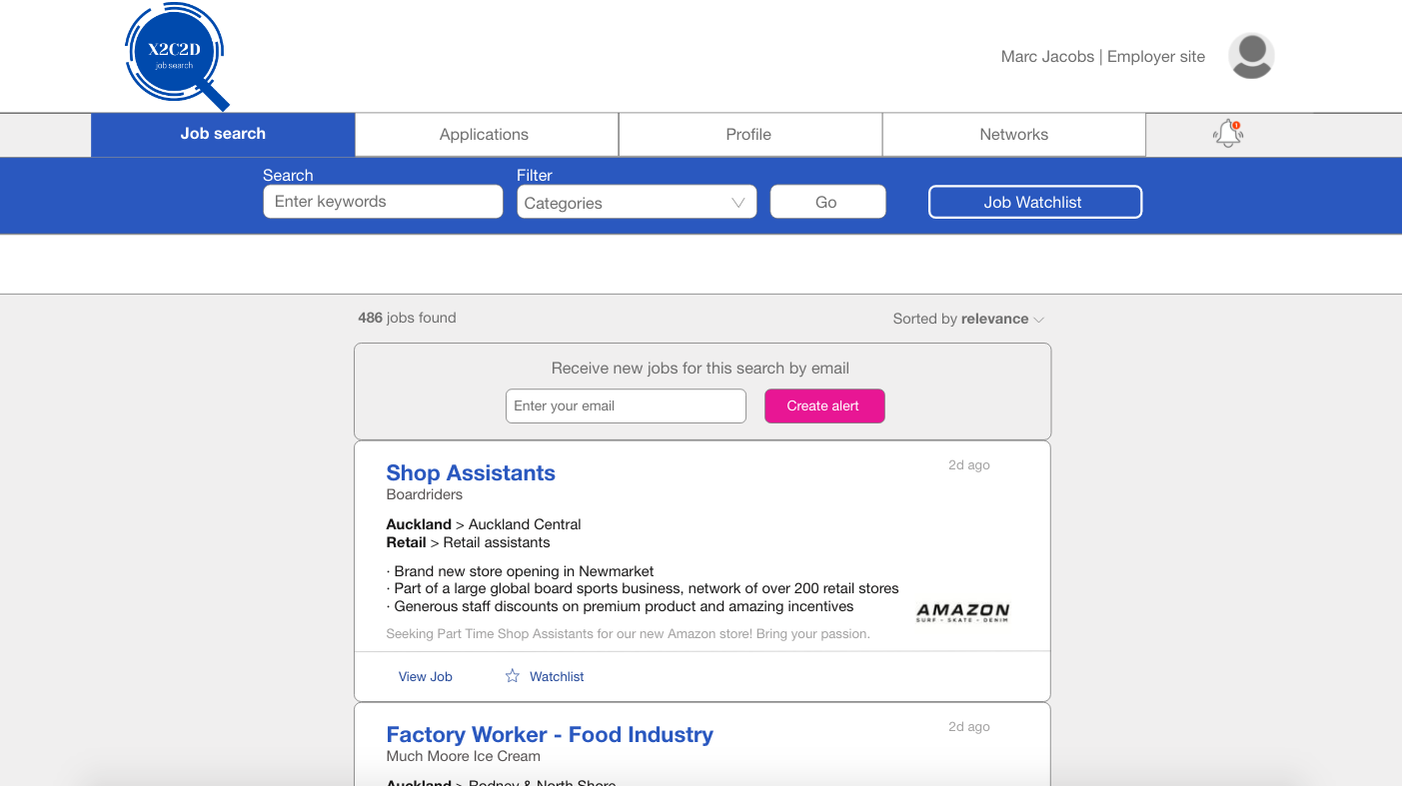

**Step 1.** Click job search tab in the navigation

**Step 2.** Click on the categories button to filter through the jobs. A drop down of the options will appear.

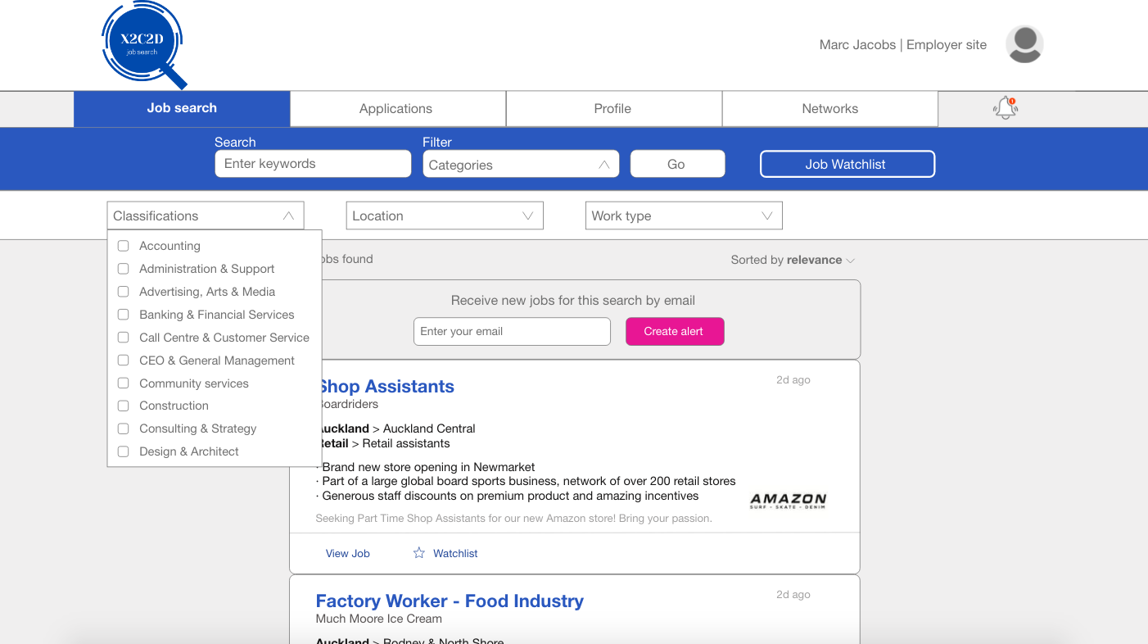

**Step 4.** Select a classification option. For demonstration purposes, select ‘Accounting’

**Step 3.** Click on the classifications button to reveal options for job classifications

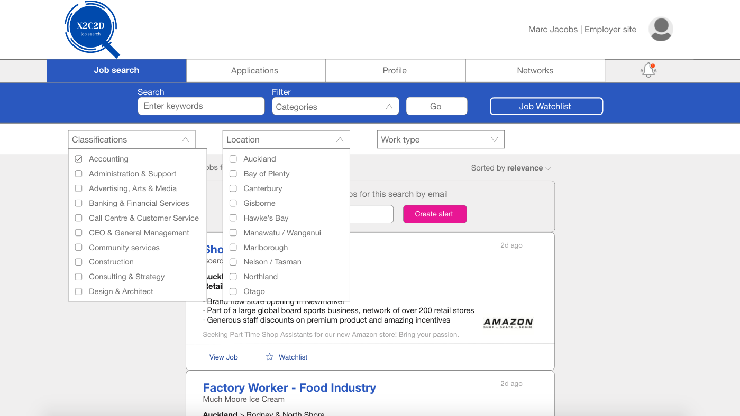

**Step 7.** Click on the work type button to reveal options for work type

**Step 6.** Select a location option. For demonstration purposes, select ‘Auckland’

**Step 5.** Click on the location button to reveal options for job locations

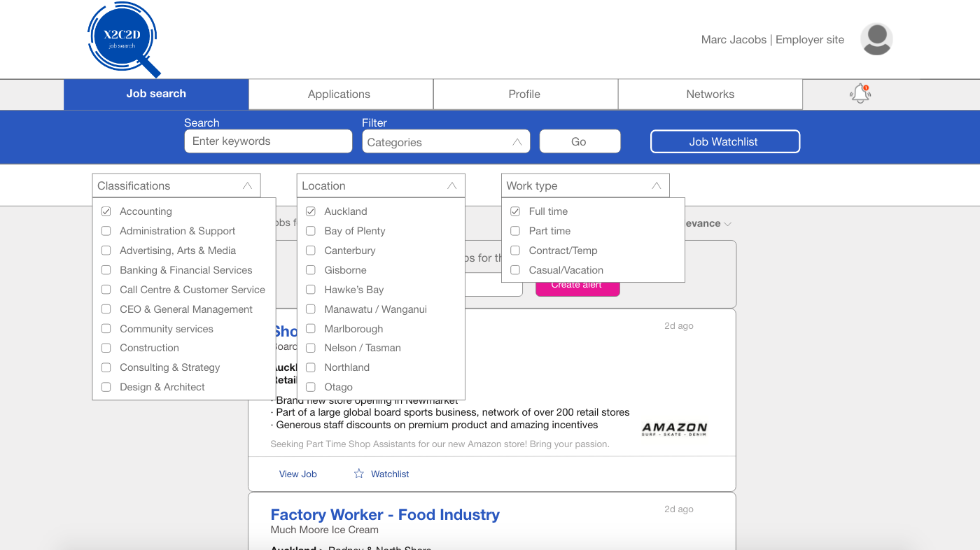

**Step 8.** Select a work type option. For demonstration purposes, select ‘Full time’

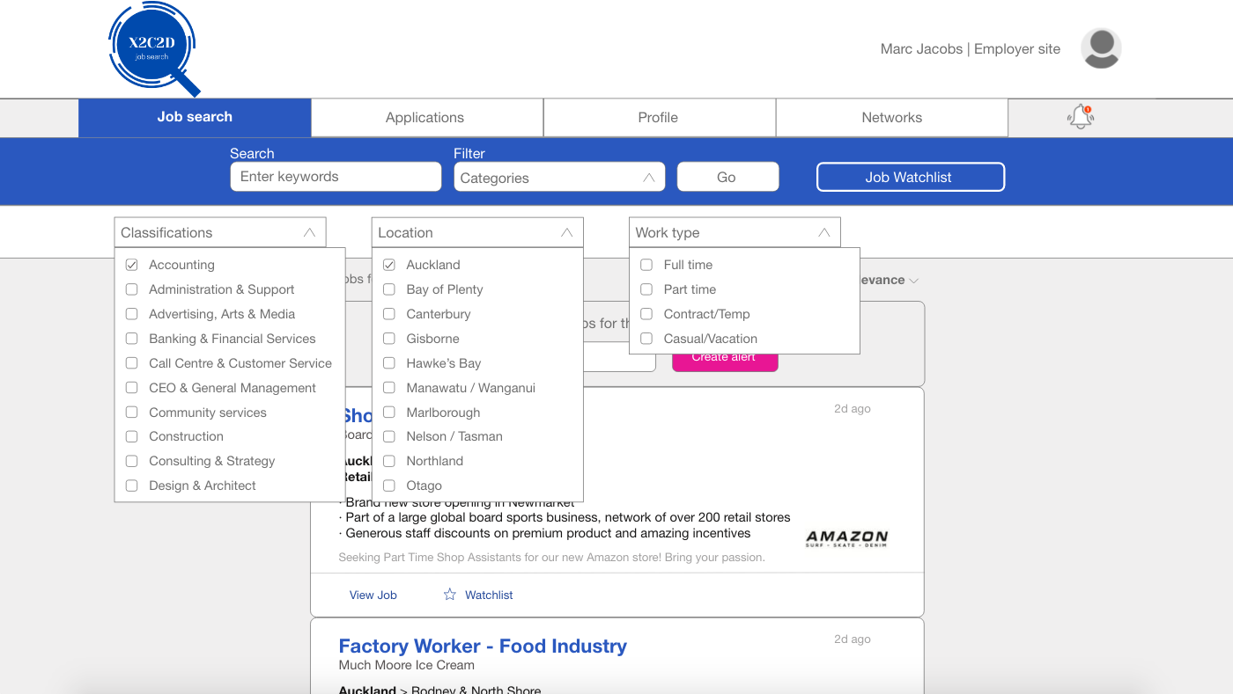

**Step 9.** Click on the Go button to proceed with the filter and view the filtered job search page.

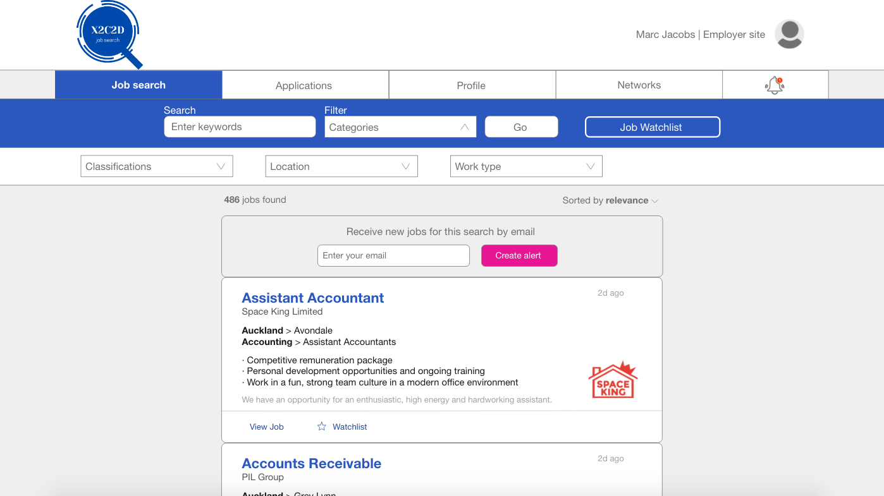

**Step 10.** The jobs related to the categories are now shown on the job search page being ‘Accounting’, ‘Auckland’ and ‘Full time’

## F#3 Test plan

|  |  |
| --- | --- |
| Goal/Description of test plan | Allows users to filter their job searches using predefined categories such as location, work type and job classifications by the options they desire. |
| Testing method | 1. Click on the Job search tab in the navigation bar 2. Click on the categories button.    * + 1. A drop down of the three categories will appear.        2. Clicking on categories again will hide the drop down 3. Click on the classifications button    * + 1. A drop down of all the job classifications will appear 4. Select a classification option    * + 1. A tick will be shown upon clicking on the empty box        2. Deselecting will untick the box        3. In the real system, users will be allowed to select multiple boxes and further sub classifications        4. For purposes of this simulation, only ‘Accounting’ can be selected 5. Click on the location button    * + 1. A drop down of all the job locations will appear 6. Select a location option    * + 1. A tick will be shown upon clicking on the empty box        2. Deselecting will untick the box        3. In the real system, users will be allowed to select multiple boxes and further sub locations (suburbs)        4. For purposes of this simulation only ‘Auckland’ can be selected 7. Click on the work type button    * + 1. A drop down of all the work types will appear 8. Select a work type option    * + 1. A tick will be shown upon clicking on the empty box        2. Deselecting will untick the box        3. In the real system, users will be allowed to select multiple boxes. No sub options will be available for worktype.        4. For purposes of this simulation only ‘Full time’ can be selected 9. Click on the Go button 10. The user can now see all the jobs related to the categories that they have selected. |
| Expected successful result | The job search page will show only jobs related to the categories that the user has selected. |
| Other notes (optional) | It is not necessary for the user to choose an option from all 3 categories (classification, location and work type) in order to filter the job searches. However, for demonstration purposes an option from all 3 categories was selected |

# UC#3

UC#3 name: Maintain Communication

## UC#3 Functionality

### F#1: Create enquiry

Applicants can ask for more information from employers by using the chat function to find out more information and details regarding the job that they are interested in.

Send Chat View Chat



### F#2: Send notifications

Employers will be able to notify different groups of people easily on one screen to potential employers regarding a job opening or send the applicants about the application status. Therefore, the applicant can move on to searching for a new job if the desired job application was rejected.

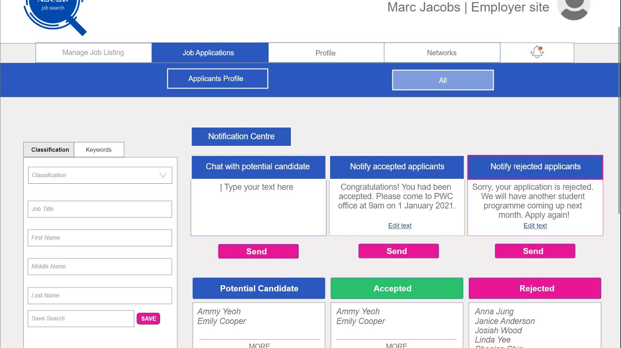

### F#3: Join Network

Follow the people that help employees to get further job opportunities. This can be done by going to the network page.

The mobile version of Join Network function’s screenshot as shown below:

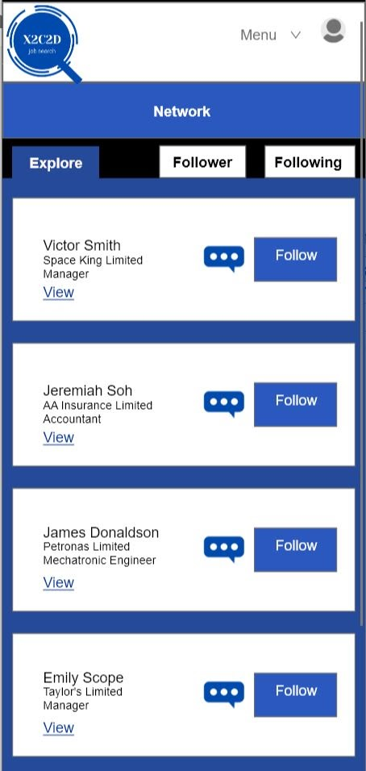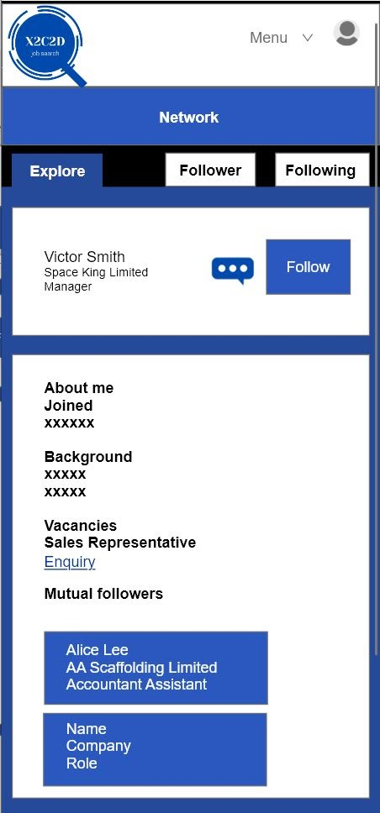

## UC#3 Data

|  |  |  |
| --- | --- | --- |
| Entity name: Job_Status_Notification | Entity name: Applicant | Entity name: Application |
| Attributes:   * jobID * applicantID * applicantStatus * isSent | Attributes:   * applicantID * applicantName * emailAddress * status | Attributes:   * applicationID * status |

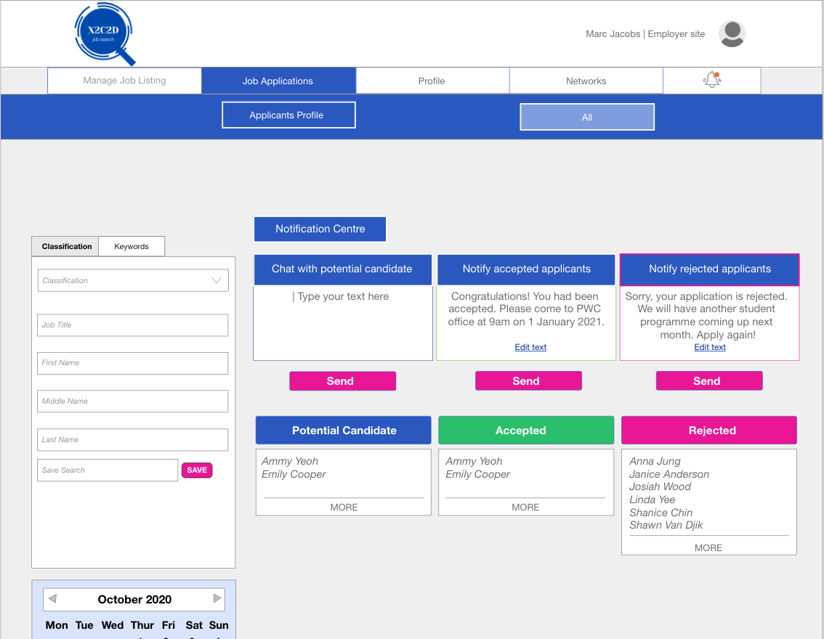

applicantStatus

applicantName

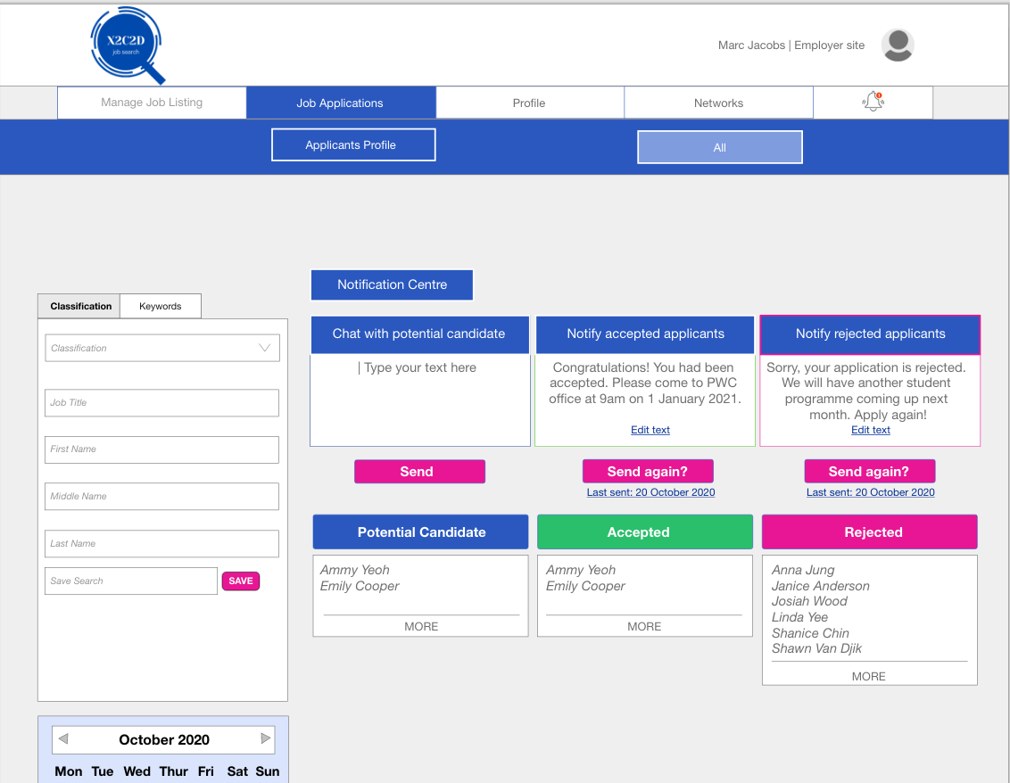

Status

isSent

## UC#3 Demonstration/simulation

Chosen function number: F#2

Chosen function name: Send Notification

**Step 1** Click on the job application tab on the employer site

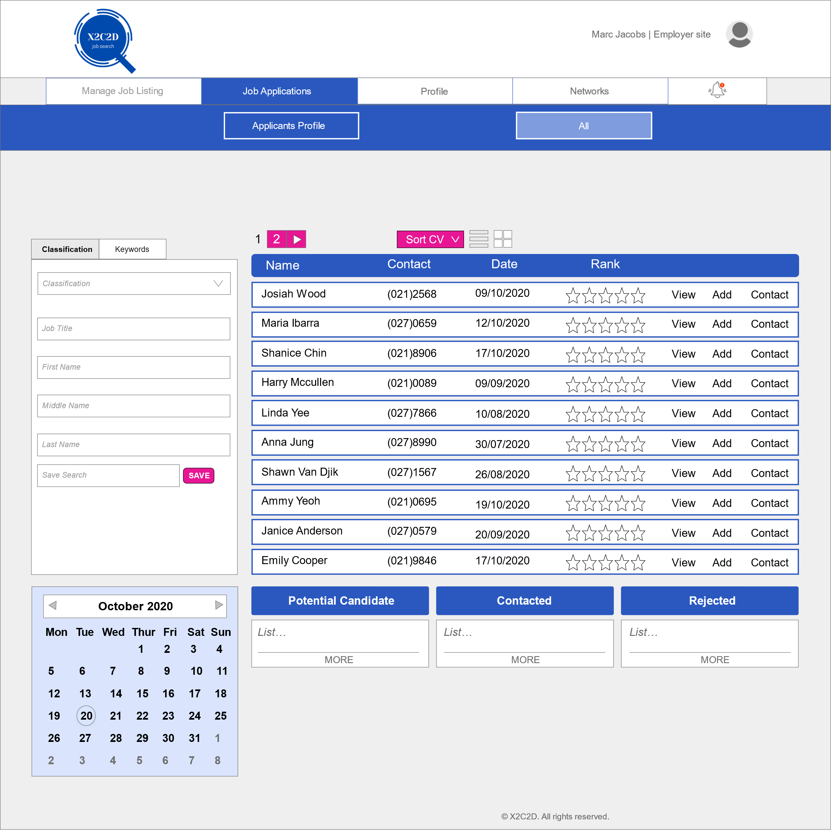

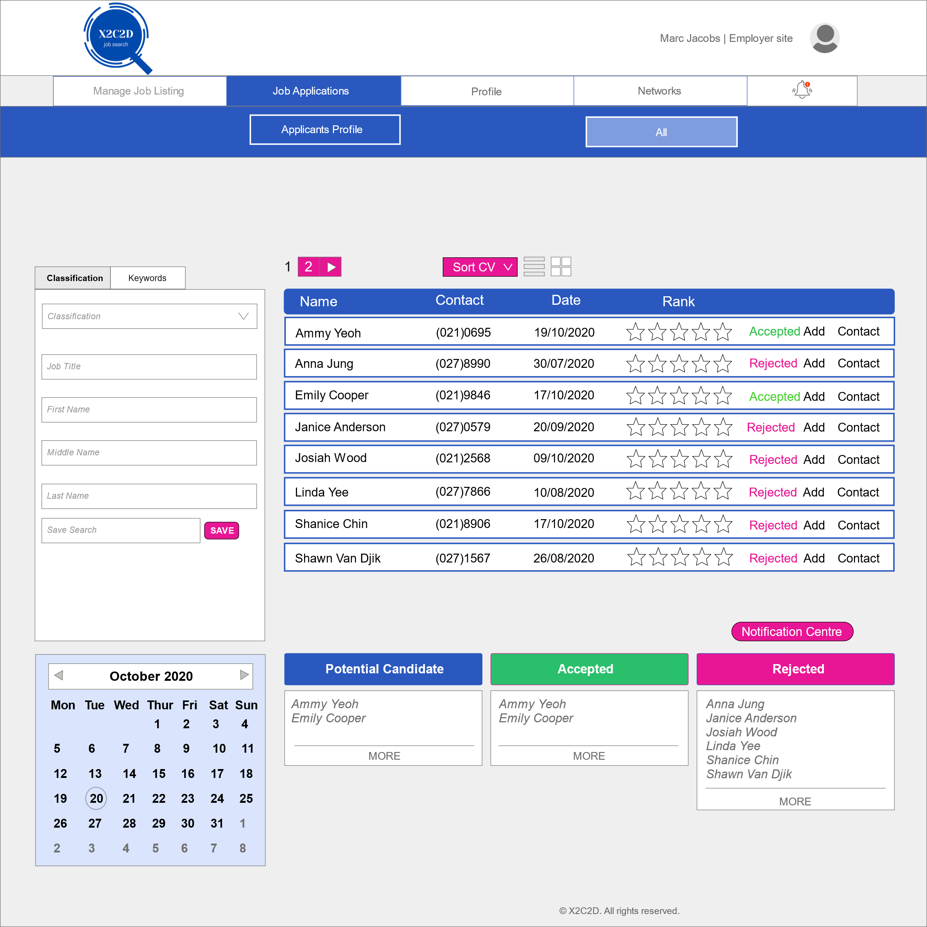

**Step 2** Employers update the status by moving the applicant to either accepted or rejected column.

**Step 3** Click on the notification centre

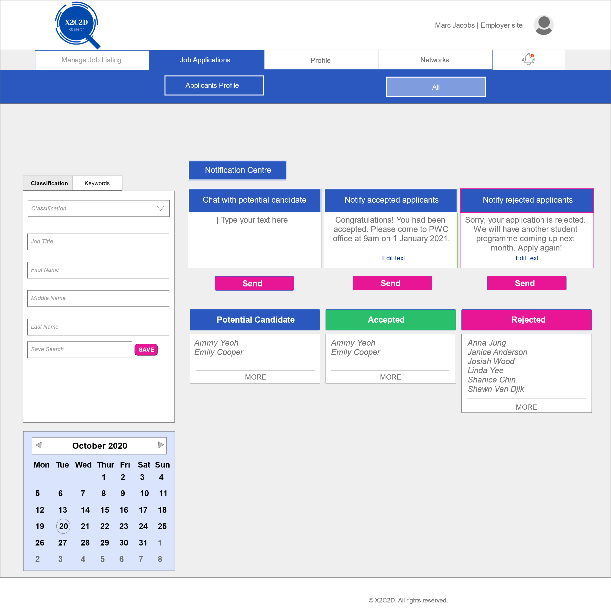

**Step 4** Edit the content to be send out in the notification for the applicant

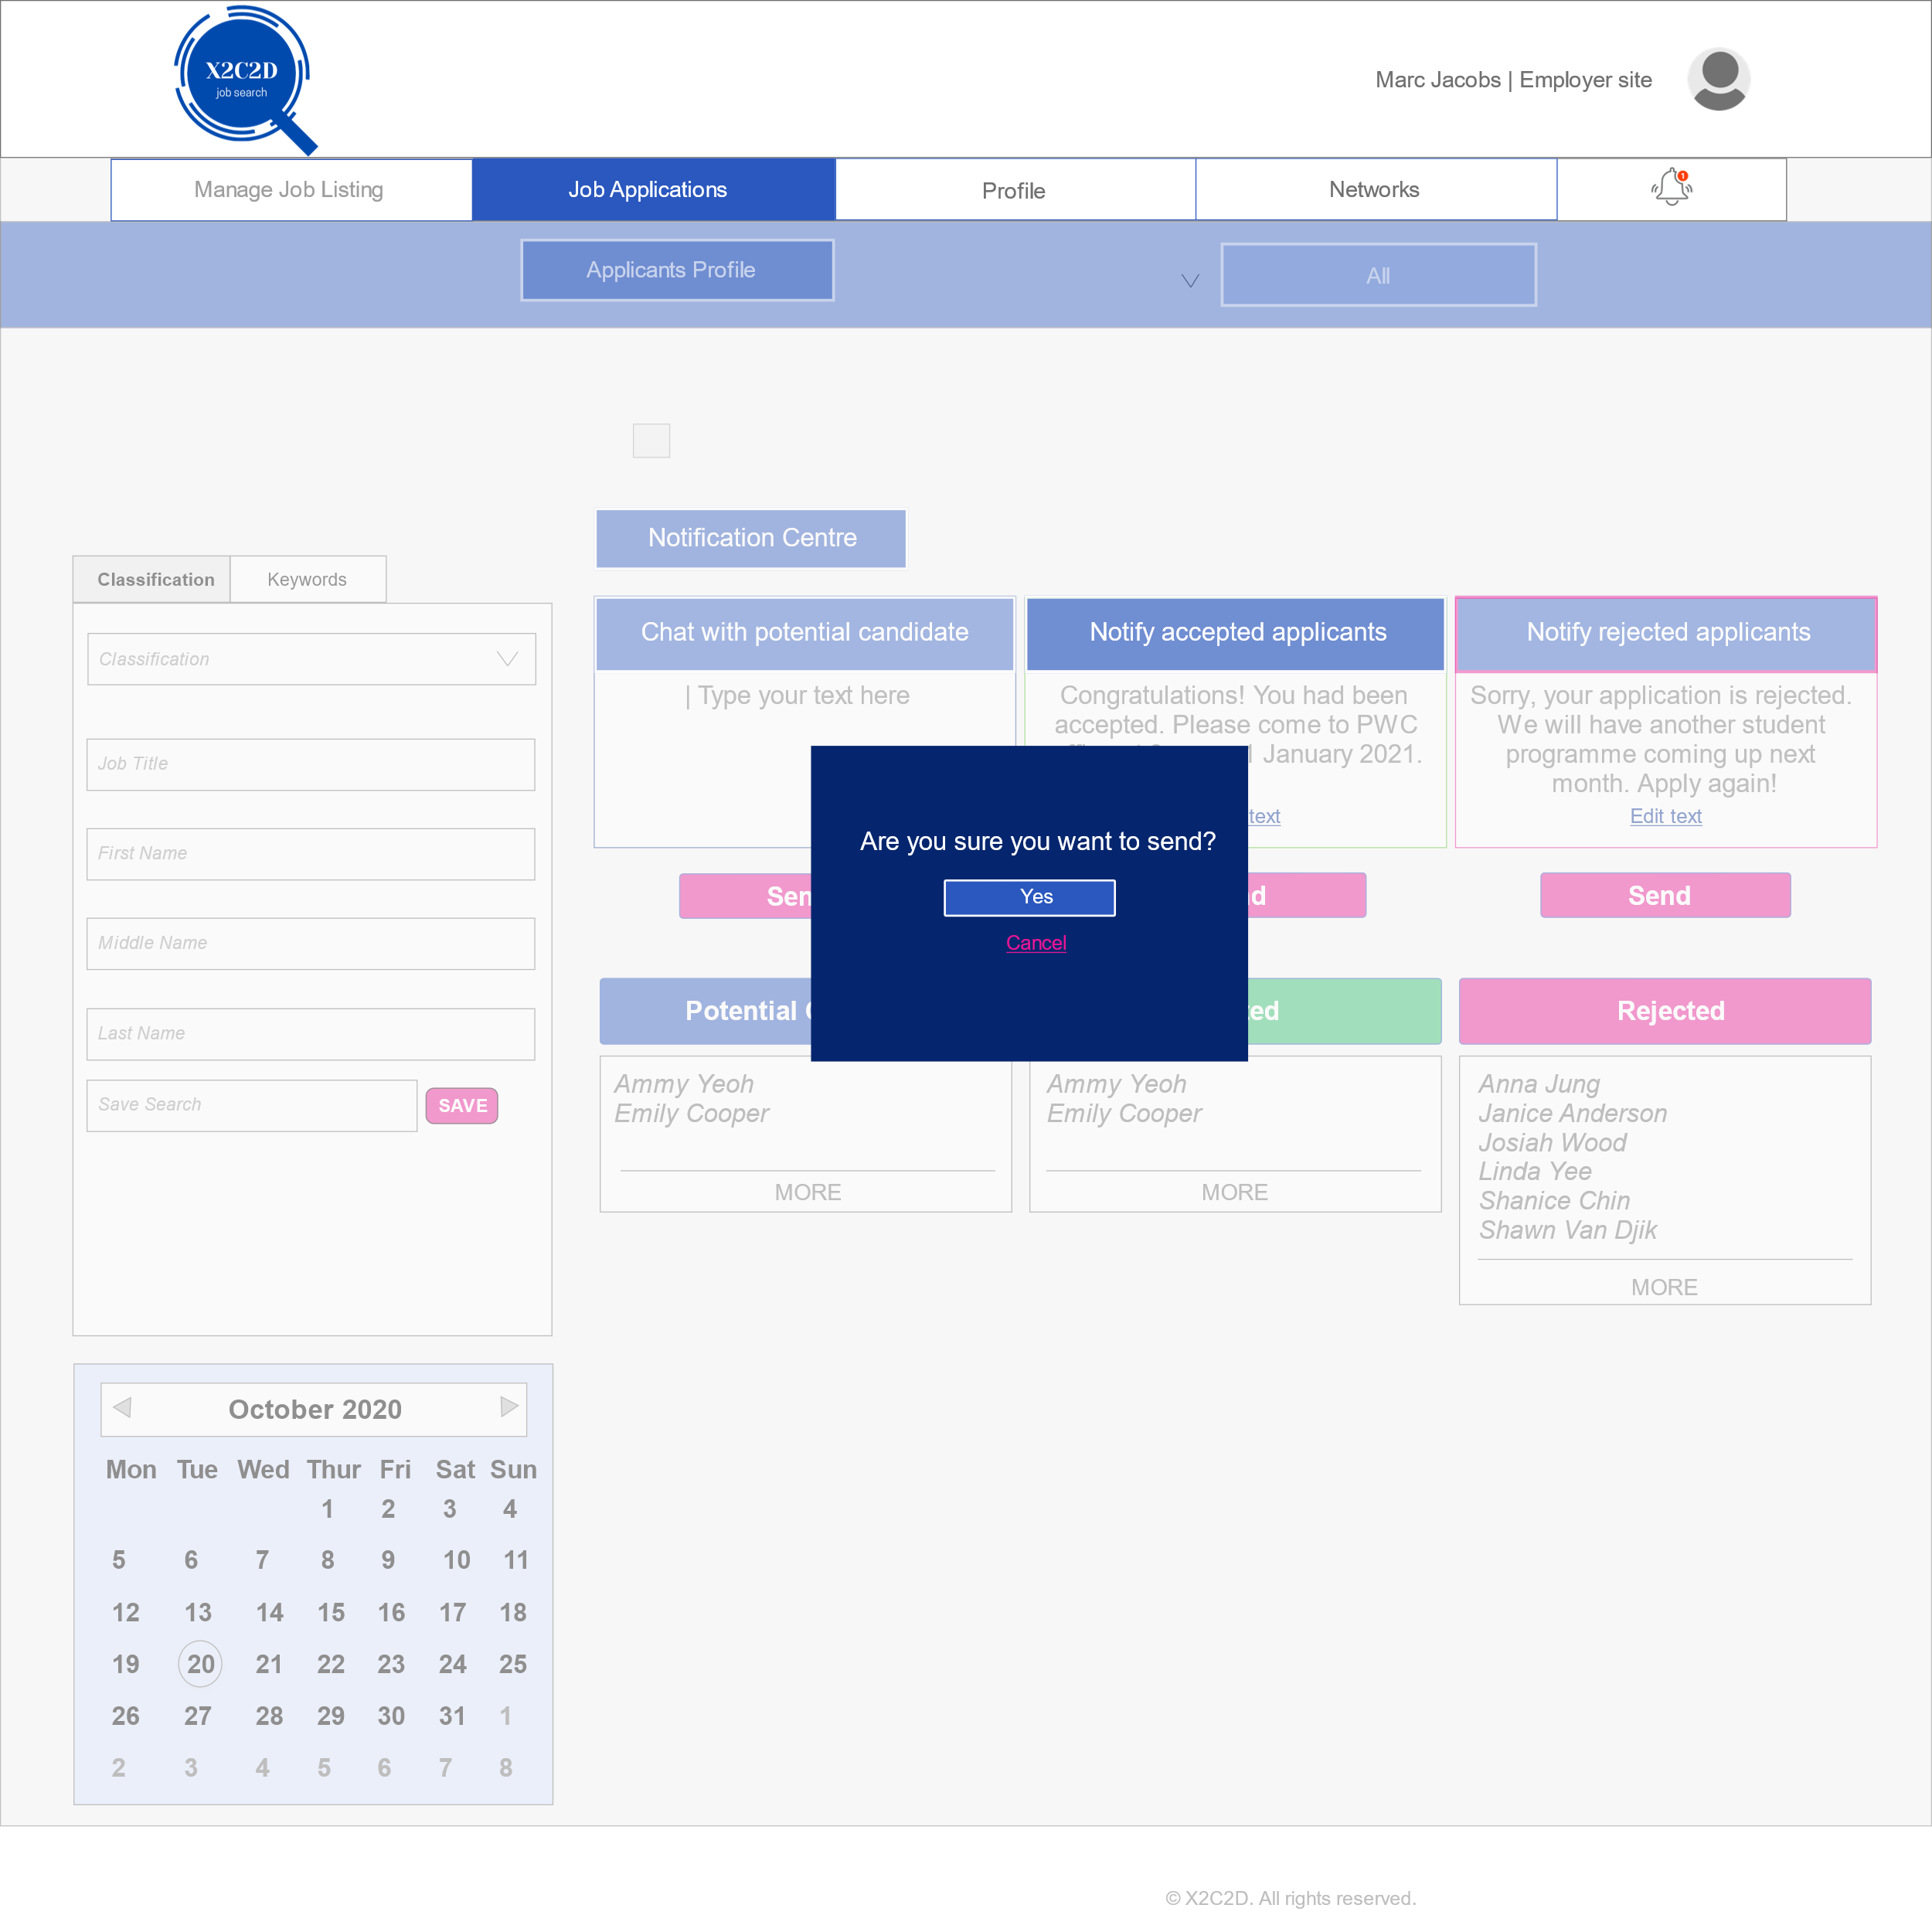

**Step 5** User presses confirm to check for mistakes in the notifications before sending

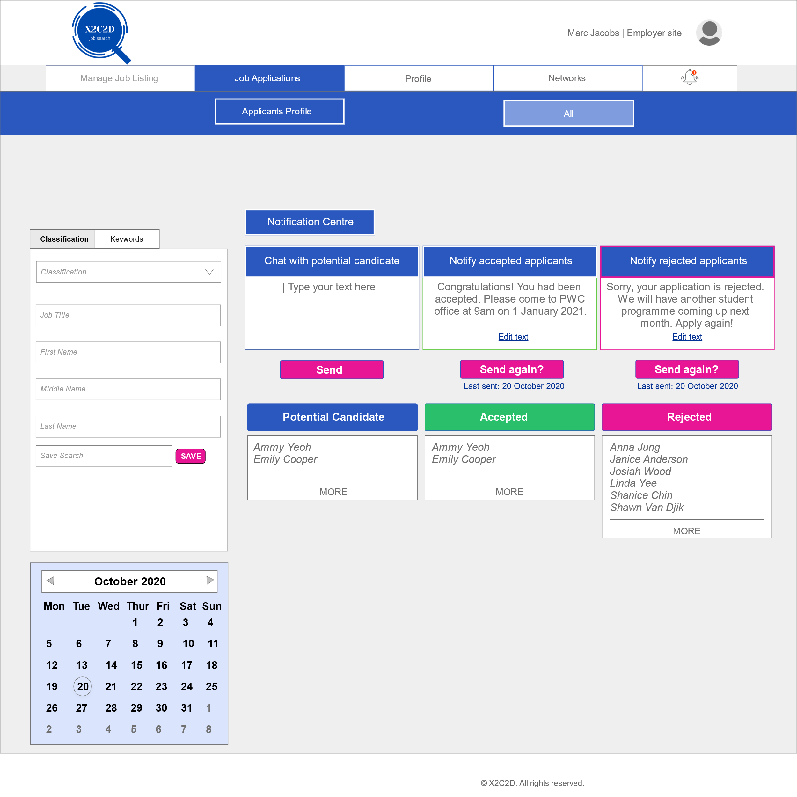

**Step 6** The website will show the date when the notification is sent. Employers have the option to send follow up notification by clicking send again

**Video Demonstration:**



## F#2 Test plan

|  |  |
| --- | --- |
| Goal/Description of test plan | Allow employers to send notification to the selected group so that informed decisions can be made. |
| Testing method | 1. Click on the job application tab on the employer site. 2. Employers update the status by moving the applicant to either accepted or rejected. 3. Click on the notification centre. 4. Edit the content to be send out in the notification for the applicant. 5. User presses confirm to check for mistakes in the notifications before sending. 6. The website will show the date when the notification is sent. Employers have the option to send follow up notification by clicking send again. |
| Expected successful result | 1. The notification will be sent out successfully from the employers site and the “send” button will change to “send again?”. 2. The notifications will arrive at the applicant or potential applicant’s notification bar. |
| Other notes (optional) | N/A |

# UC#4

UC#4 name: Maintain job application

## UC#4 Functionality

### F#1 Sort CV

Sort CV is located in the ‘Job Application’. This function will enable the employer to sort out the Applicants CV’s based on applicants ‘Name’, ‘Recently viewed’, ‘Rank’, and ‘Date’ from applicant’s chosen job classifications when they first search for their job.

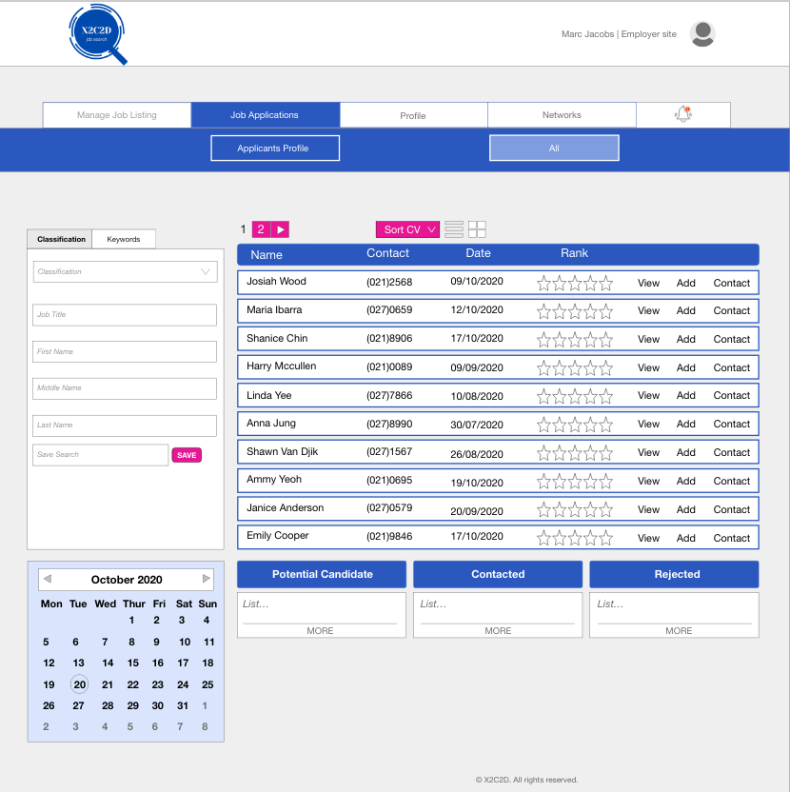

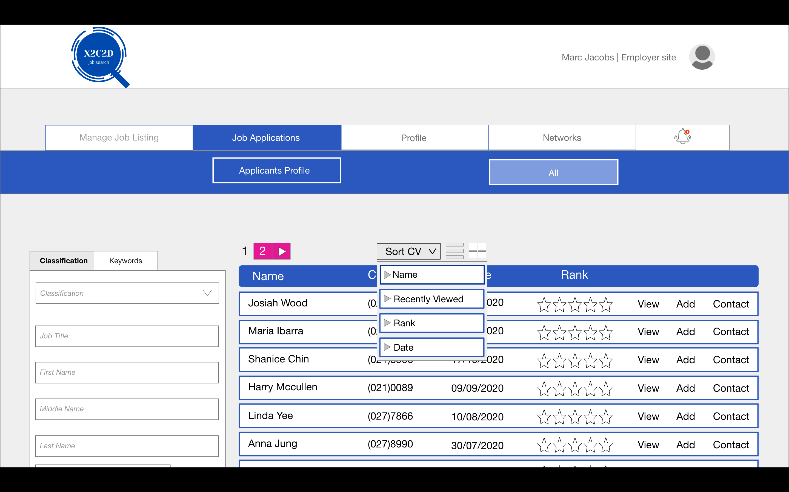

Sort CV also come in a mobile version which screenshot is shown below:

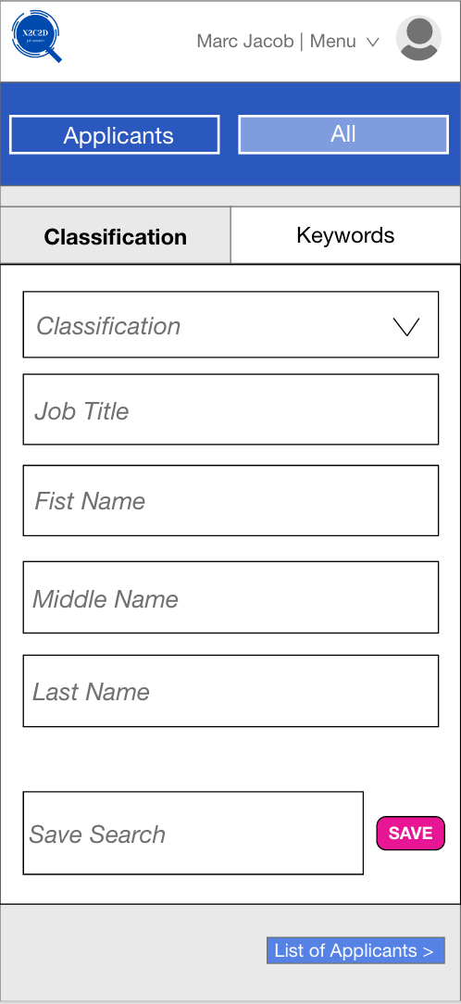 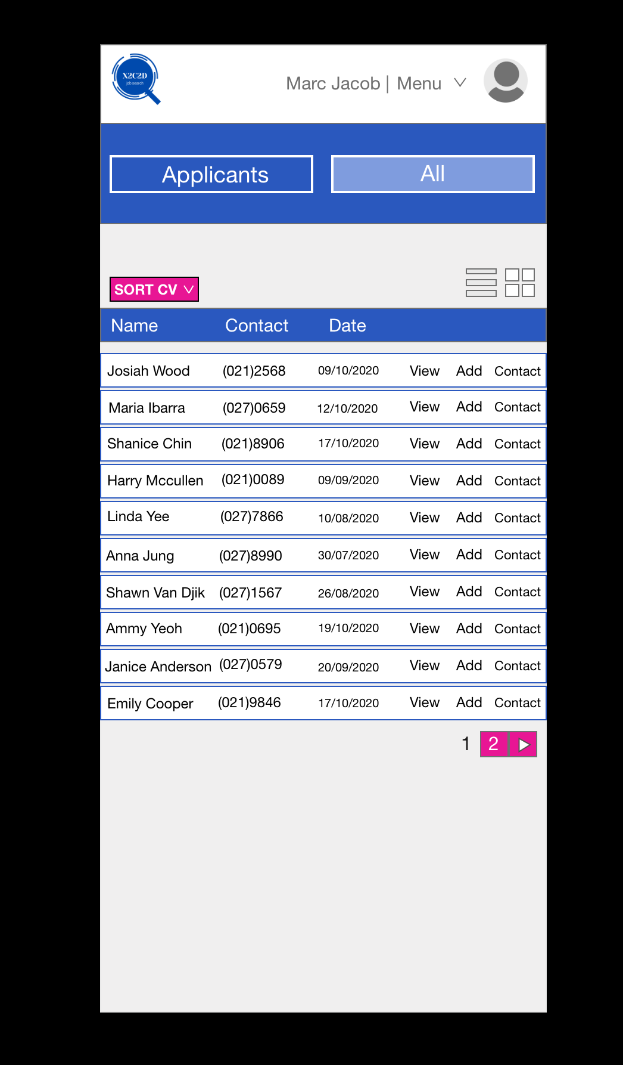

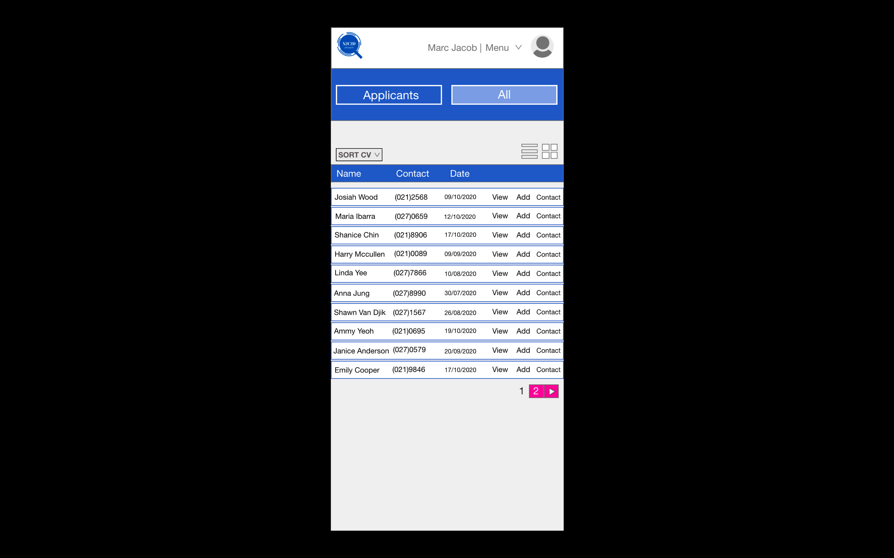 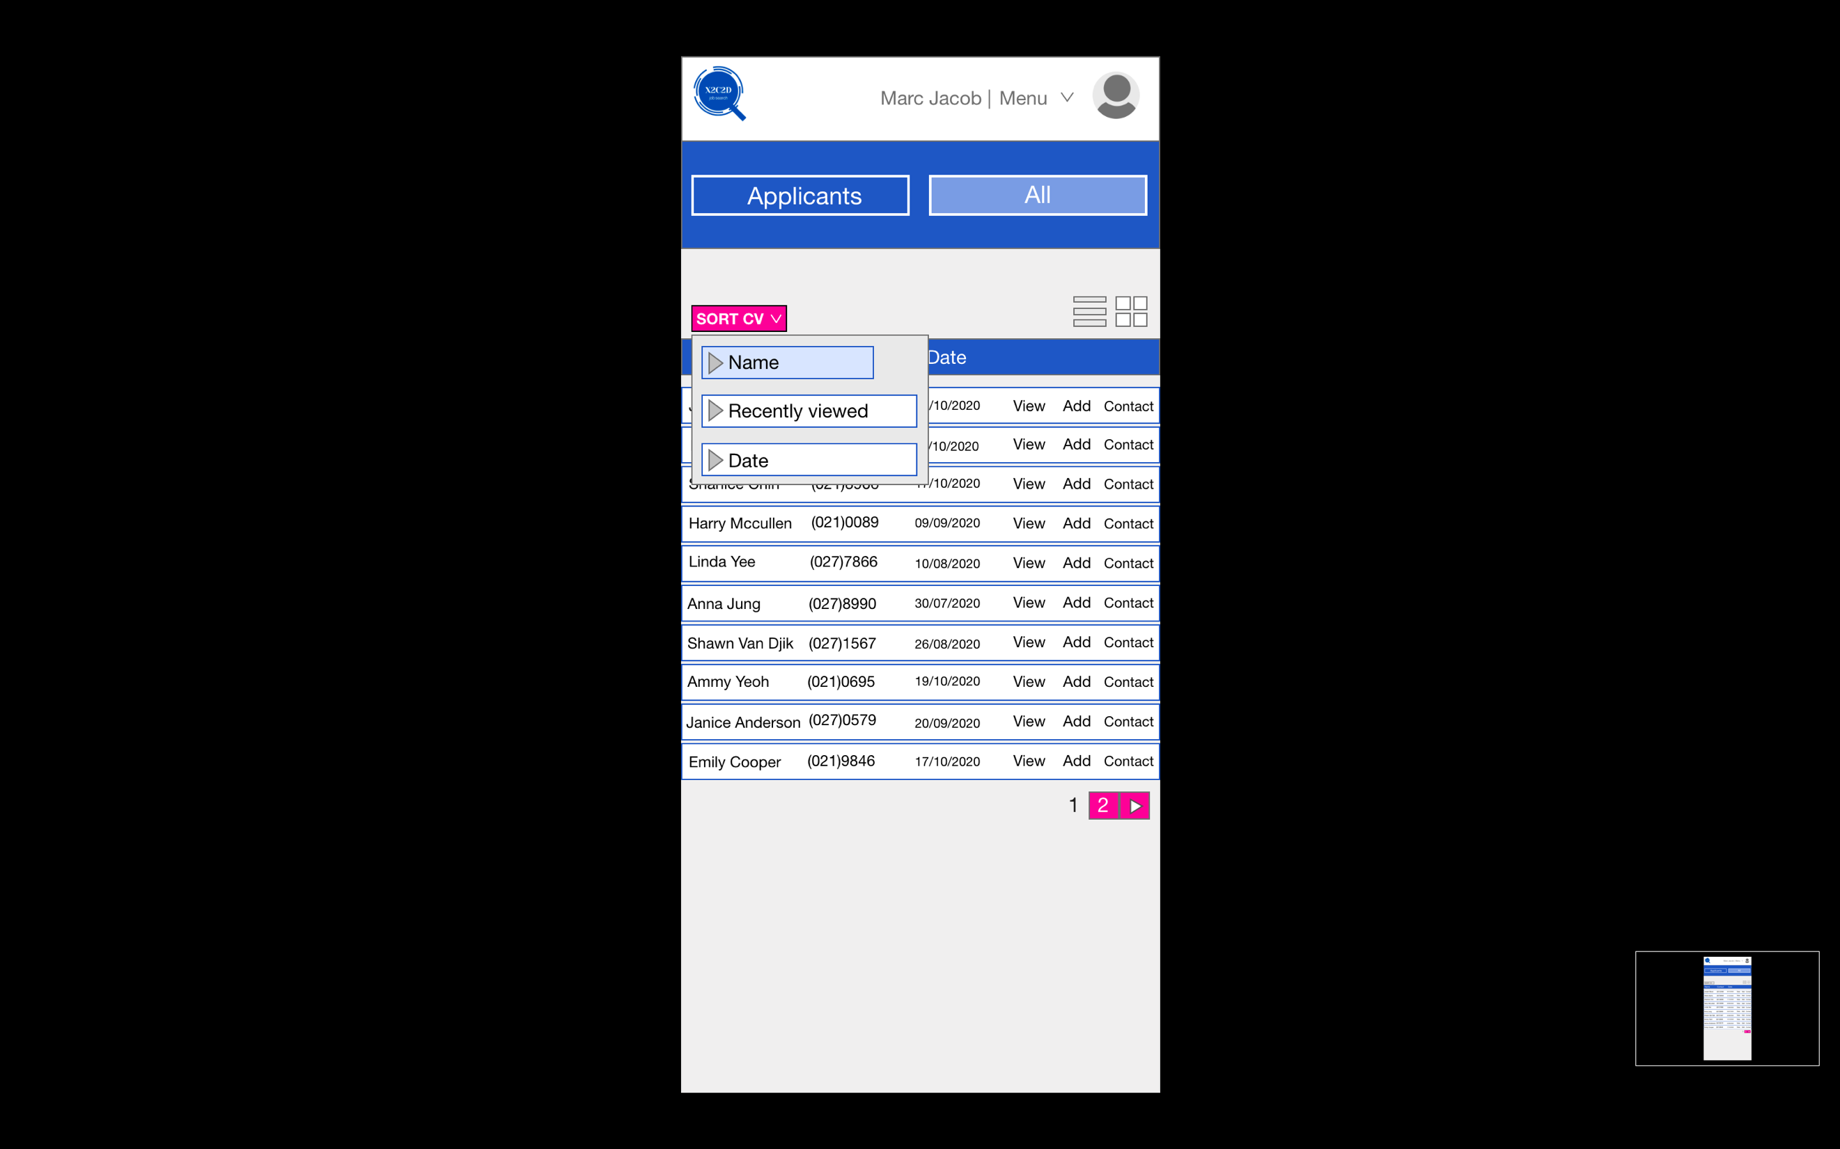 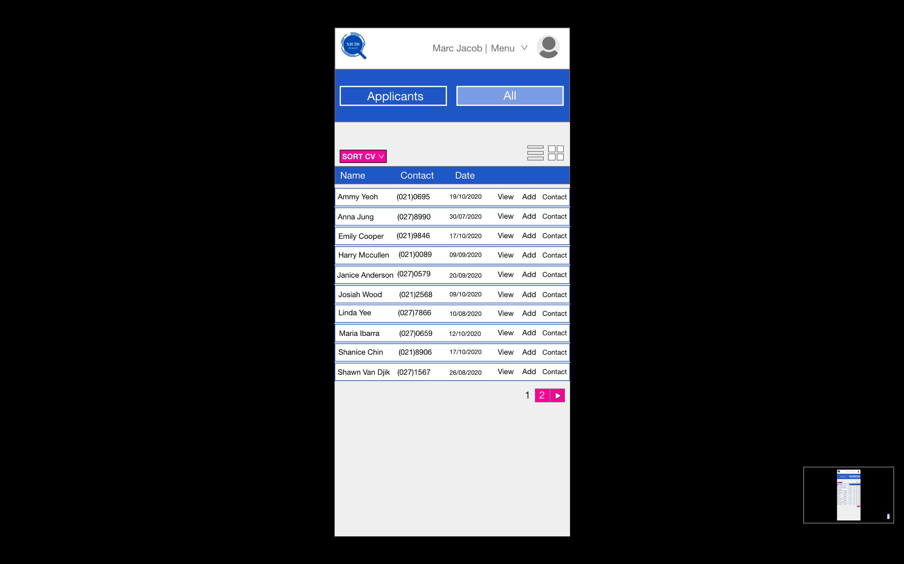

### F#2: Rank Applications

The Rank Applications function will enable the Employer to mark or stars the applications as a potential or declined applicant. The rank system will mark the best applicant with five star (potential/accepted) and the worst applicant with no star or one star (rejected).

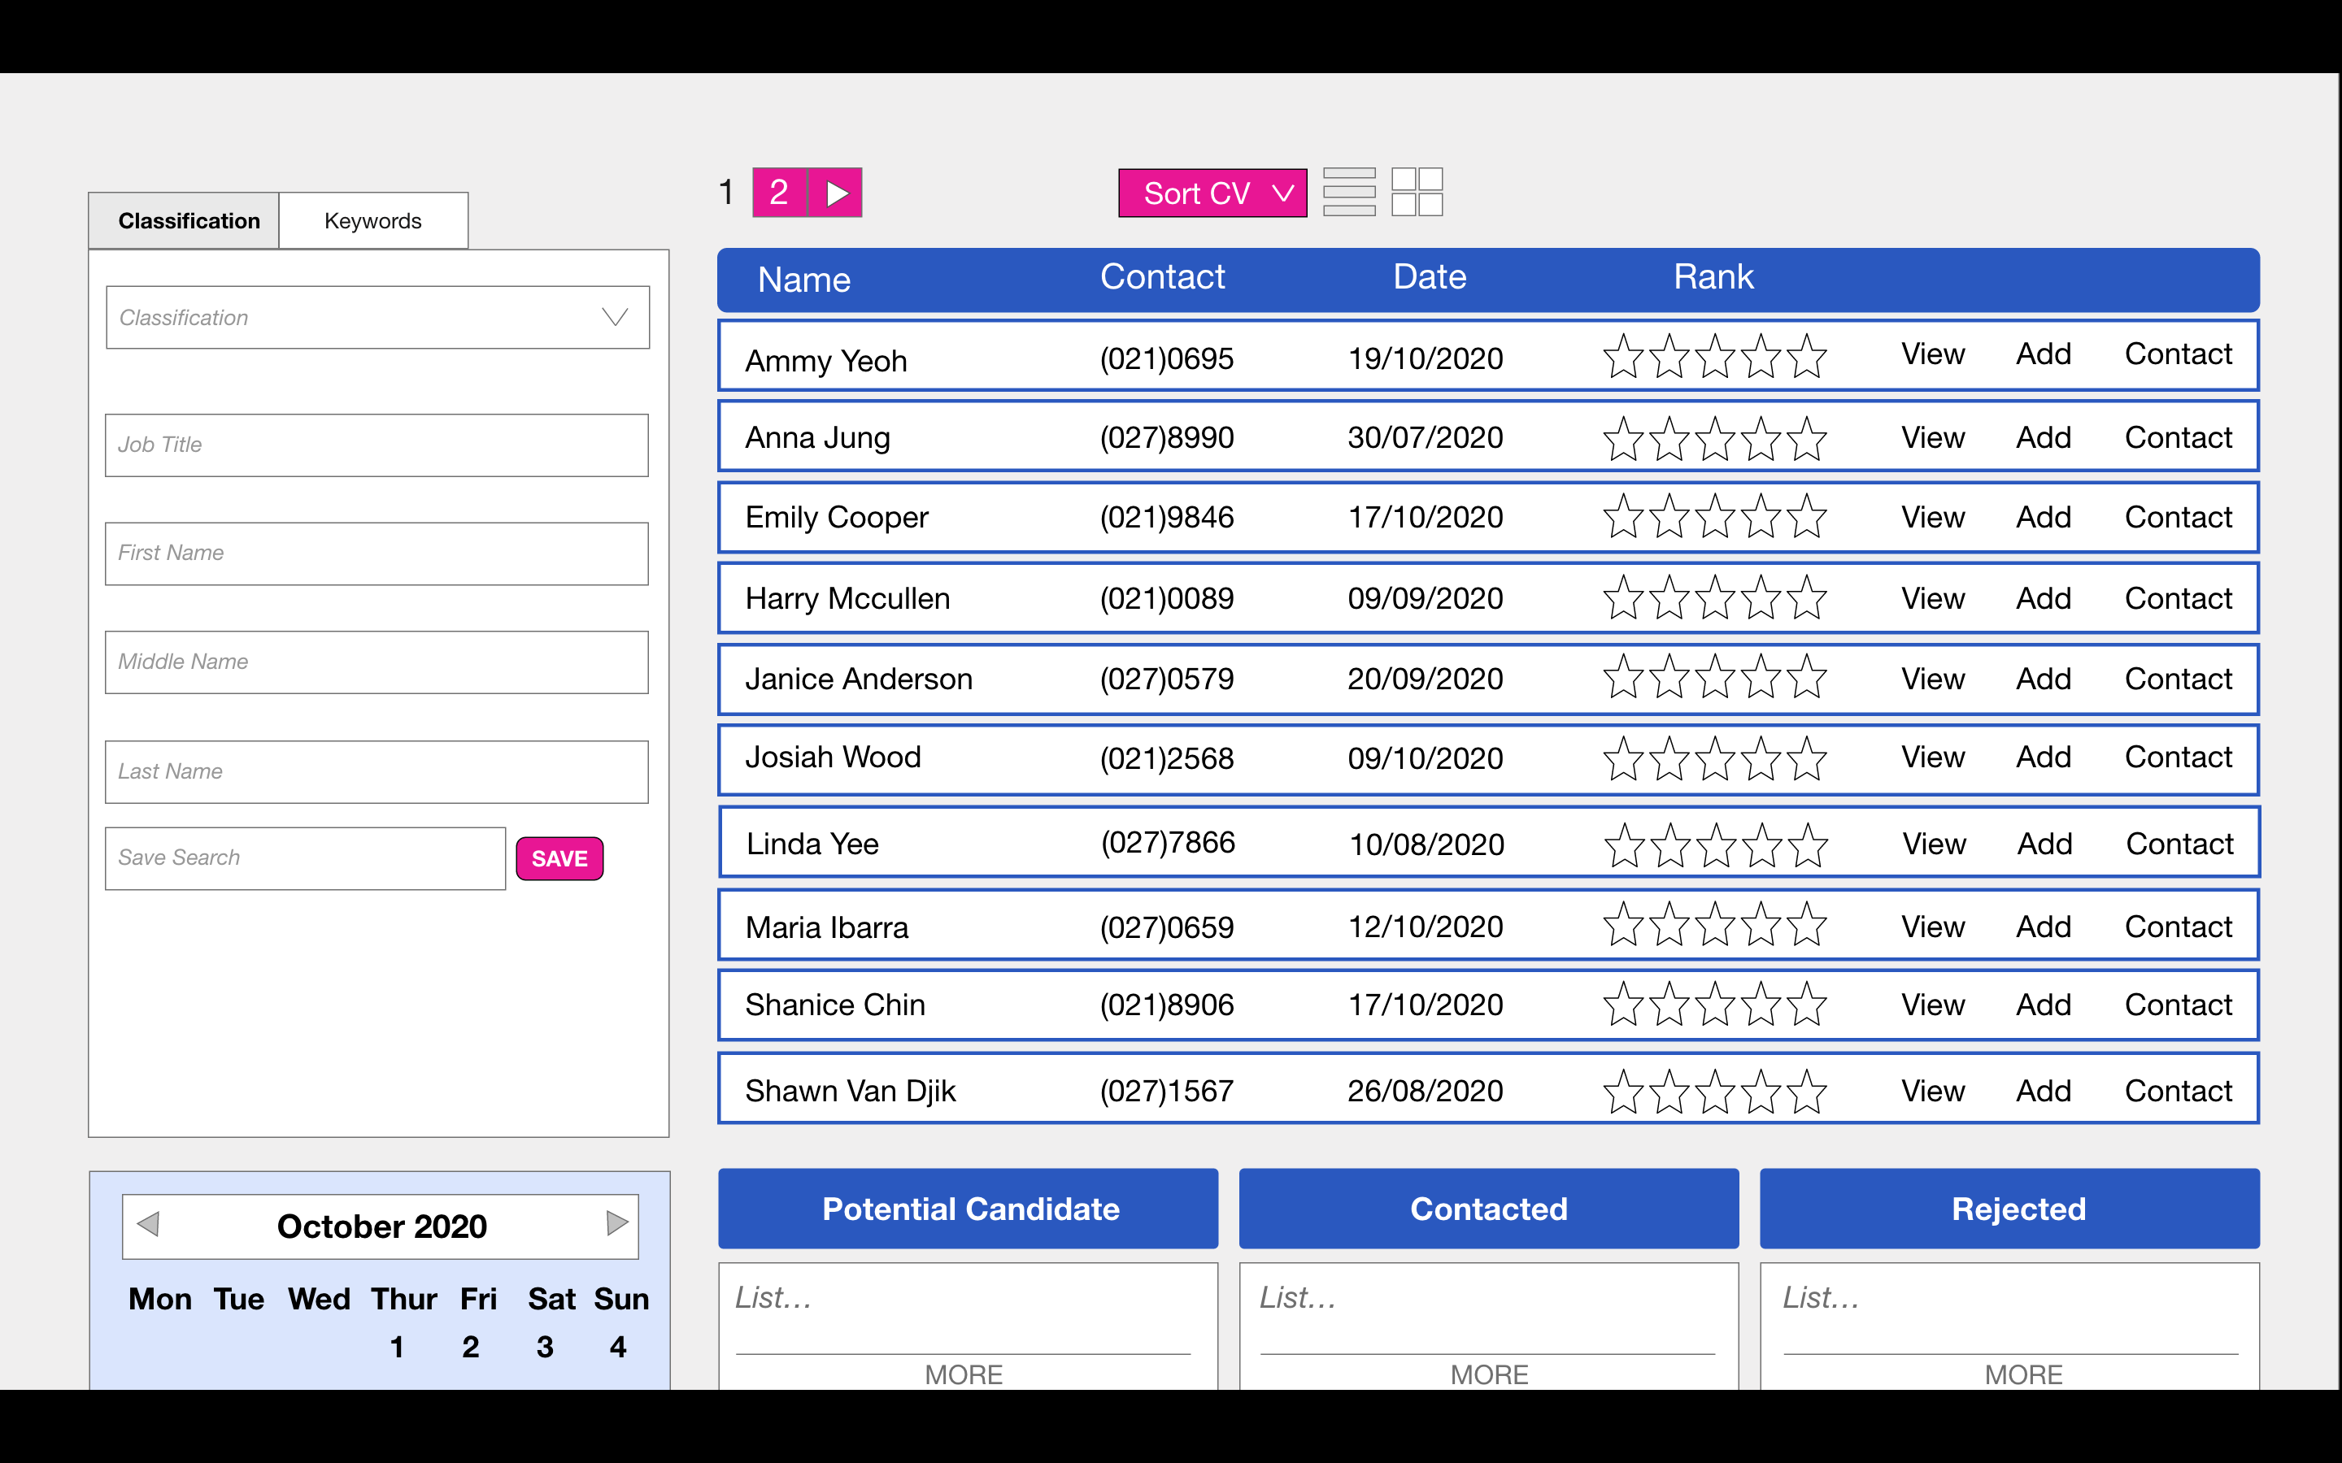

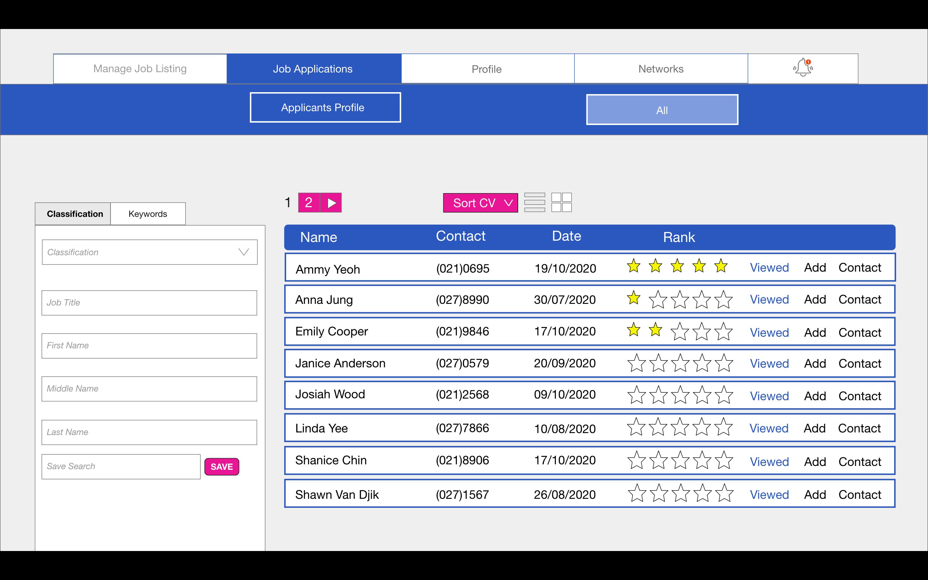

### F#3 View Profile

‘View Profile’ function will enable the employer to view the submitted applicant’s profile from their job application

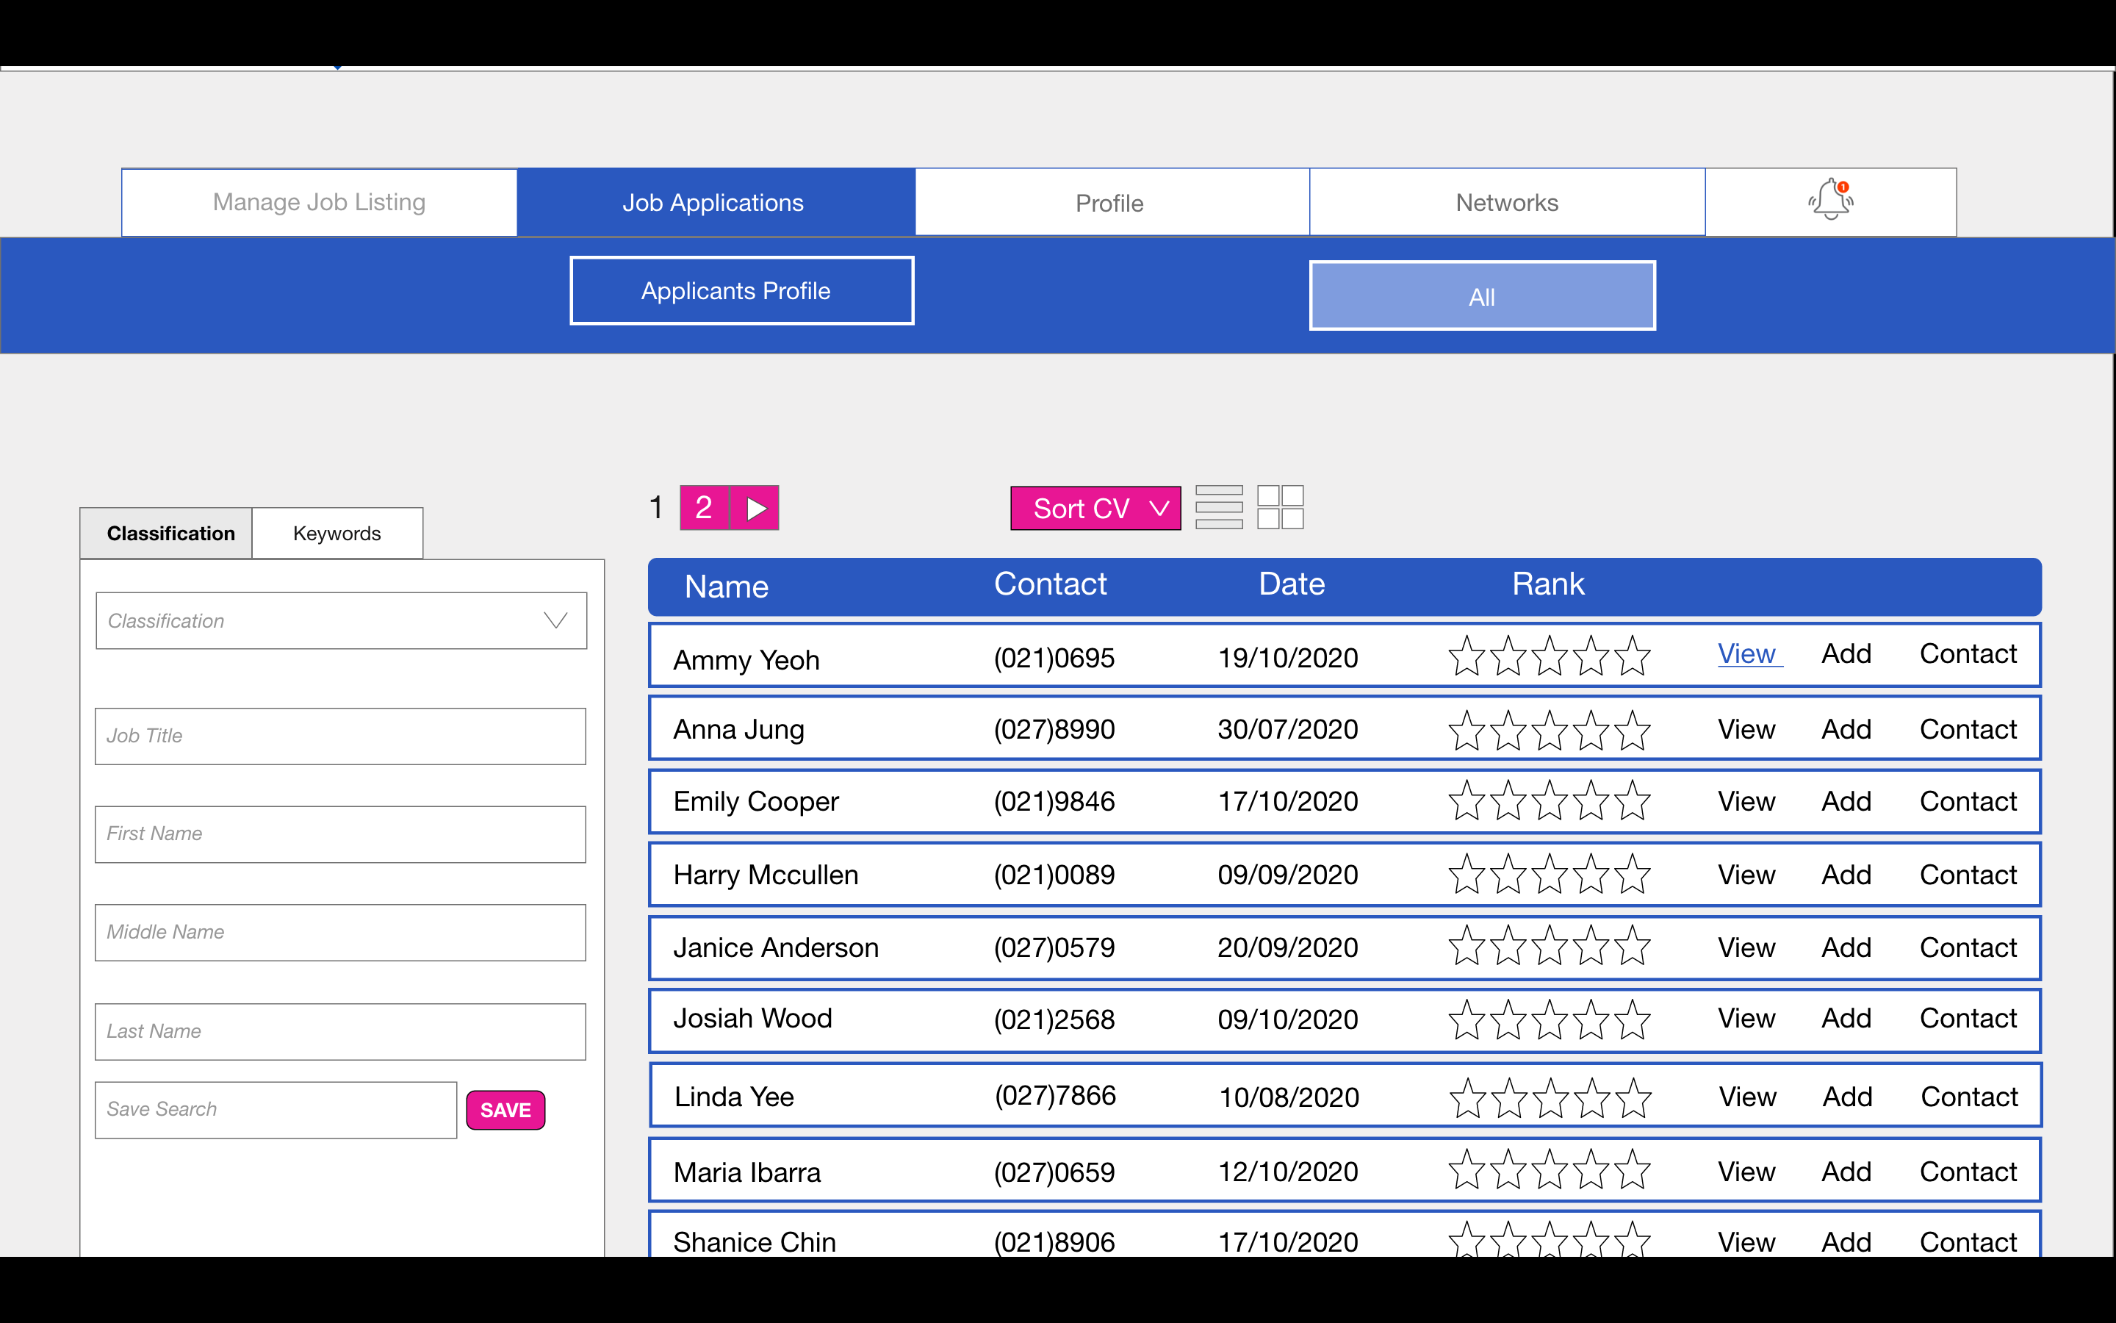

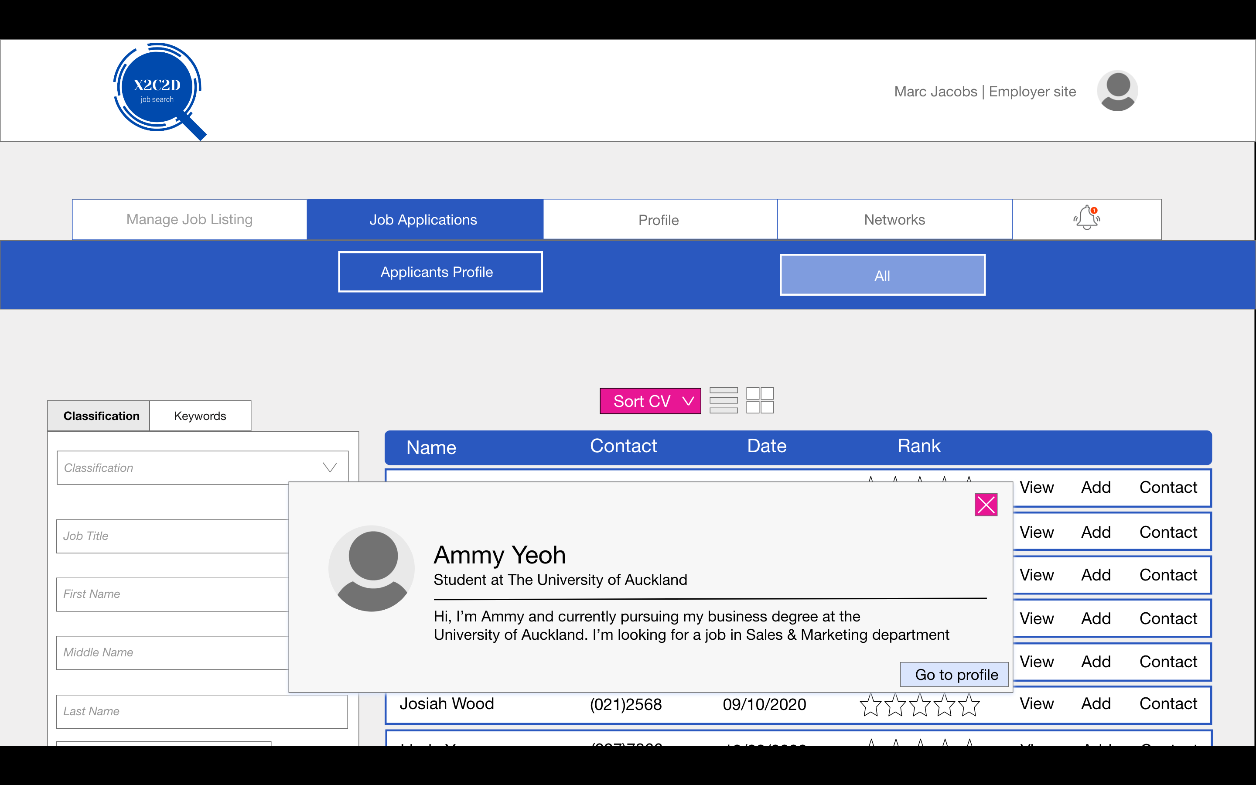

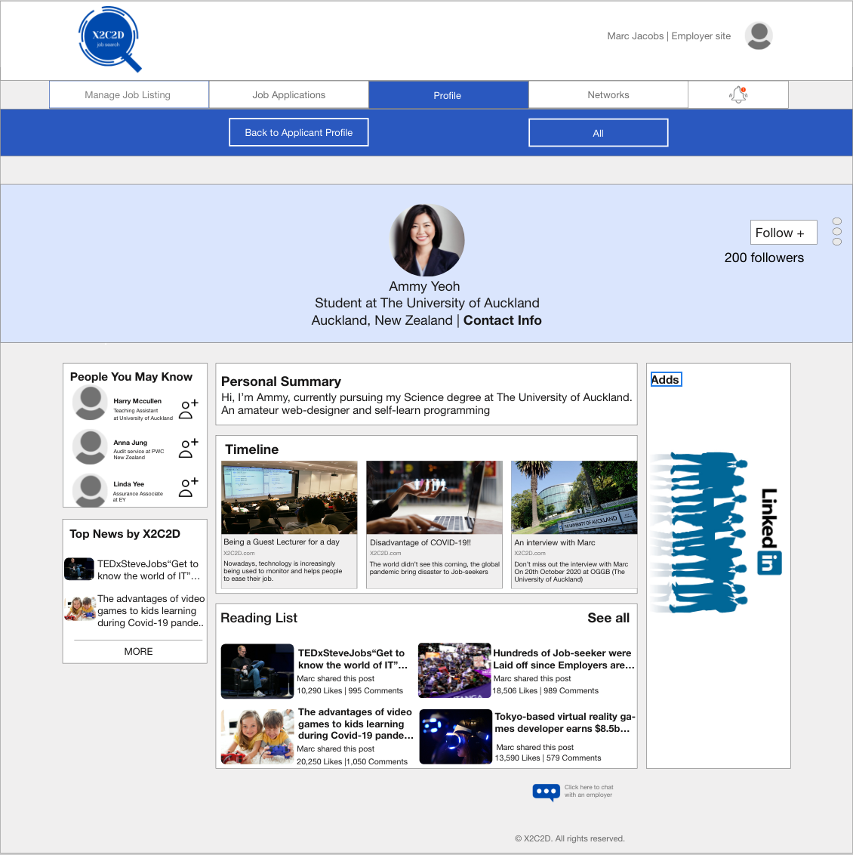

## UC#4 Data

|  |  |  |
| --- | --- | --- |
| Entity name: Employer | Entity name: Applicant | Entity Name:Classification |
| Attributes:   * employerID * employerName * employerEmail * employerProfile_Picture * viewApplicant * addApplicant * contactApplicant | Attributes:   * applicantUser_Name * applicantApplication_Number * applicantFull_Name * applicantProfile_Picture * applicantEmail * applicantContact_Detail * applicant_CV | Attributes:   * jobClassification * jobCategory |



applicantContact_Detail

contactApplicant

addApplicant

viewApplicant

employerProfile_Picture

employerName

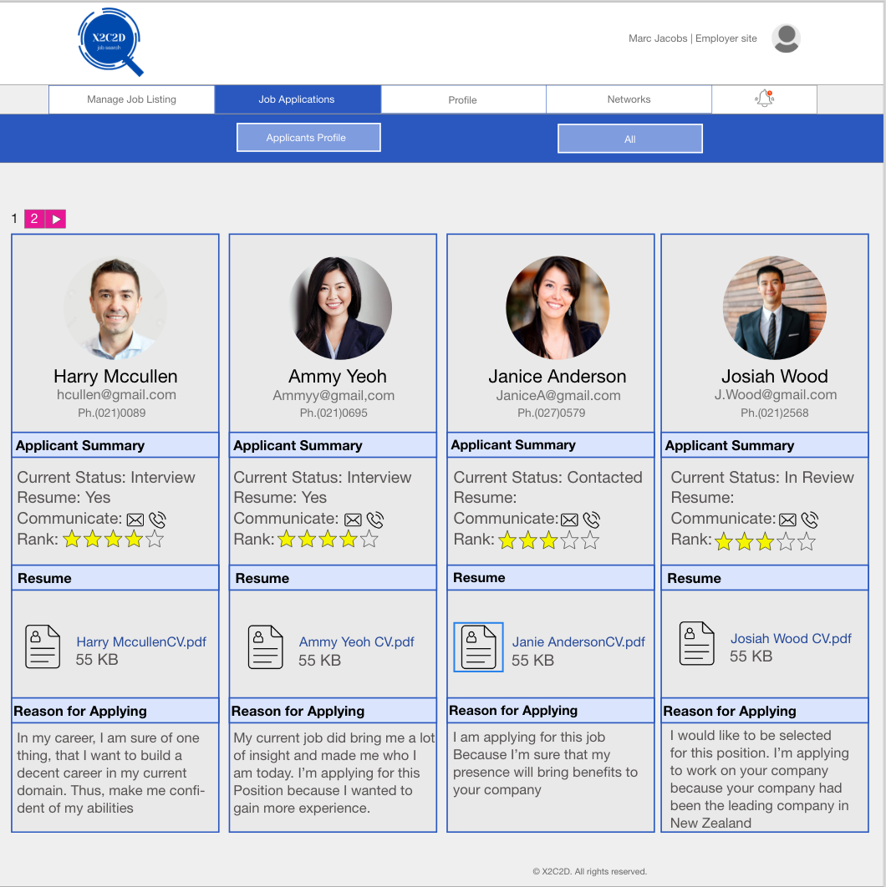

applicant_CV

applicantFull_Name

applicant_email

applicantProfile_Picture

## UC#4 Demonstration/simulation

Chosen function number: F#3

Chosen function name: View Profile



**Step 1.** To view the applicant profile, employer have to click on View



**Step 2.** Once ‘view’ is clicked, a box that briefly show the applicant profile will pop up

**Step 2.** Once it’s load, a “View Profile” button will appear and Employer should click on the button to view the applicant profile

**Step 3.** Employer have to click on ‘Go to profile’ button to view the full profile of the applicant



**Step 4.** Now the employer can see the applicant profile

**Step 5.** Once employer finished viewing the applicant profile and wish to go back to the applicant profile page, the employer should click on ‘Back to Profile’ navigation bar

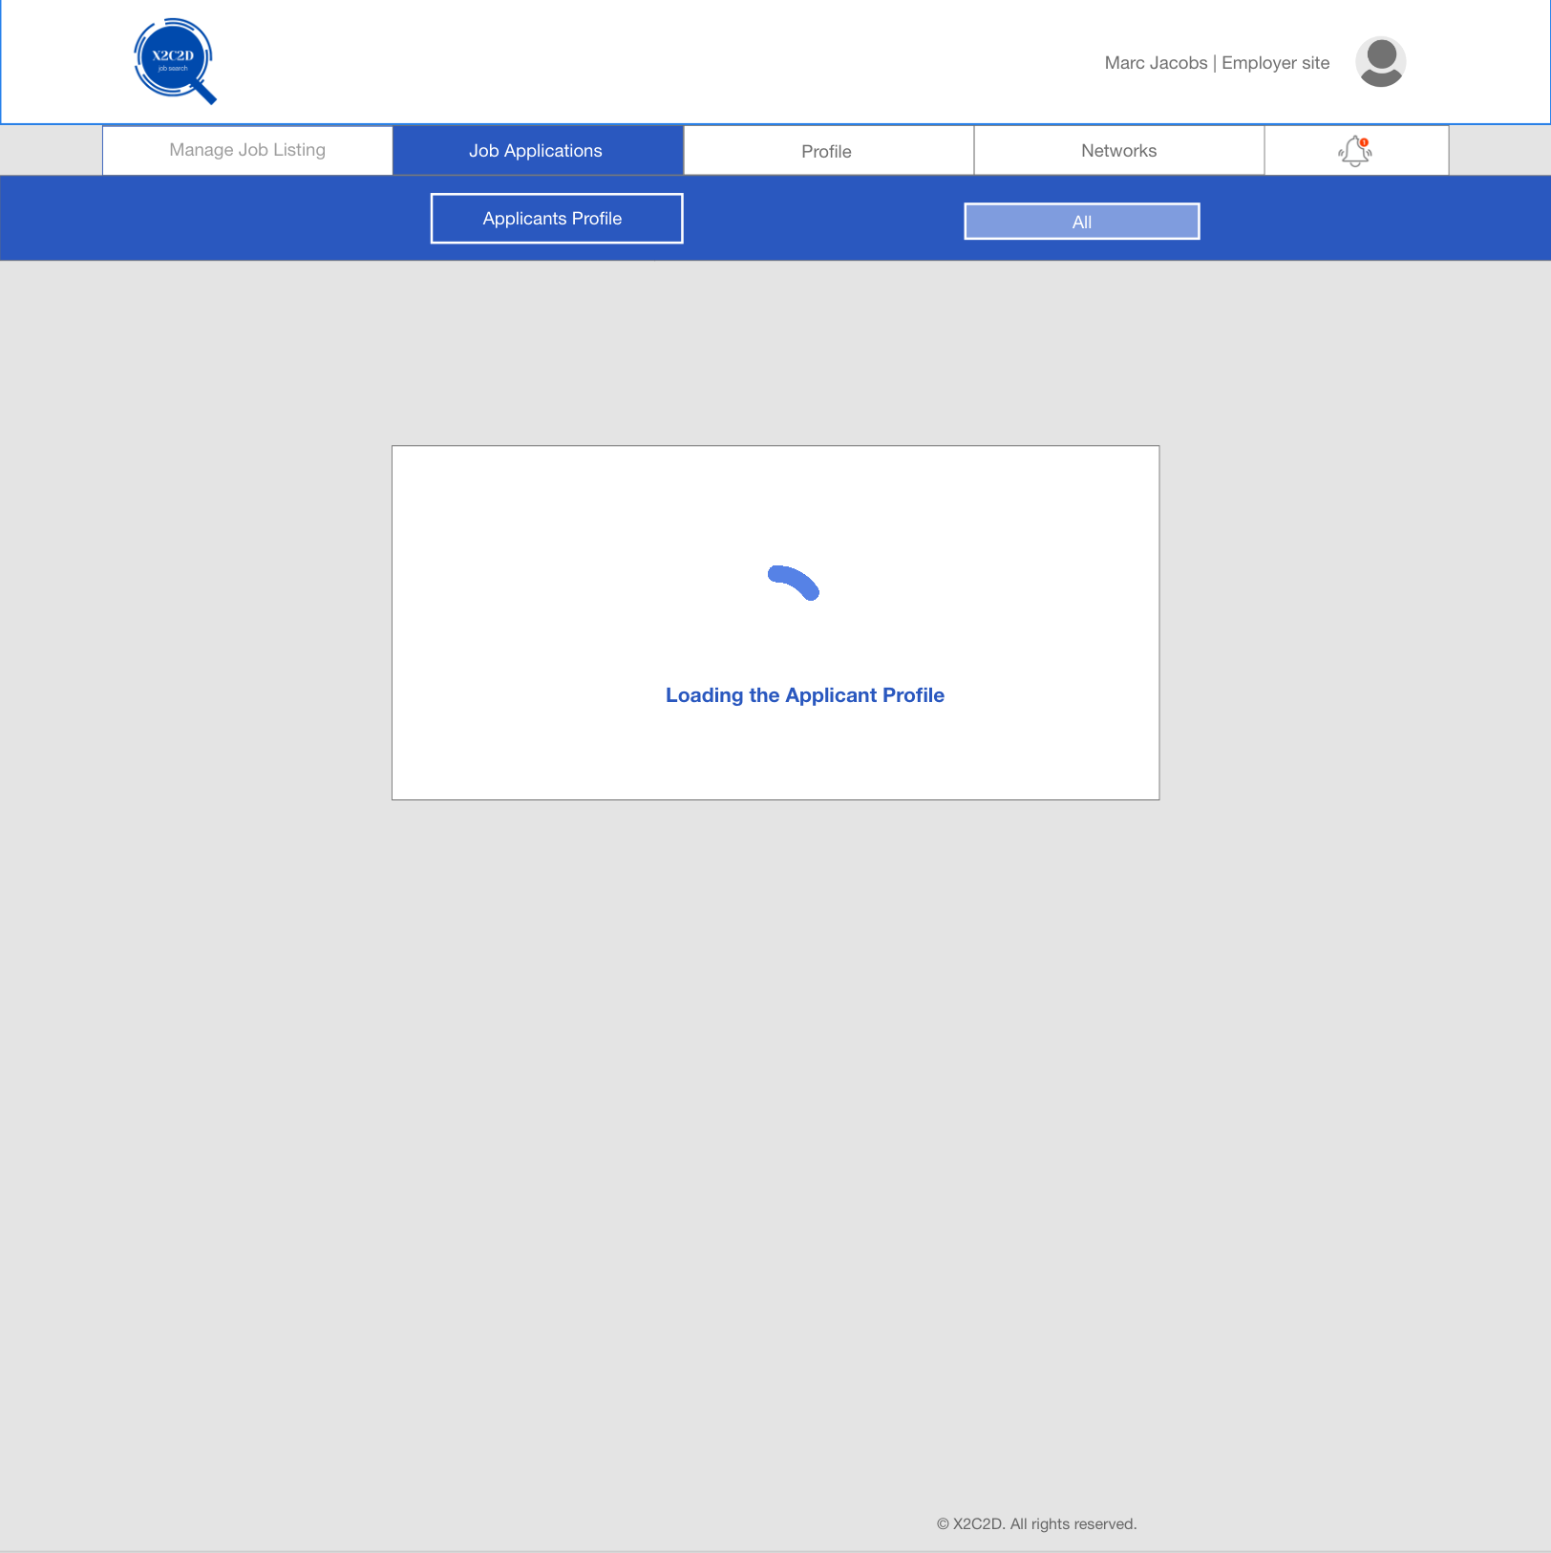

**Step 6.** A loading page will appear once ‘Go back to profile” navigation bar is clicked

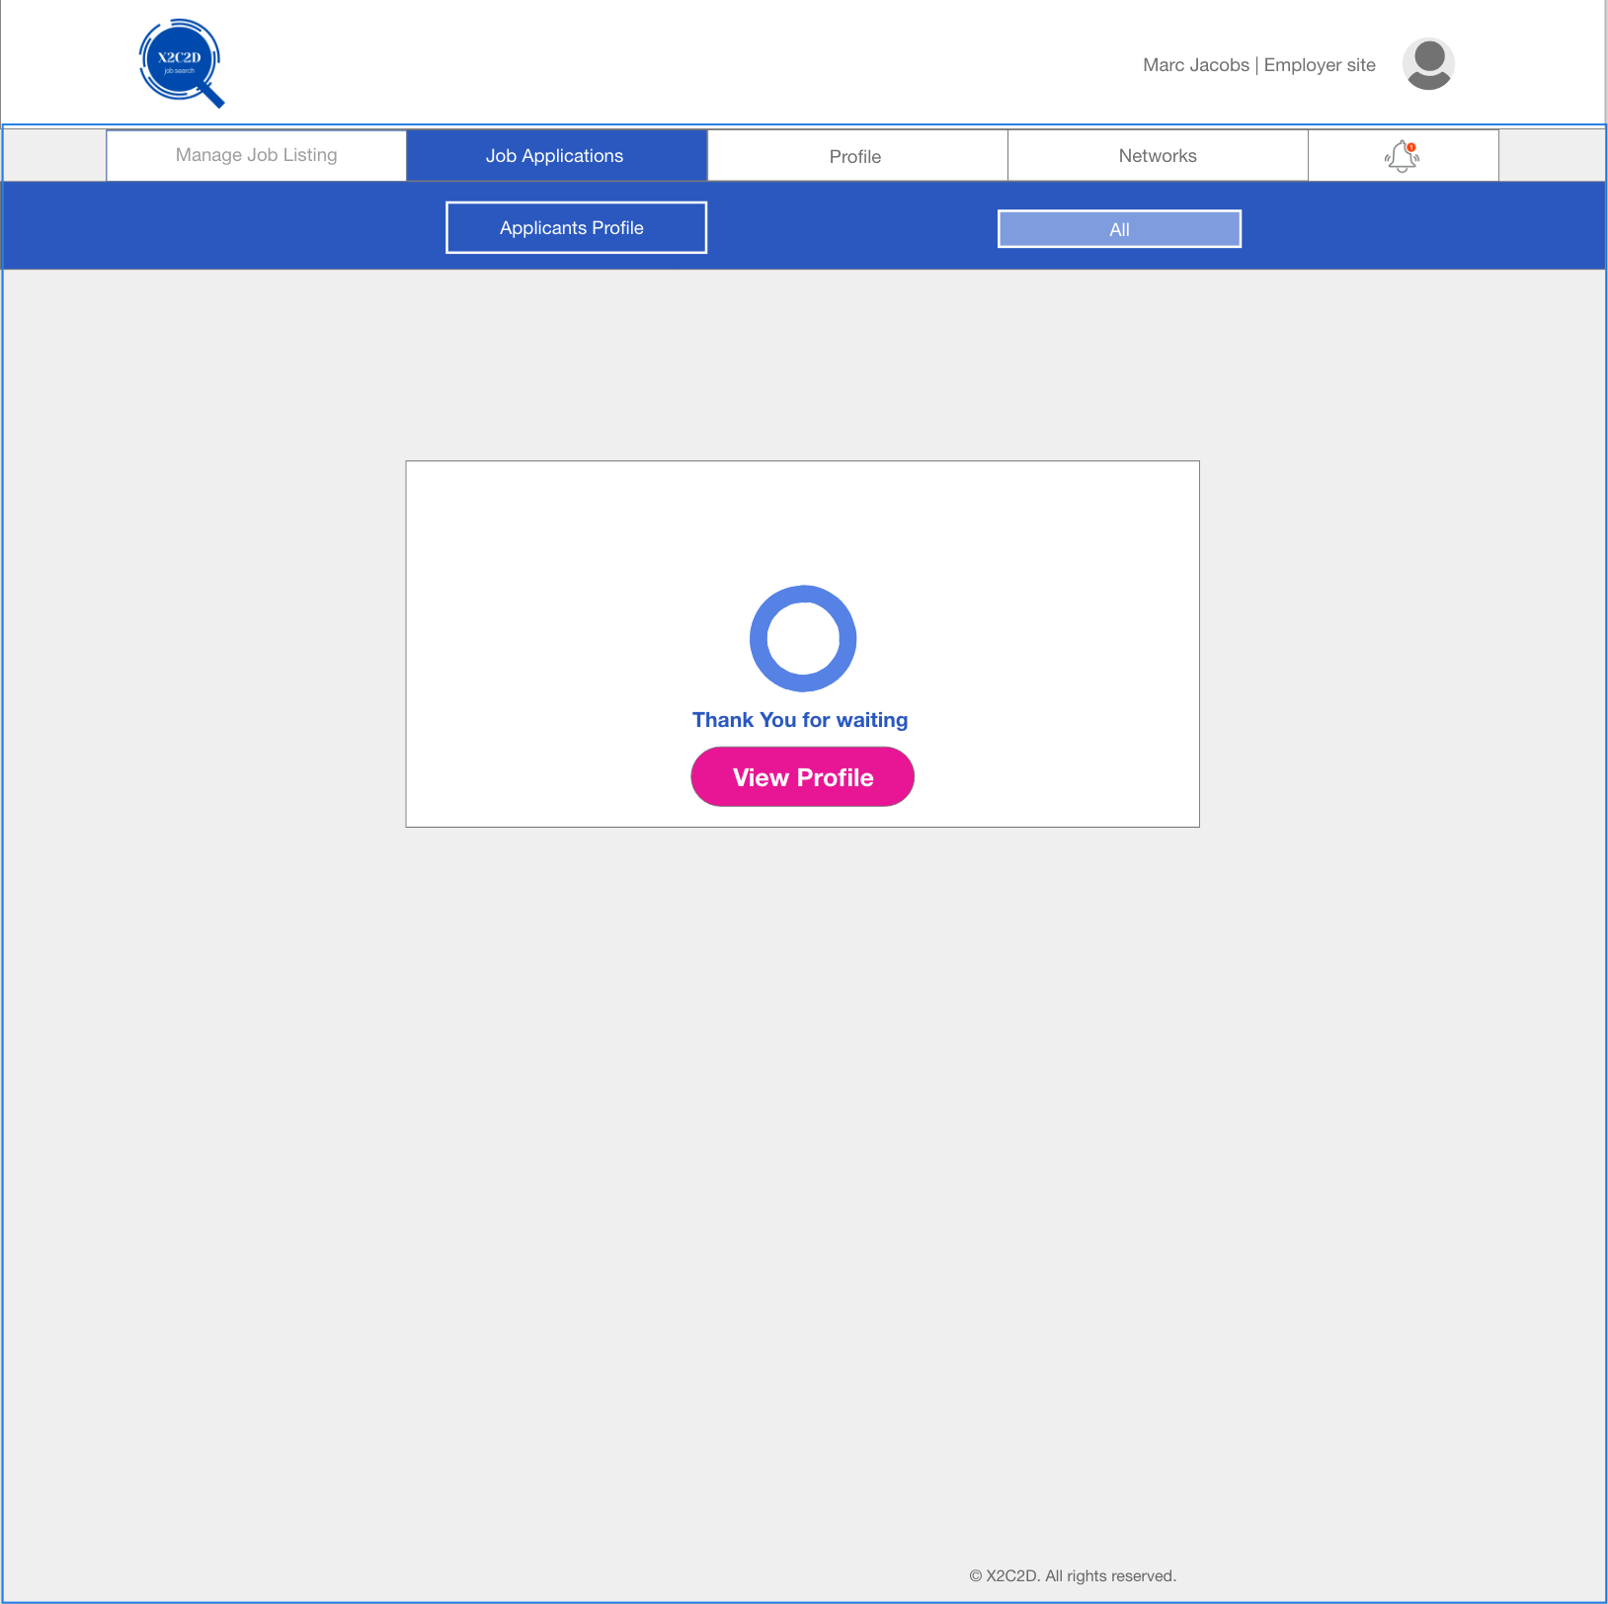

**Step 7.** Once the page is all load, Employer have to click on the ‘View Profile’ button to view the rest of the applicant profile

**Step 8.** The employer are now back to the Applicants Profile page

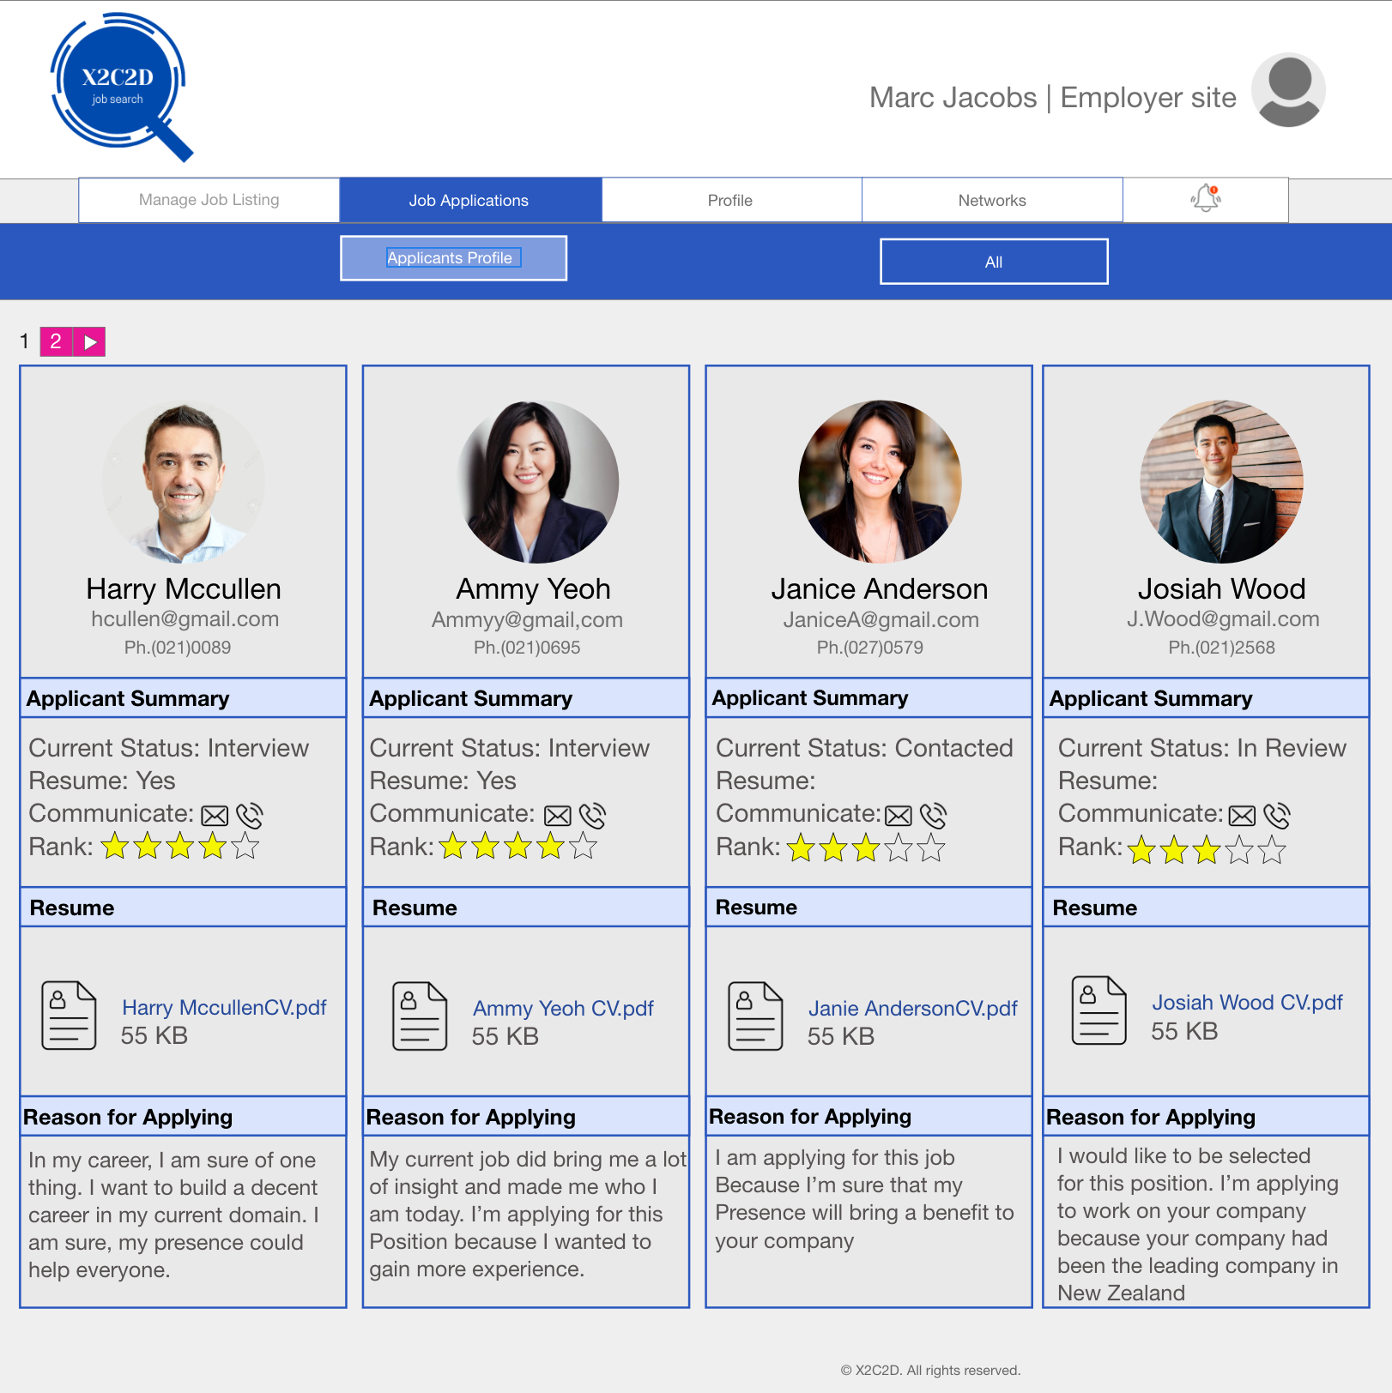

## F#1Test plan

|  |  |
| --- | --- |
| Goal/Description of test plan | Allow employer to Sort applicant CV by the option they desired to choose |
| Testing method | 1. Click on Job Application navigation bar 2. Employer Sort the applicant CV by hovering and click to ‘Sort CV’ button 3. The ‘Sort CV’ button clicked, a dropdown tray will show several option    1. An option to sort CV by Name    2. An option to sort CV by Recently Viewed    3. An option to sort CV by Rank    4. An option to sort CV by Date    5. When the employer is hovering over the option, each box will turn to blue colour 4. Then if employer clicked on Name option 5. The Applicant CV’s will be sort out by Name in an alphabetical order |
| Expected successful result | Enable the employer to organise the applicant CV’s based on the option they have selected. The option given by the Sort CV button will sort the applicant CV’s by ‘Name’, ‘Recently Viewed’, ‘Rank’, and ‘Date’. |
| Other notes (optional) | For testing method on step 4, the rest of the option will have the same function as Sort CV by ‘Name’. For instance, if the employer choose to sort CV by ‘Recently Viewed’ the system will sort the CV’s based on the one that had been viewed. |

# UC#5

UC#5 name: Manage Job Listing

## UC#5 Functionality

### F#1 Post Job

The Post Job function will enable the employer to post a job listing

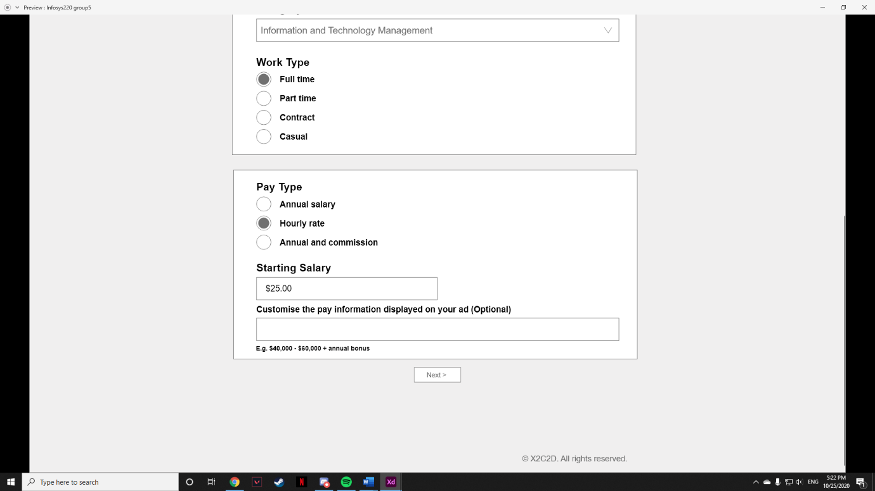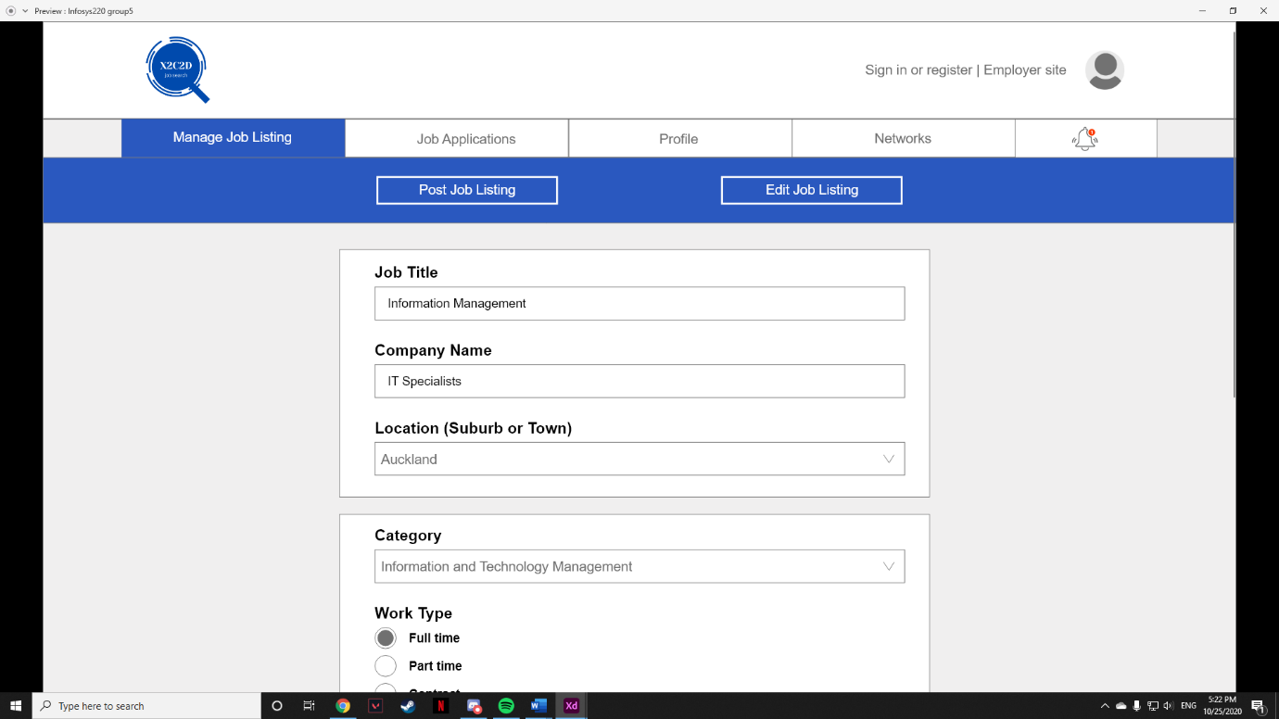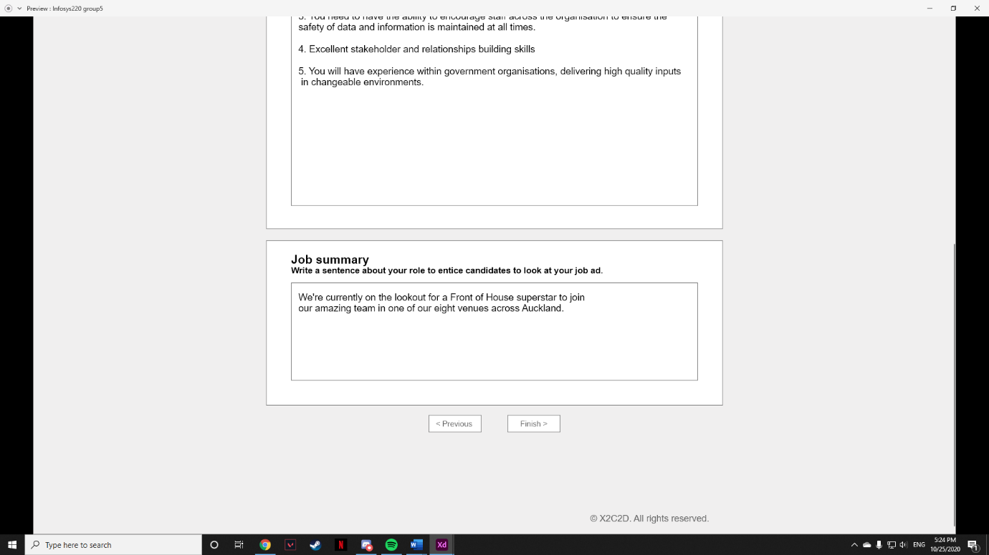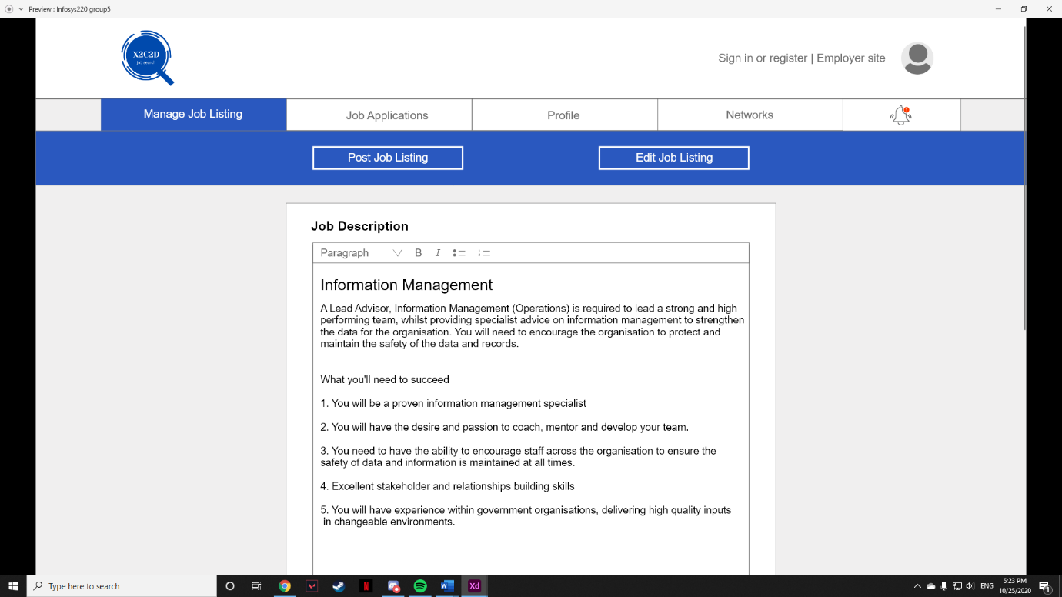

### F#2 Edit job listing

Same to its name, the function of Edit job listing is to enable employer on editing the job listing

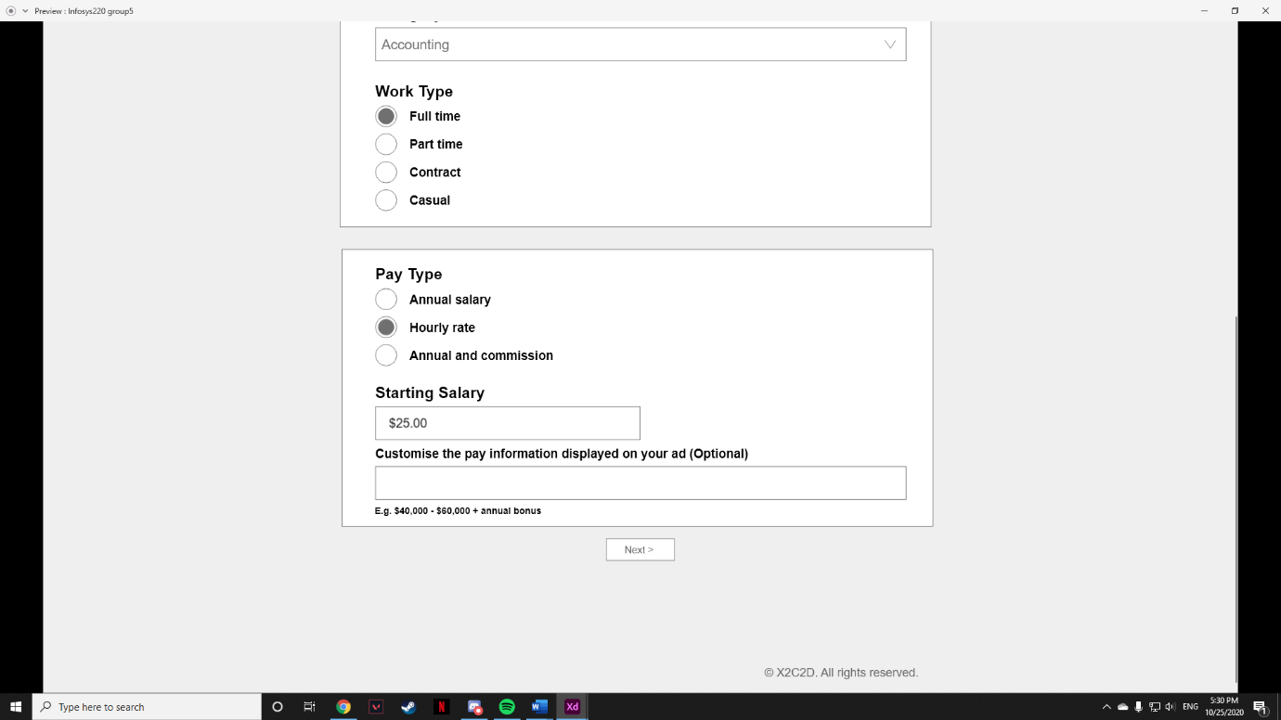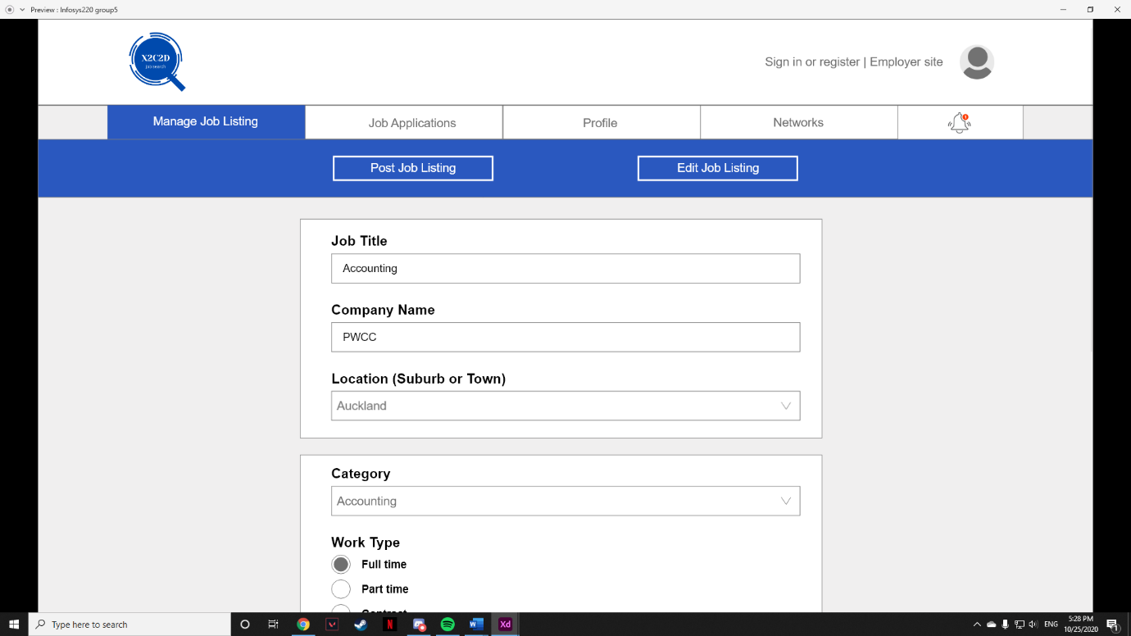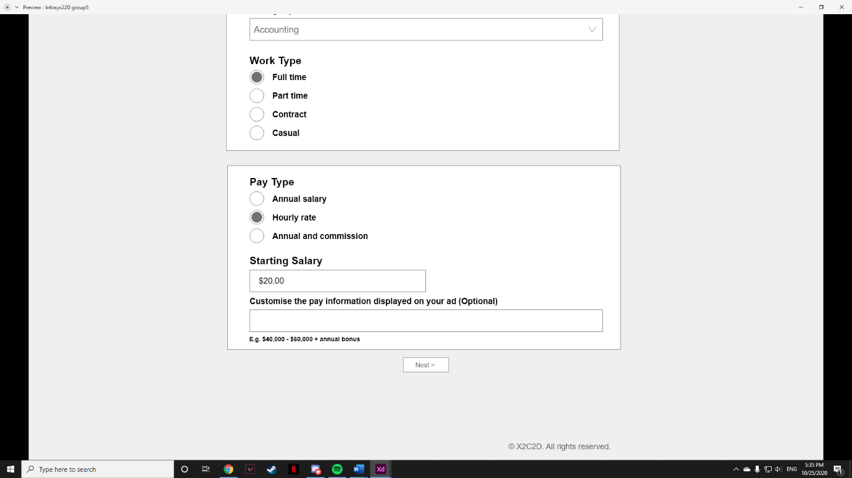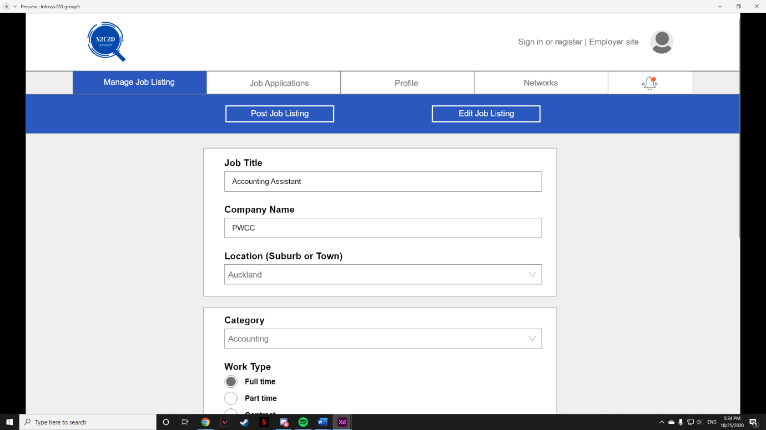

### F#3 Delete job listing

Delete job listing function will enable employer to delete the job listing they want to delete

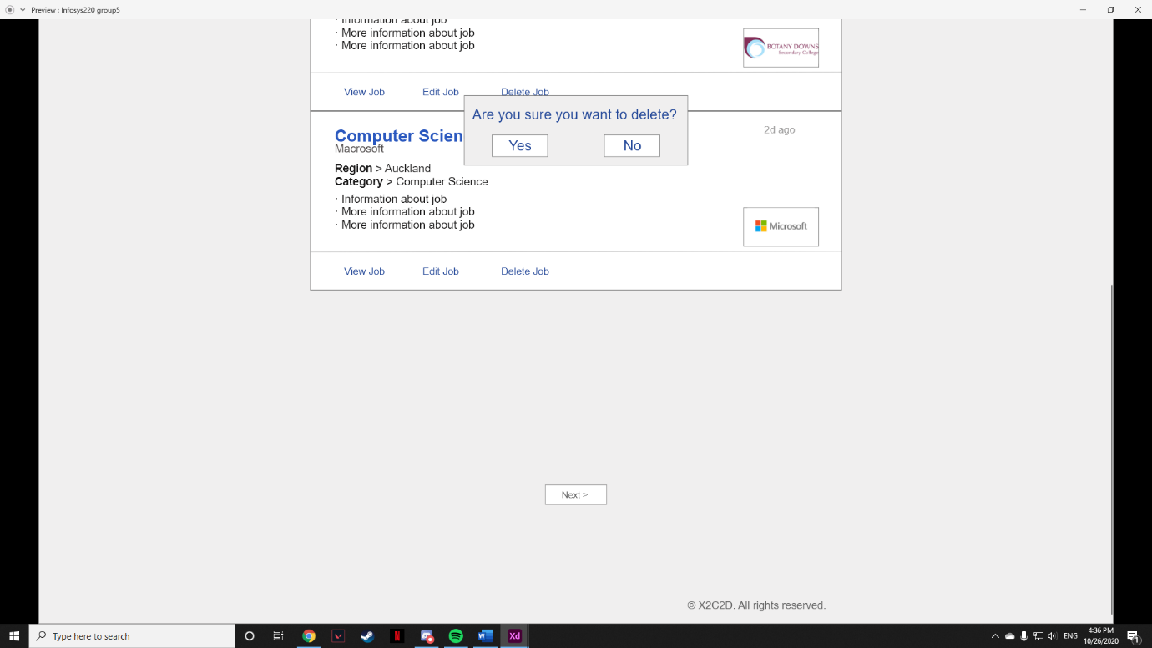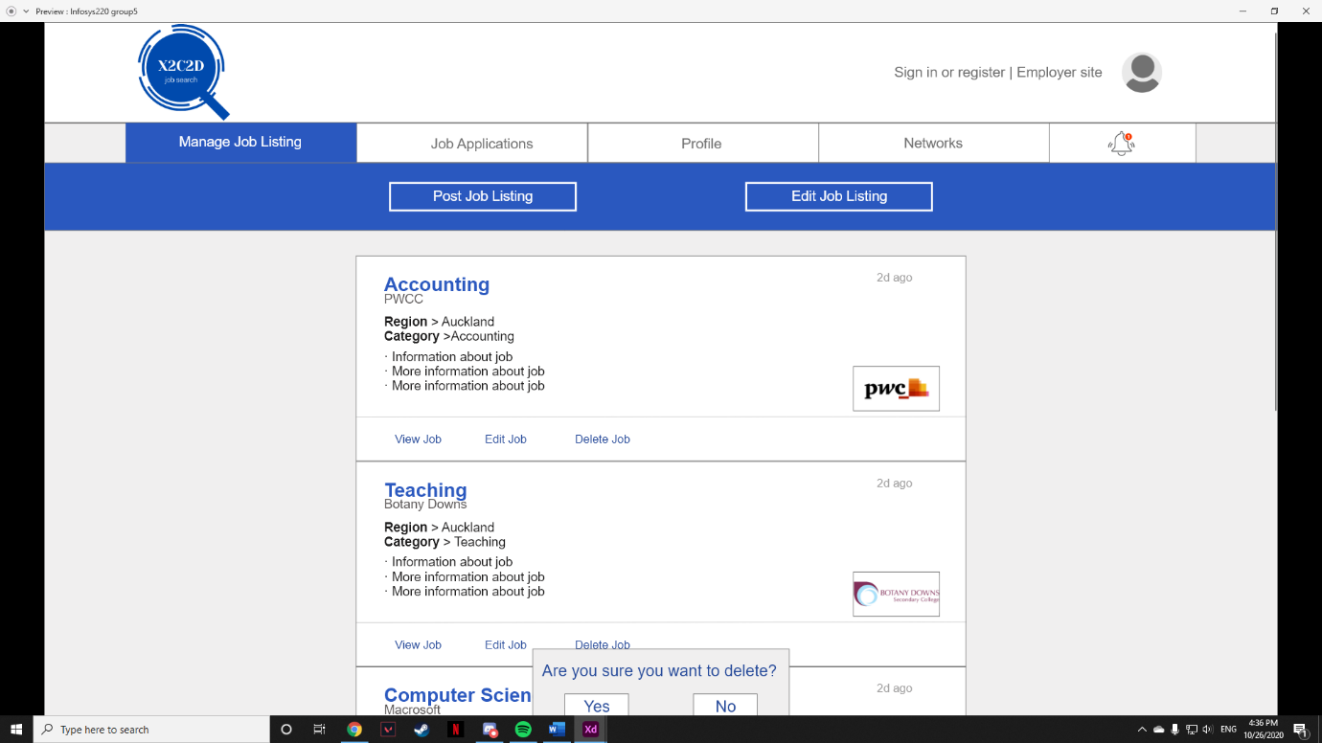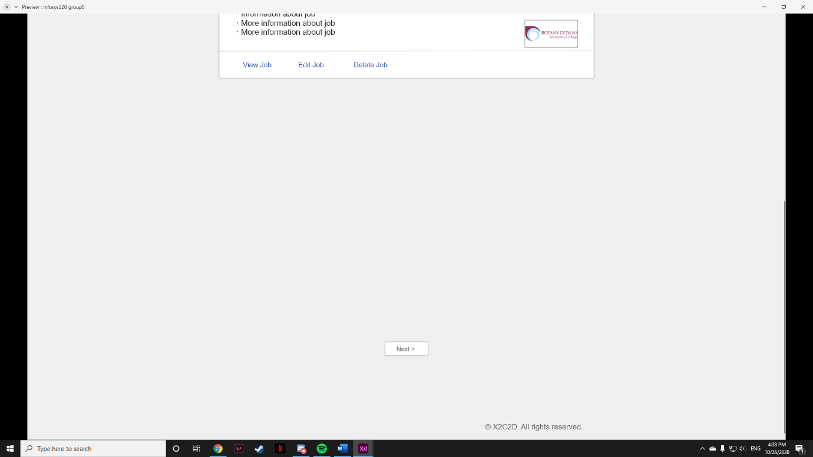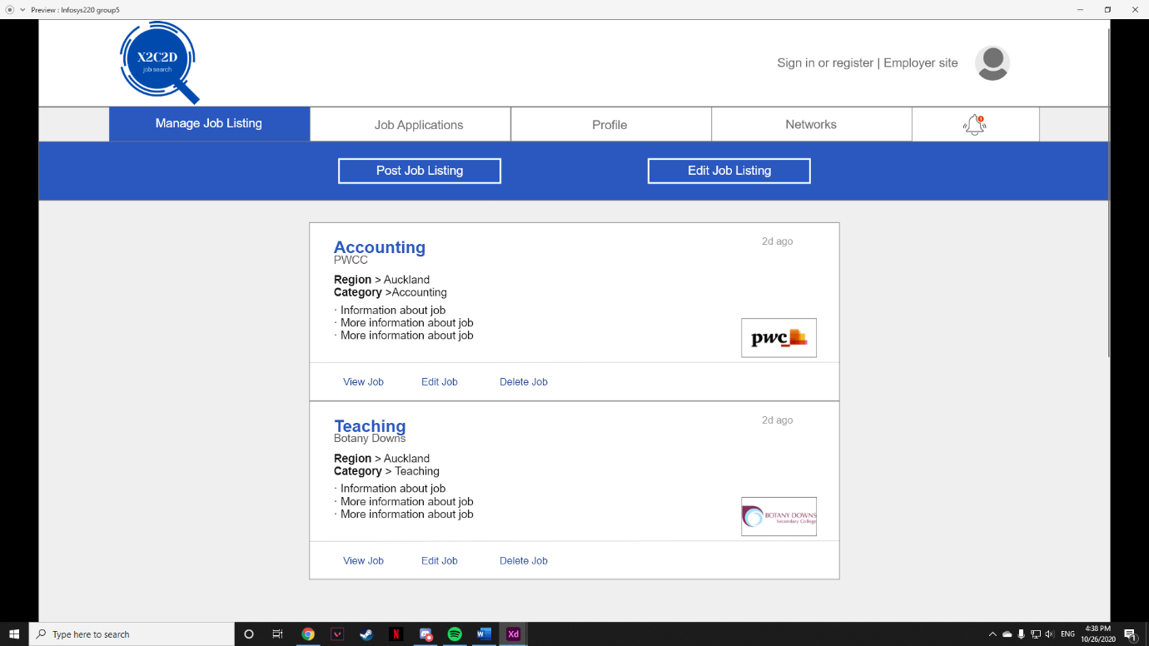

### F#4 View job listing (mobile)

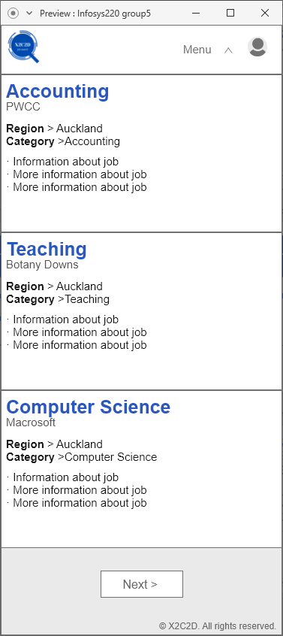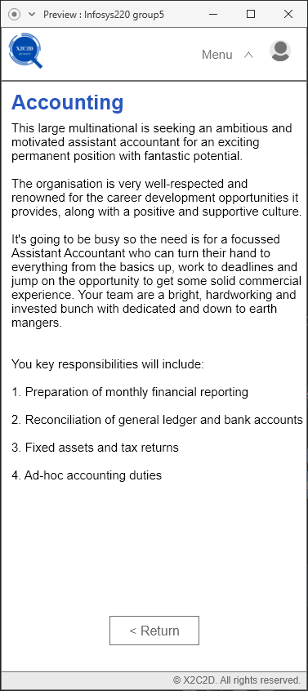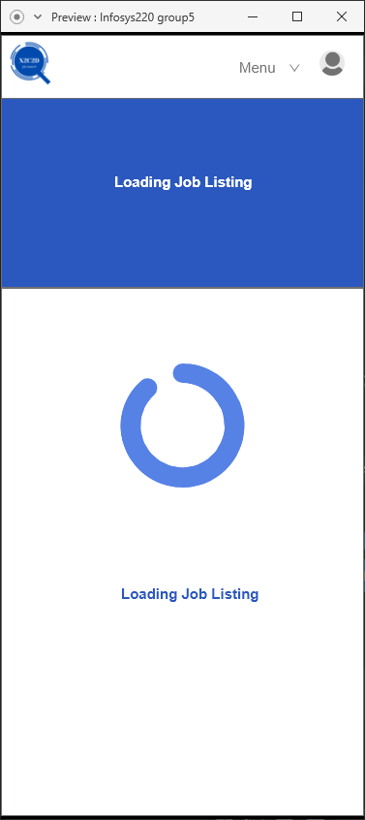View job listing function will enable employer to view their posted job listings on both the website and mobile.

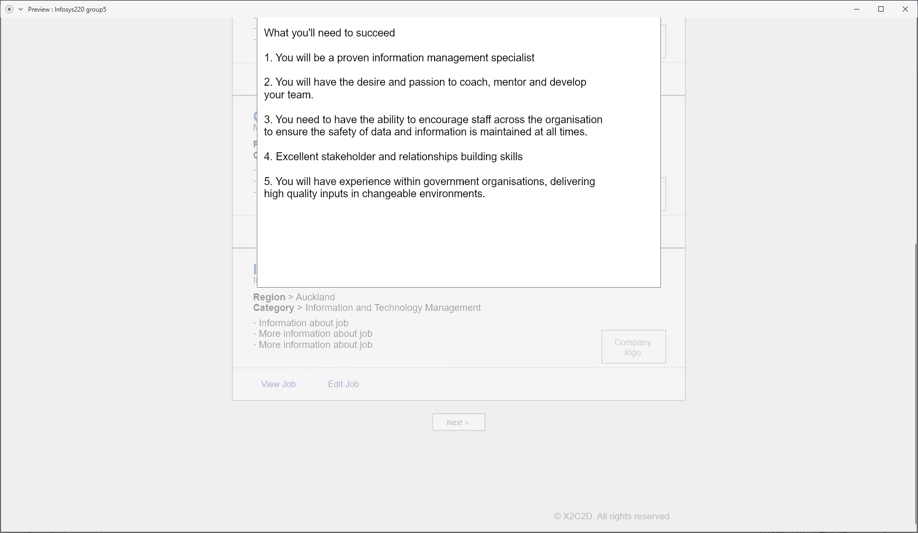

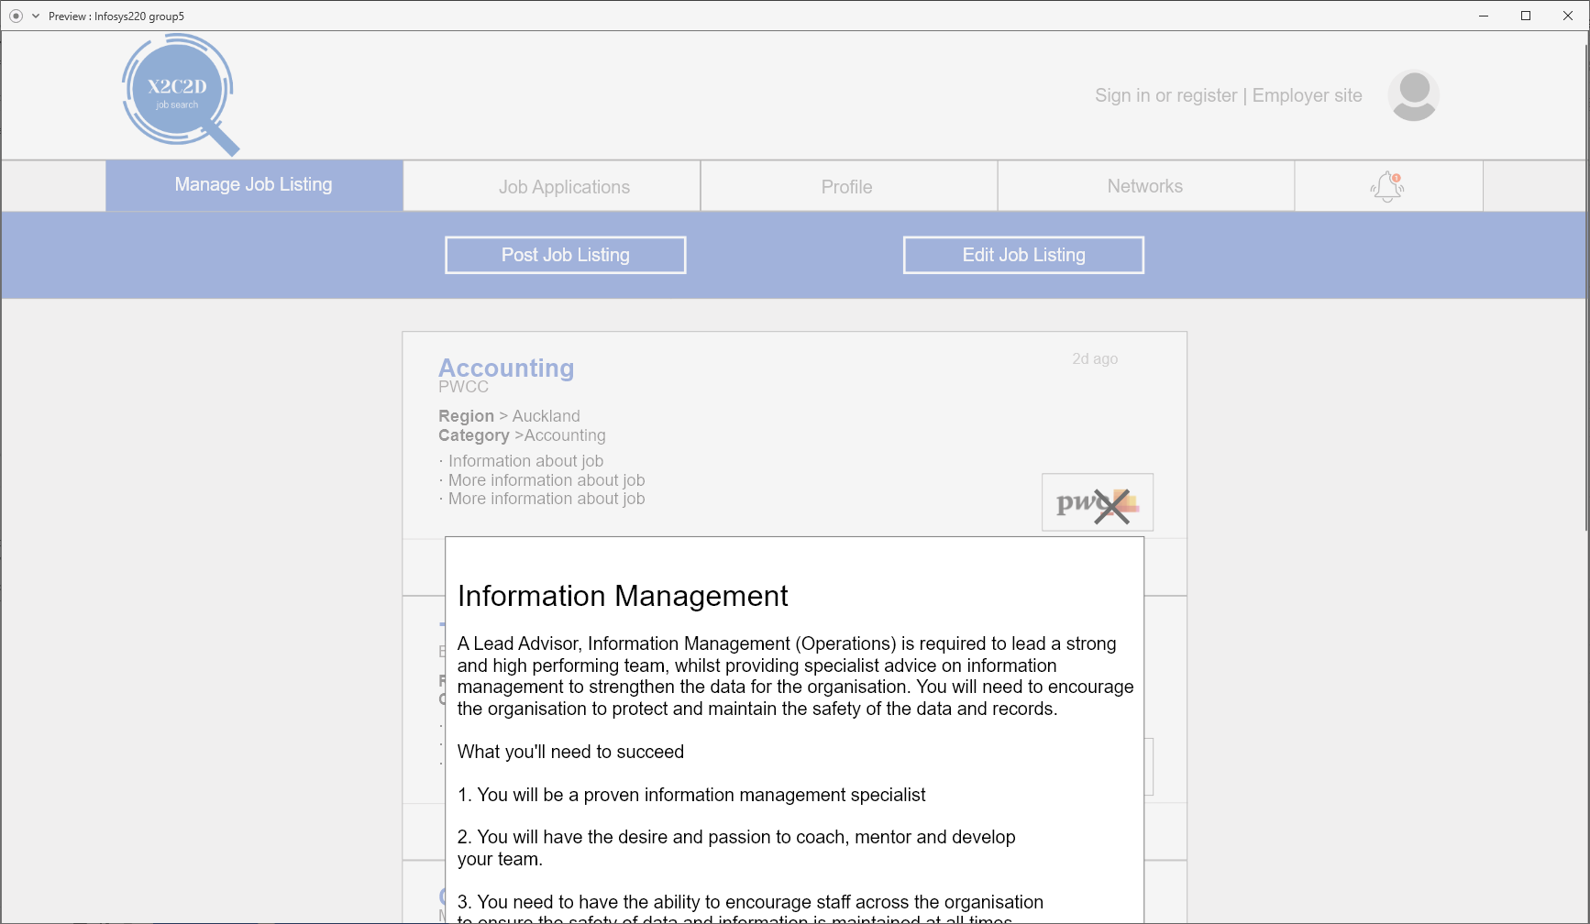

## UC#5 Data

|  |  |  |
| --- | --- | --- |
| Entity name: Job | Entity name: JobDetail | Entity name: Location |
| Attributes:   * jobID (PK) * jobDetailID * jobName * companyName * location * jobCategory * dateListed * photo | Attributes:   * jobDetailID(PK) * jobName * companyName * location * category * workType * payType * startingSalary * optionalInfomation * jobDescription * jobSummary | Attributes:   * locationID (PK) * location |

jobID

location

jobName

jobDetailID

companyName



## UC#5 Demonstration/simulation

Chosen function number: F#1

Chosen function name: Post Job

**Step 1.** Click on the “Post Job Listing” button to post a new job listing

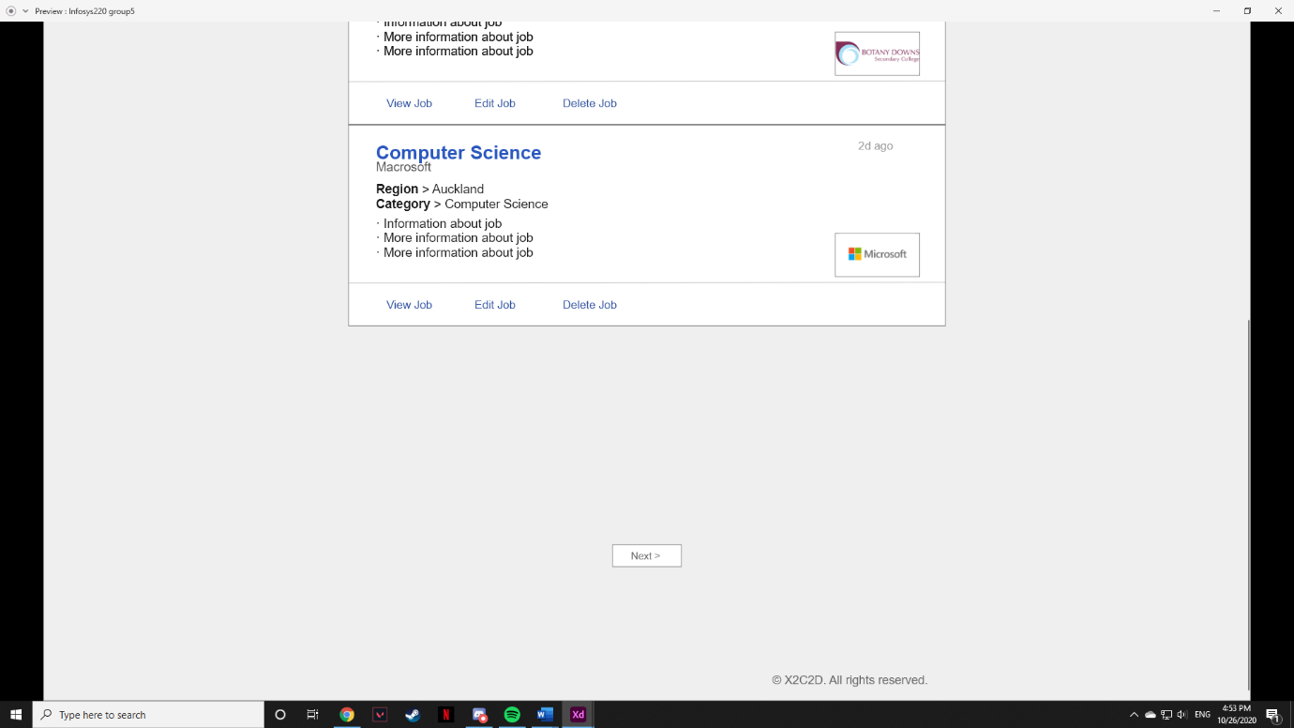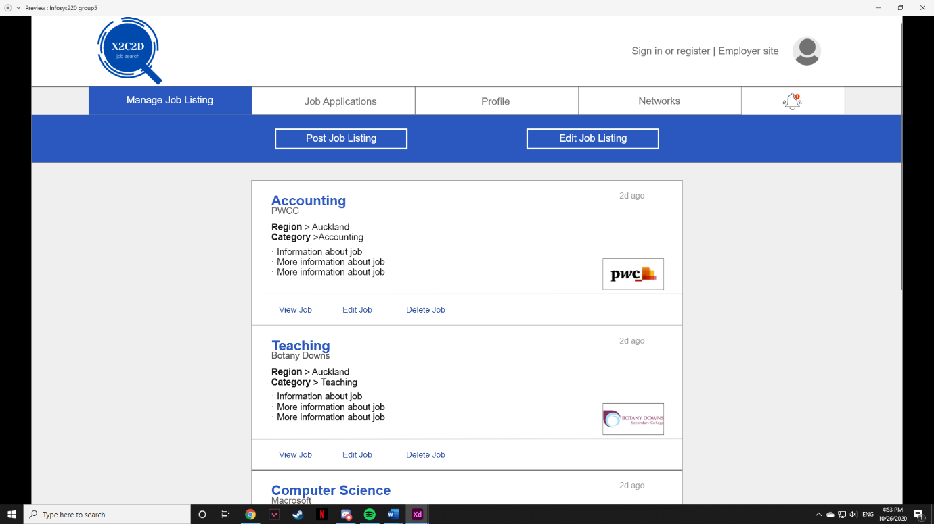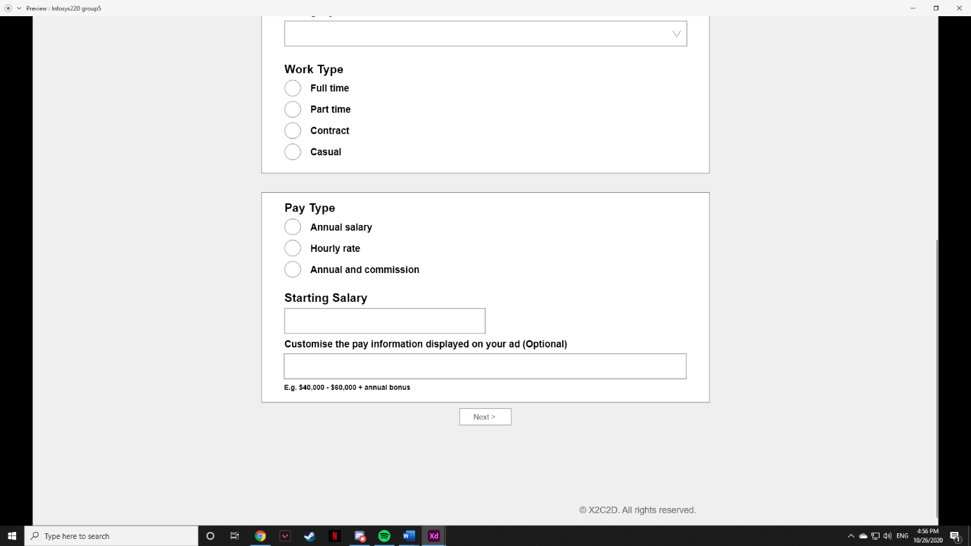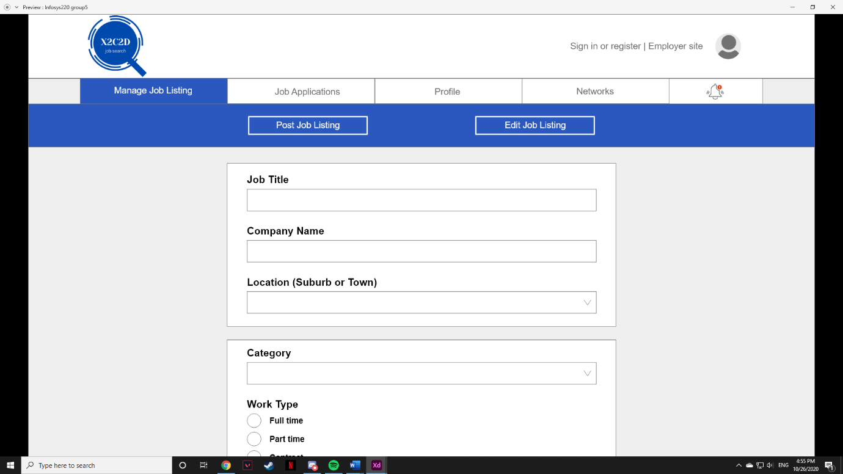

**Step 2.** Fill in job title, company name, work type, pay type and starting salary.

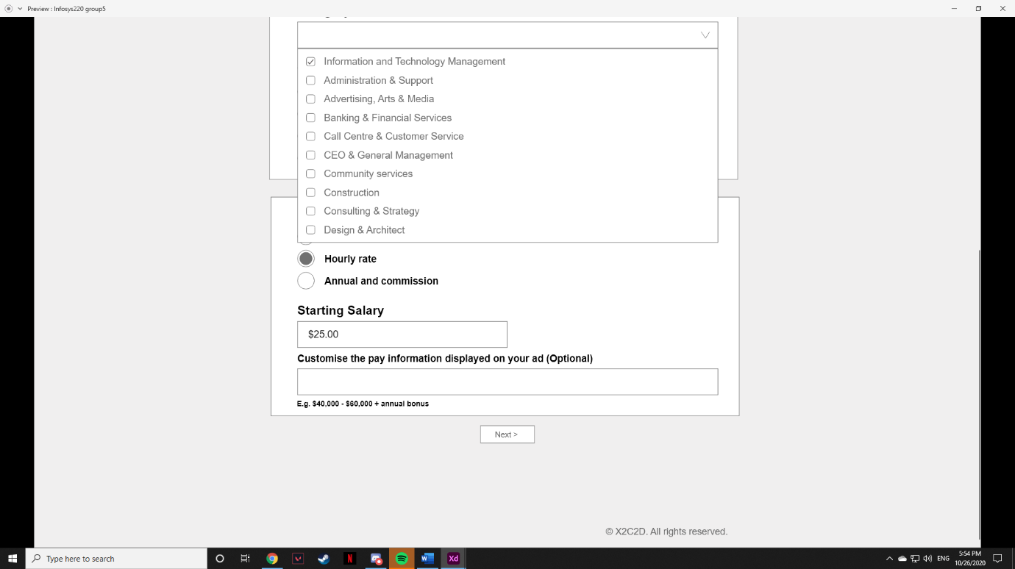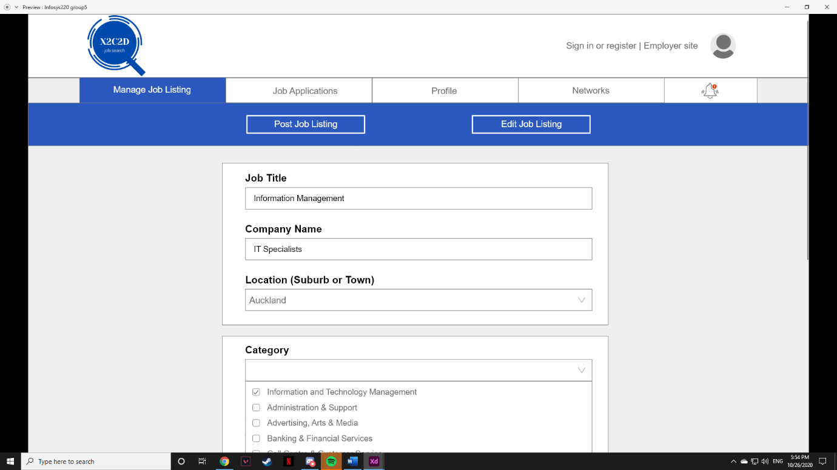

**Step 3.** Click on the text box under location and category to reveal a dropdown menu. click on the textbox again to close the menu.

**Step 4.** Click on the first option, “Auckland” and “Information and Technology management”, the box on the left of the option should be ticked.

**Step 5.** Click on the textbox again to close the menu, the selected option should now appear inside the textbox.

**Step 6.** Click on the next button once all the necessary sections are completed.

**Step 7.** Fill in the job description and job summary.

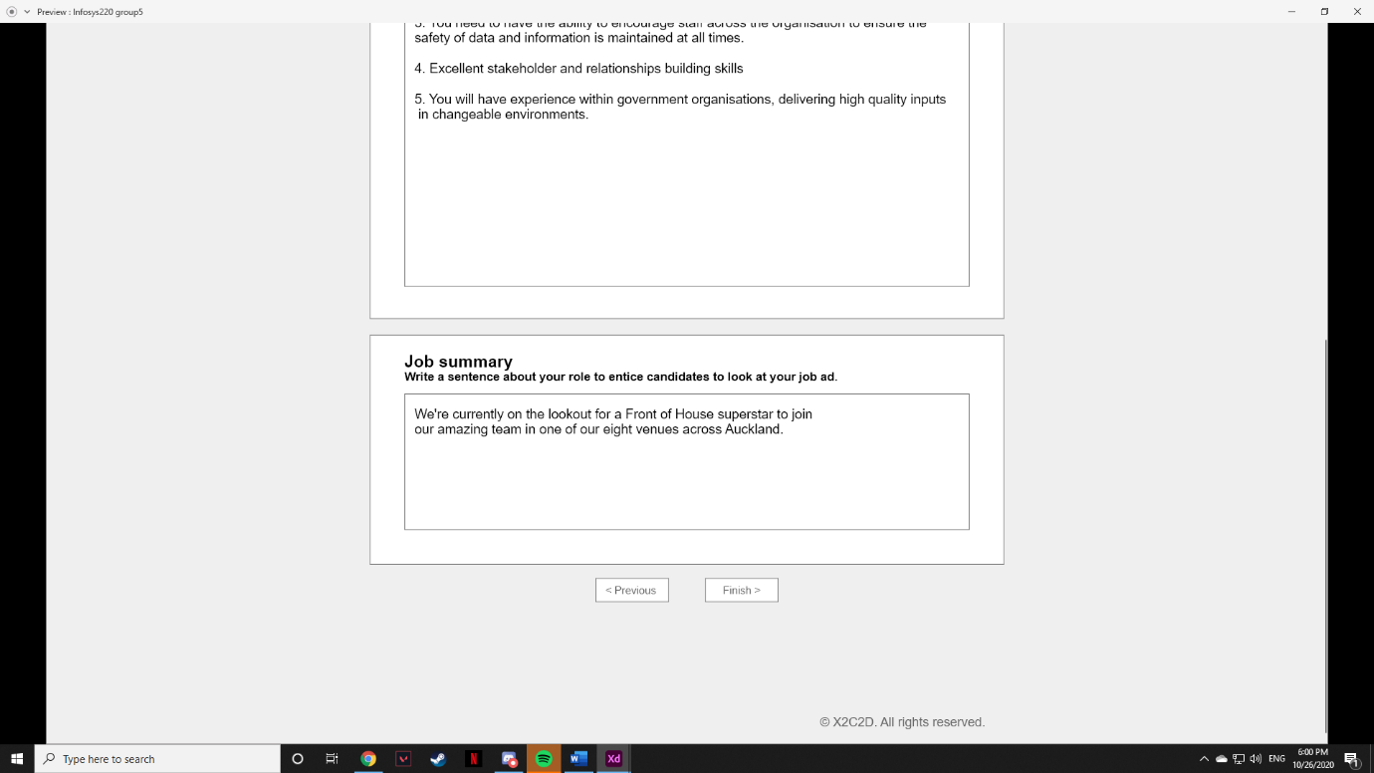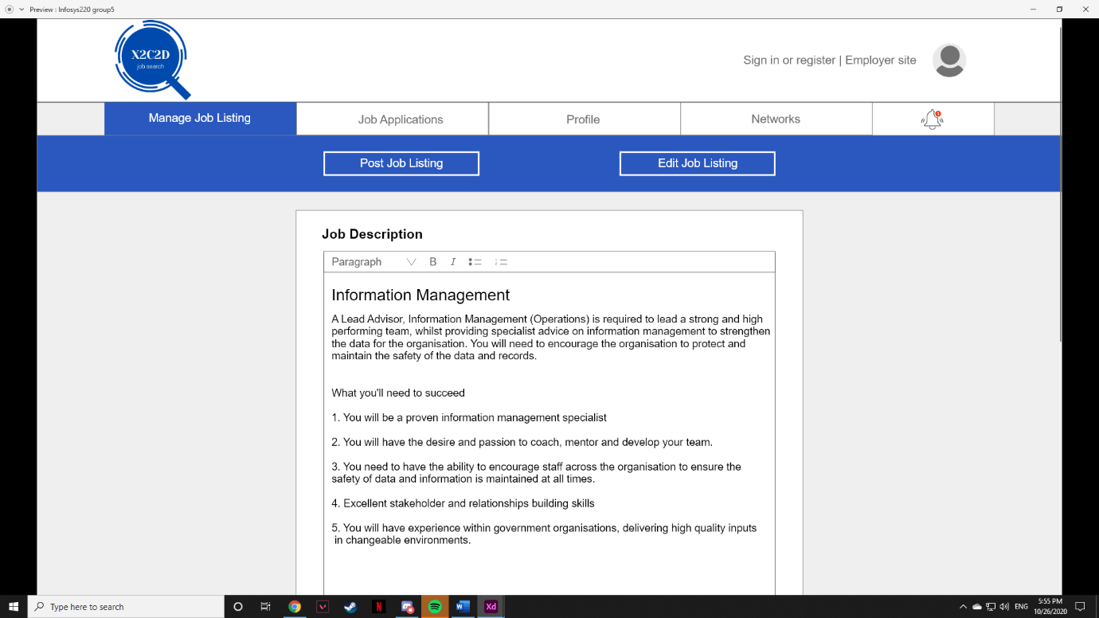

**Step 8.** Click on the finish button once when both the job description and job summary are filled in.

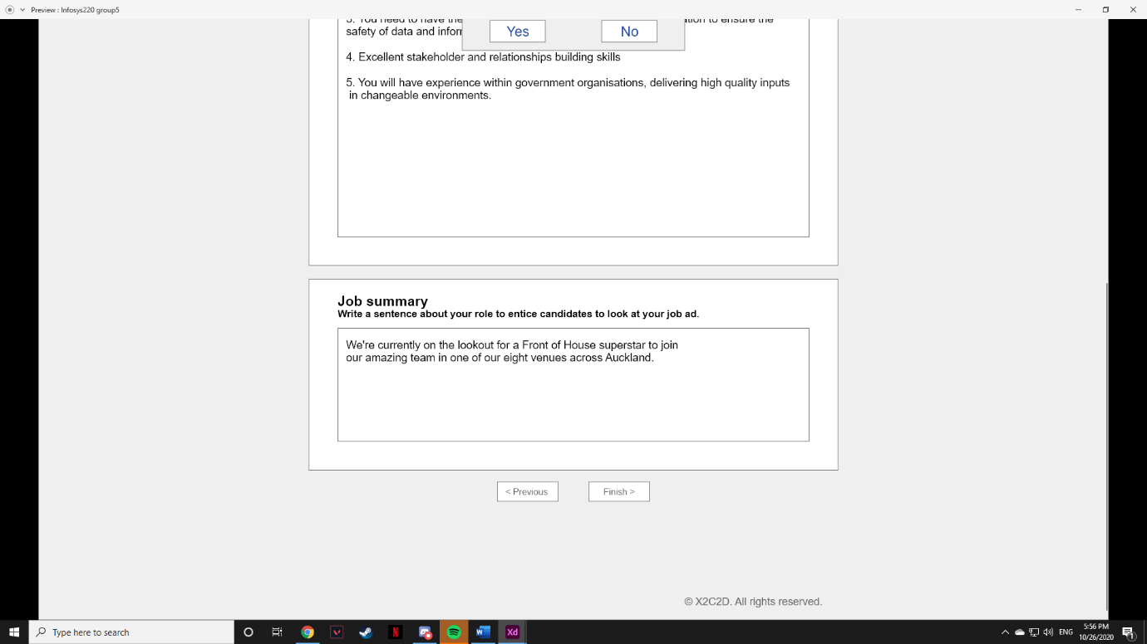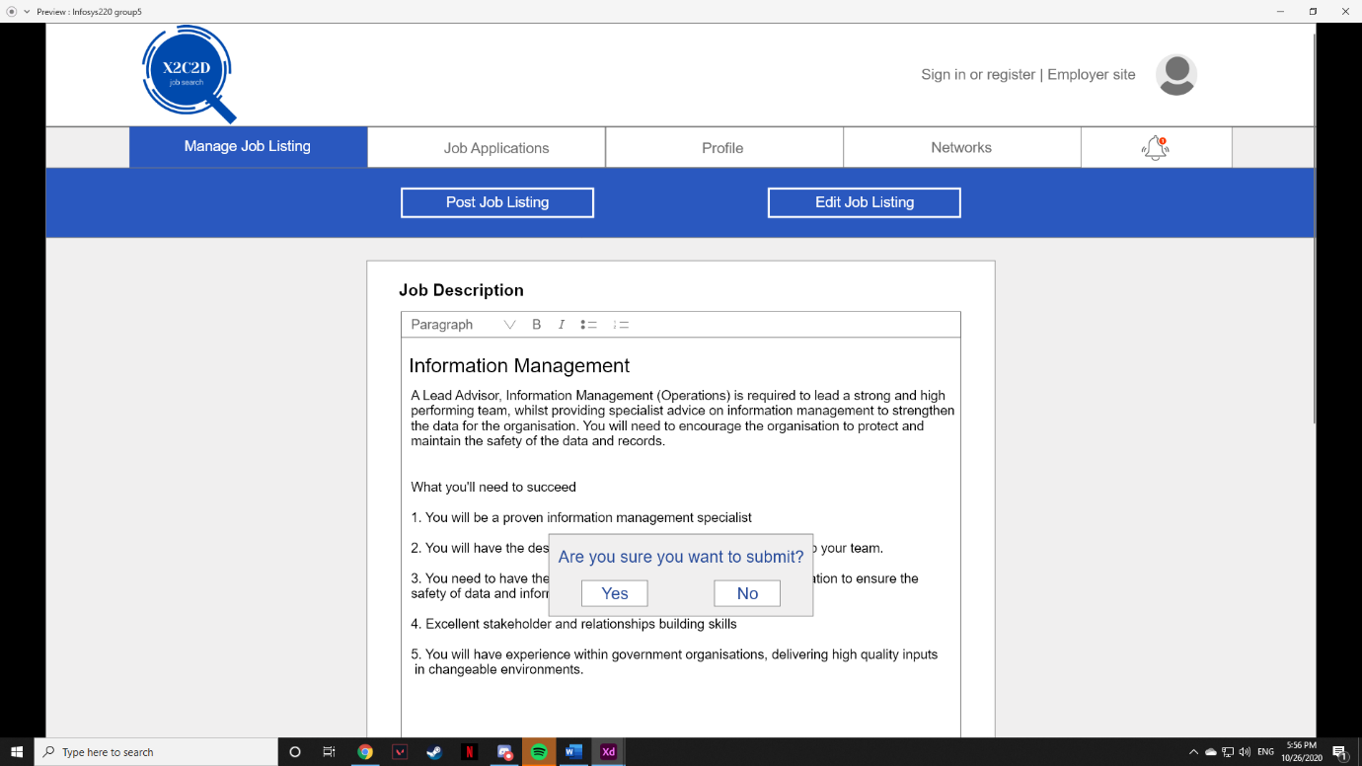

**Step 9**. If you want to change any detail then click no, else click yes to submit.

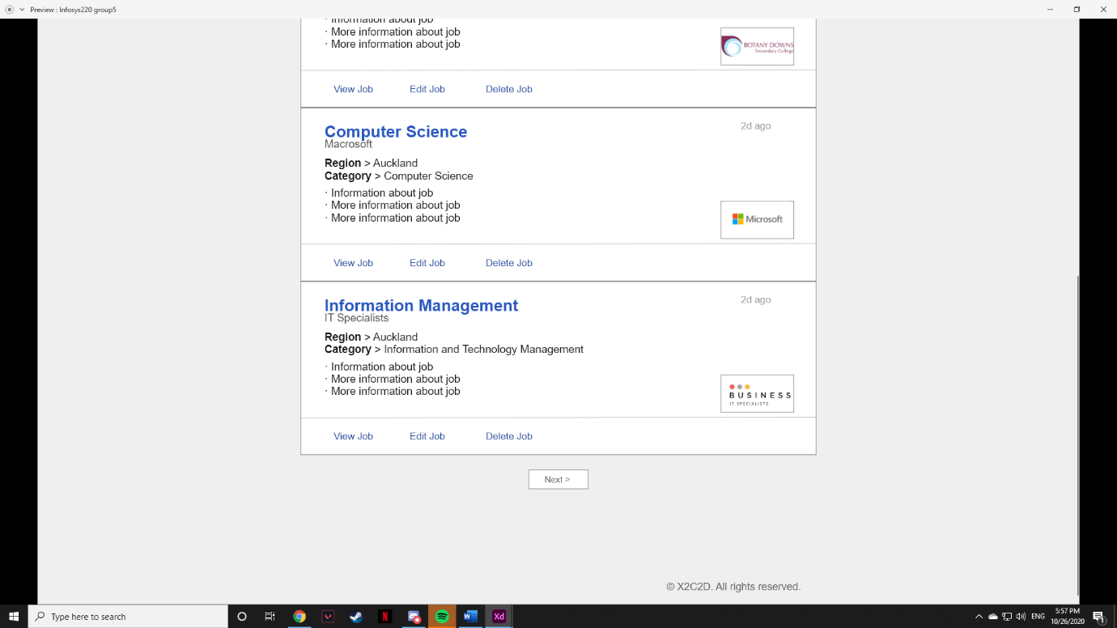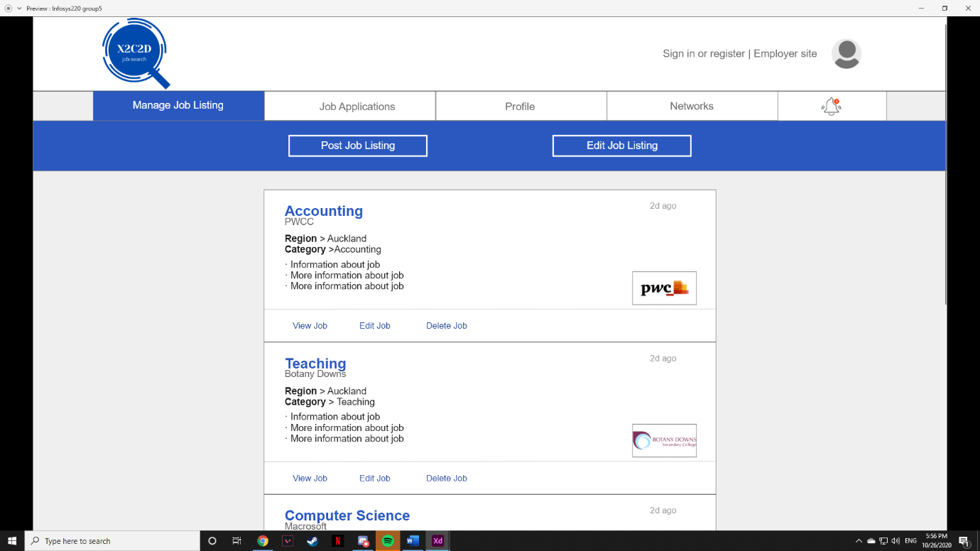

The New job listing is now posted and available to be viewed, edited or deleted.

## F#1 Test plan

|  |  |
| --- | --- |
| Goal/Description of test plan | Allows employers to create new job listing for their company. These job listing will be posted up on the website for employees to view and apply for if interested. |
| Testing method | 1. Click on the “Post Job Listing” button to post a new job listing. 2. Fill in job title, company name, work type, pay type and starting salary. 3. Click on the text box under location and category to reveal a dropdown menu. click on the textbox again to close the menu. 4. Click on the first option, “Auckland” and “Information and Technology management”, the box on the left of the option should be ticked. 5. Click on the textbox again to close the menu, the selected option should now appear inside the textbox. 6. Click on the next button once all the necessary sections are completed. 7. Fill in the job description and job summary. 8. Click on the finish button once when both the job description and job summary are filled in. 9. If you want to change any detail then click no, else click yes to submit.    1. A pop-up screen will appear to confirm if the user would like to submit or not. |
| Expected successful result | A new job listing would appear on the original page for the user to be able to view, edit or delete the post. The detail of the job listing should reflect what was filled in to create the job listing |
| Other notes (optional) | For step 9. The user can select “No”. This demonstrates the design principle forgiveness as the job listing would not be posted if the option “No” was chosen. As a result of clicking “No” it would take the user back to the job description and job summary page in which they are able to click on the “previous” button to return back to the first page when posting a job listing which further displays the design principle forgiveness. |

# Design principles

## 1. User in control

The user in control means that “The user should always feel in control of the software rather than feeling controlled by the software.” Hence, The User-In-Control principle ensures that users are in control of our web portal and not the other way around. Our web portal allows customised/personalised dashboard, clicking the edit dashboard button will lead to a pop up allowing users to select a dashboard theme and wanted features by checking the boxes. This functionality allows users to choose what they want and not feel restricted on a single dashboard.

 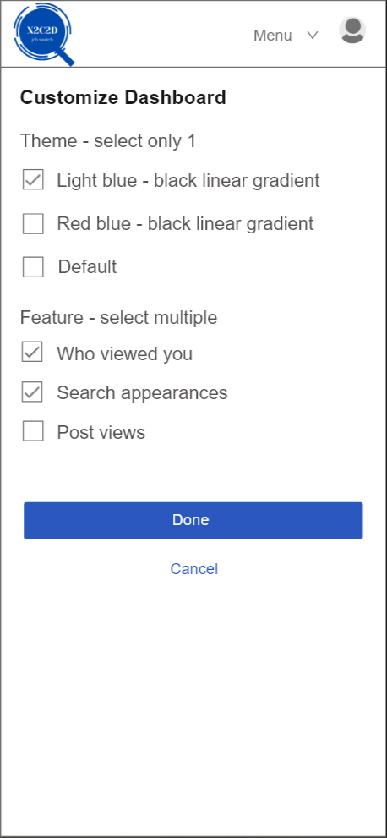

As we can see on the screenshot, the user can freely select the theme they wanted. At the same time, users are enables to select multiple feature



Once the users choose on their desired theme, their dashboard’s theme will change based on the theme they choose

### 2. Directness

On the Directness design principle, we have several example for it. First one would be the bell icon to show the notification as most users are used to it in other social media platforms. This familiar design can reduce the mental workload of users as a  metaphor as it gives a more direct and intuitive interface for the tasks of the users. Users will know and expect that they can view the notifications if they click on the bell icon.

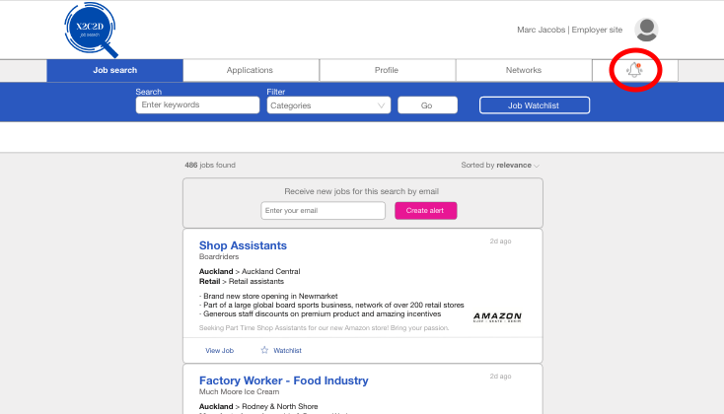

The bell icon that show the notification to users

Second example of directness shown in our mobile interface is the coloured star icon, which is job added to watchlist

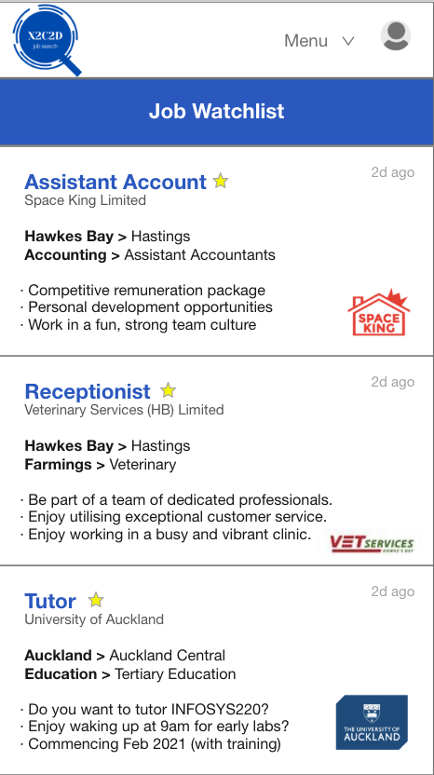

The watchlist function in a coloured star icon

The last example would be our functionality that allows adding resumes. A document image lets users know where they can add their resumes at. This is in line with visible information that helps reduces user’s mental workload.

 

The document image that the let users know, in which area to add their resumes

### 3. Consistency

Consistency makes the interface more familiar and predictable for the user. This principle allows users to transfer existing knowledge to new tasks. Our web portal has a similar colour scheme throughout all the applications and across environments. The colours we have chosen are grey, blue and pink. Blue colour blue signifies trust, confidence and intelligence which reflect the job searching process as the user should trust the information on the portal as well as themselves and have confidence that they will find a job. Additionally, blue is known to slow human metabolism and produce a calming effect which is beneficial as job hunting can be quite stressful. We chose grey to compliment blue as it does not contrast blue but instead create a nice balanced. Grey symbolises reliability which is a quality important to X2C2D as we want our users to have confidence and trust the information on the job portal. However, just blue and grey can end up appearing dull and old fashioned hence, we have added pops of pink across the portal.

The bright pink stands out and draws the users attention. Therefore, we have often used pink for meaningful buttons just as removing a job from a job list and deleting information from profiles. Aside from colours, we have also used the same navigation bar (desktop), menu (mobile) and page layout across the interfaces.

Consistency within Application/system:

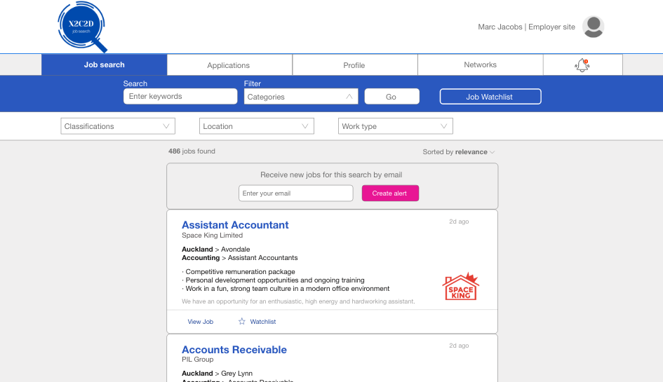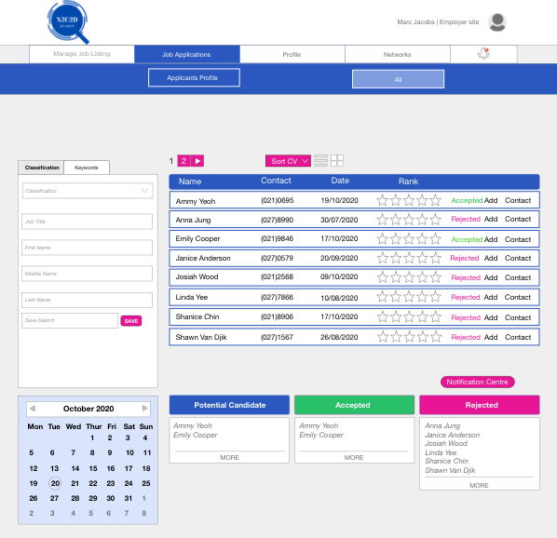

Consistency across environment:

 

The usage of blue, grey and white color over our desktop and mobile app, which incorporate the design principle of consistency

### 4. Forgiveness

X2C2D is designed to reduce user simple errors. For example, a prompt dialogue box will show up before the message is sent out by the applicant to the employee. This can enable the applicant to double check the content before sending it out. Therefore, the “are you sure you want to send” command prompt helps reduce this error and trial and error will not be punished.

Another example would be when a user accidentally clicks the delete button. There will be another popup to confirm the deletion. The user is able to click cancel if a mistake was made clicking on delete.

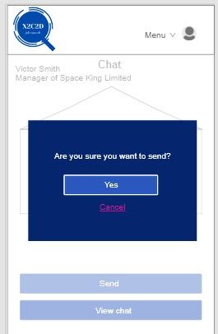 

The pop-up confirmation message box that will show up if the user accidentally press the wrong button (e.g did not intend to press delete, but accidentally pressed it)

### 5. Feedback

The feedback principle ensures that feedback is always provided for a user’s actions. The feedback principle allows the user to understand and engage with the web-portal based on their interaction with it. An example would be the circular loading bar helps in engaging with the user as it informs the user of how much and how much longer before a page is loaded. This is appropriate for the task as it provides the user feedback on when the page will load instead of a blank page with no information. If there was no loading bar shown, the user may be confused as to what is happening and may think the screen has become unresponsive.

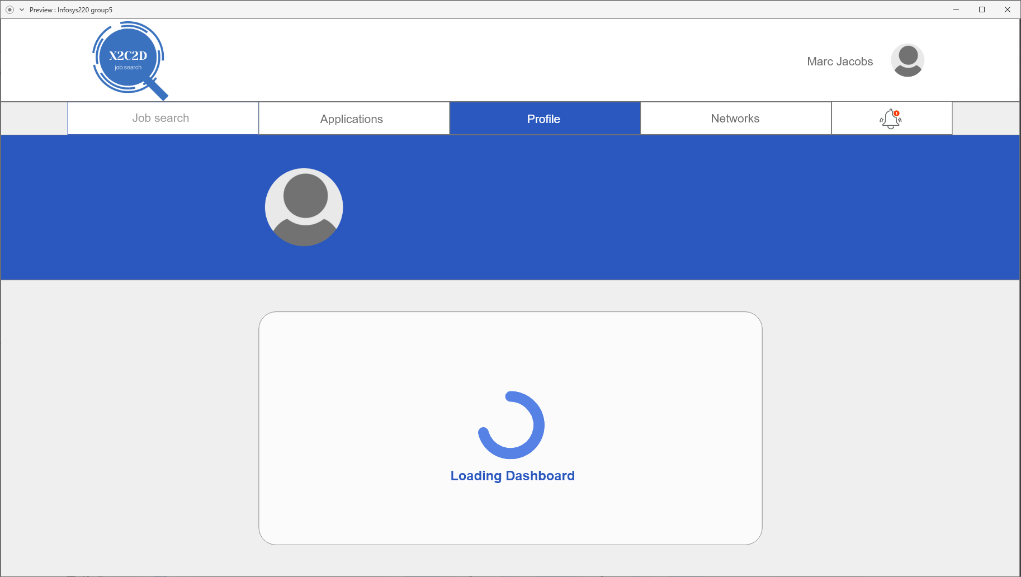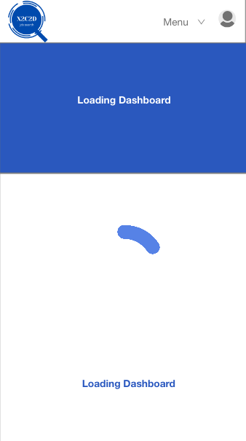

Loading screen which inform the user that the system is processing the request

Another example would be in the job search page where users can add jobs to a job watchlist. Once, the user selects a job to add, a pop up message will appear to inform the user that the job has been added to the watchlist. If the user clicks on the button again, a message will appear to inform the user that the job has been removed.

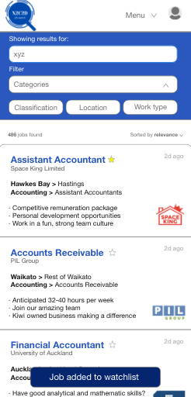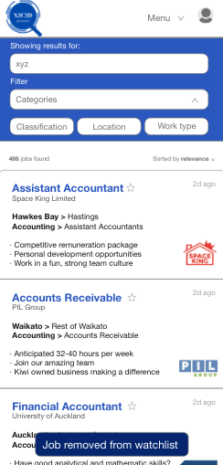

### 6. Aesthetics

The aesthetics principle ensures that visual attributes communicate significant cues and provide valuable impressions to the interactive behaviour of objects. X2C2D has incorporated the aesthetics principle within our web portal to ensure that the portal is user friendly and easy to use.

The theme colour chosen for X2C2D is blue and white. The choice of colour provides a harmonious and professional vibe to the website. The use of colour pink in some of the buttons highlight the importance of the buttons. Green buttons show that the actions had been carried out successfully. Providing an aesthetically pleasing features allows the user to feel comfortable and reduces chances of users feeling overwhelmed by the web-portal and leaving the page.

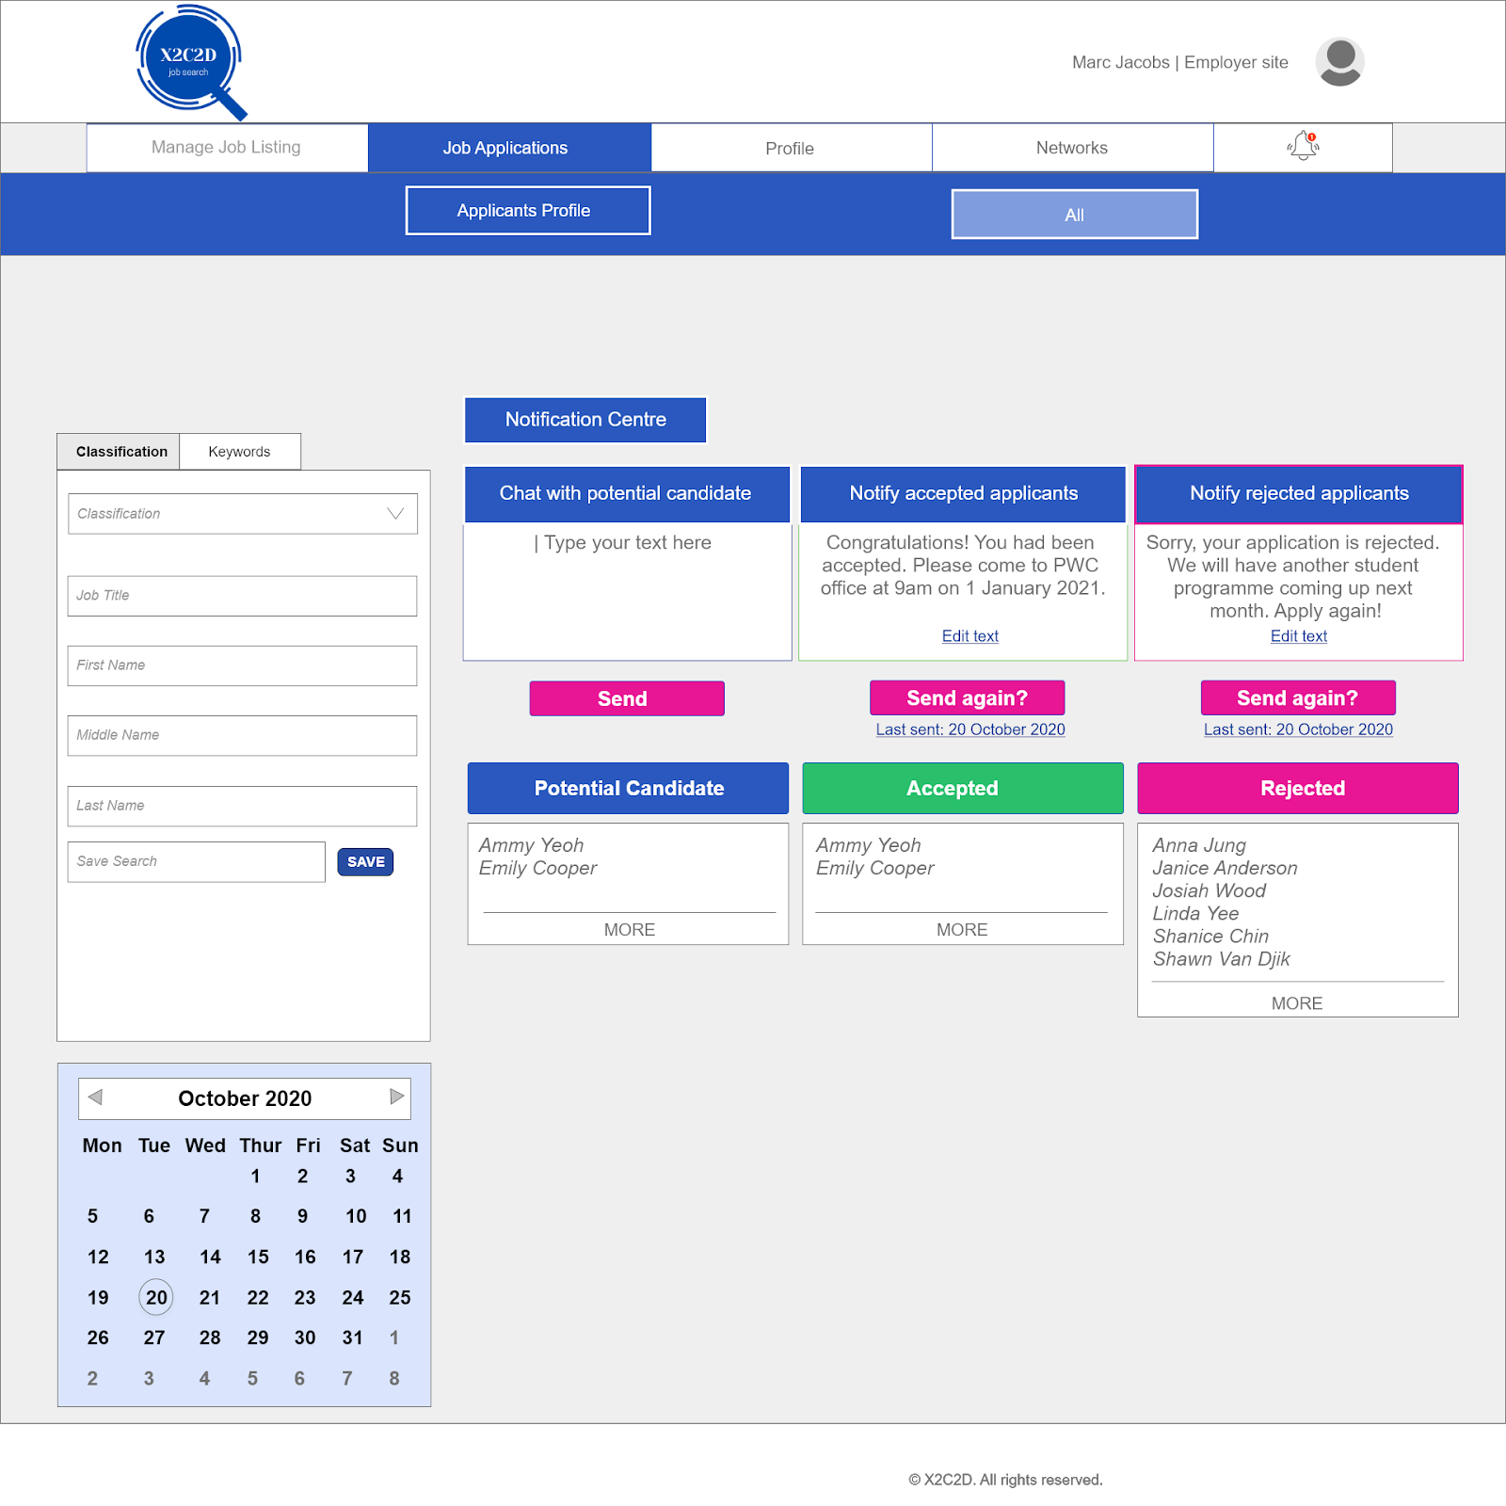

### 7. Simplicity

Simplicity ensures that the web portal is easy for the user to learn and use. The web portal for X2C2D balances between function and complexity to ensure that the user is not overwhelmed with information. For example, within the job portal we have many drop down buttons to display more information and options. This allows more information to be shown without deferring to a secondary screen which makes the application easier to learn and less-error prone.

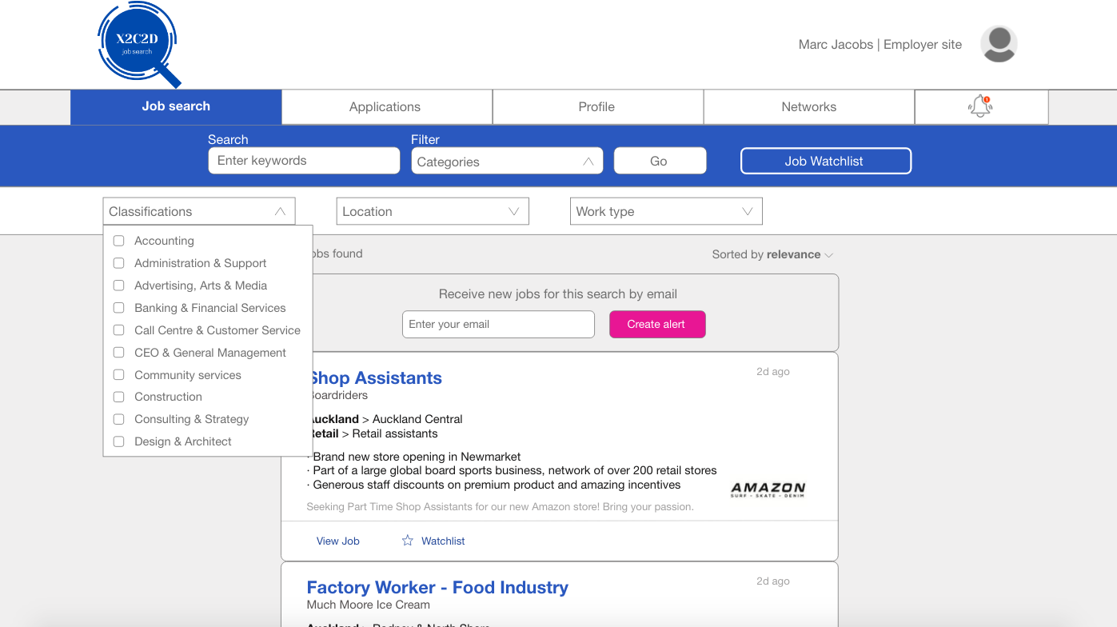

Our website X2C2D provides a lot of features. In order to prevent the users from being overwhelmed, the tabs below the portal logo enable users to switch between different features such as manage job listing, job application, profile or network tabs easily. On the other hand, we included this simplicity feature in the mobile site as well in the menu section. Users can easily switch to the functions that they want to use. It is easy to use as the portal manages complexity by using progressive disclosure.

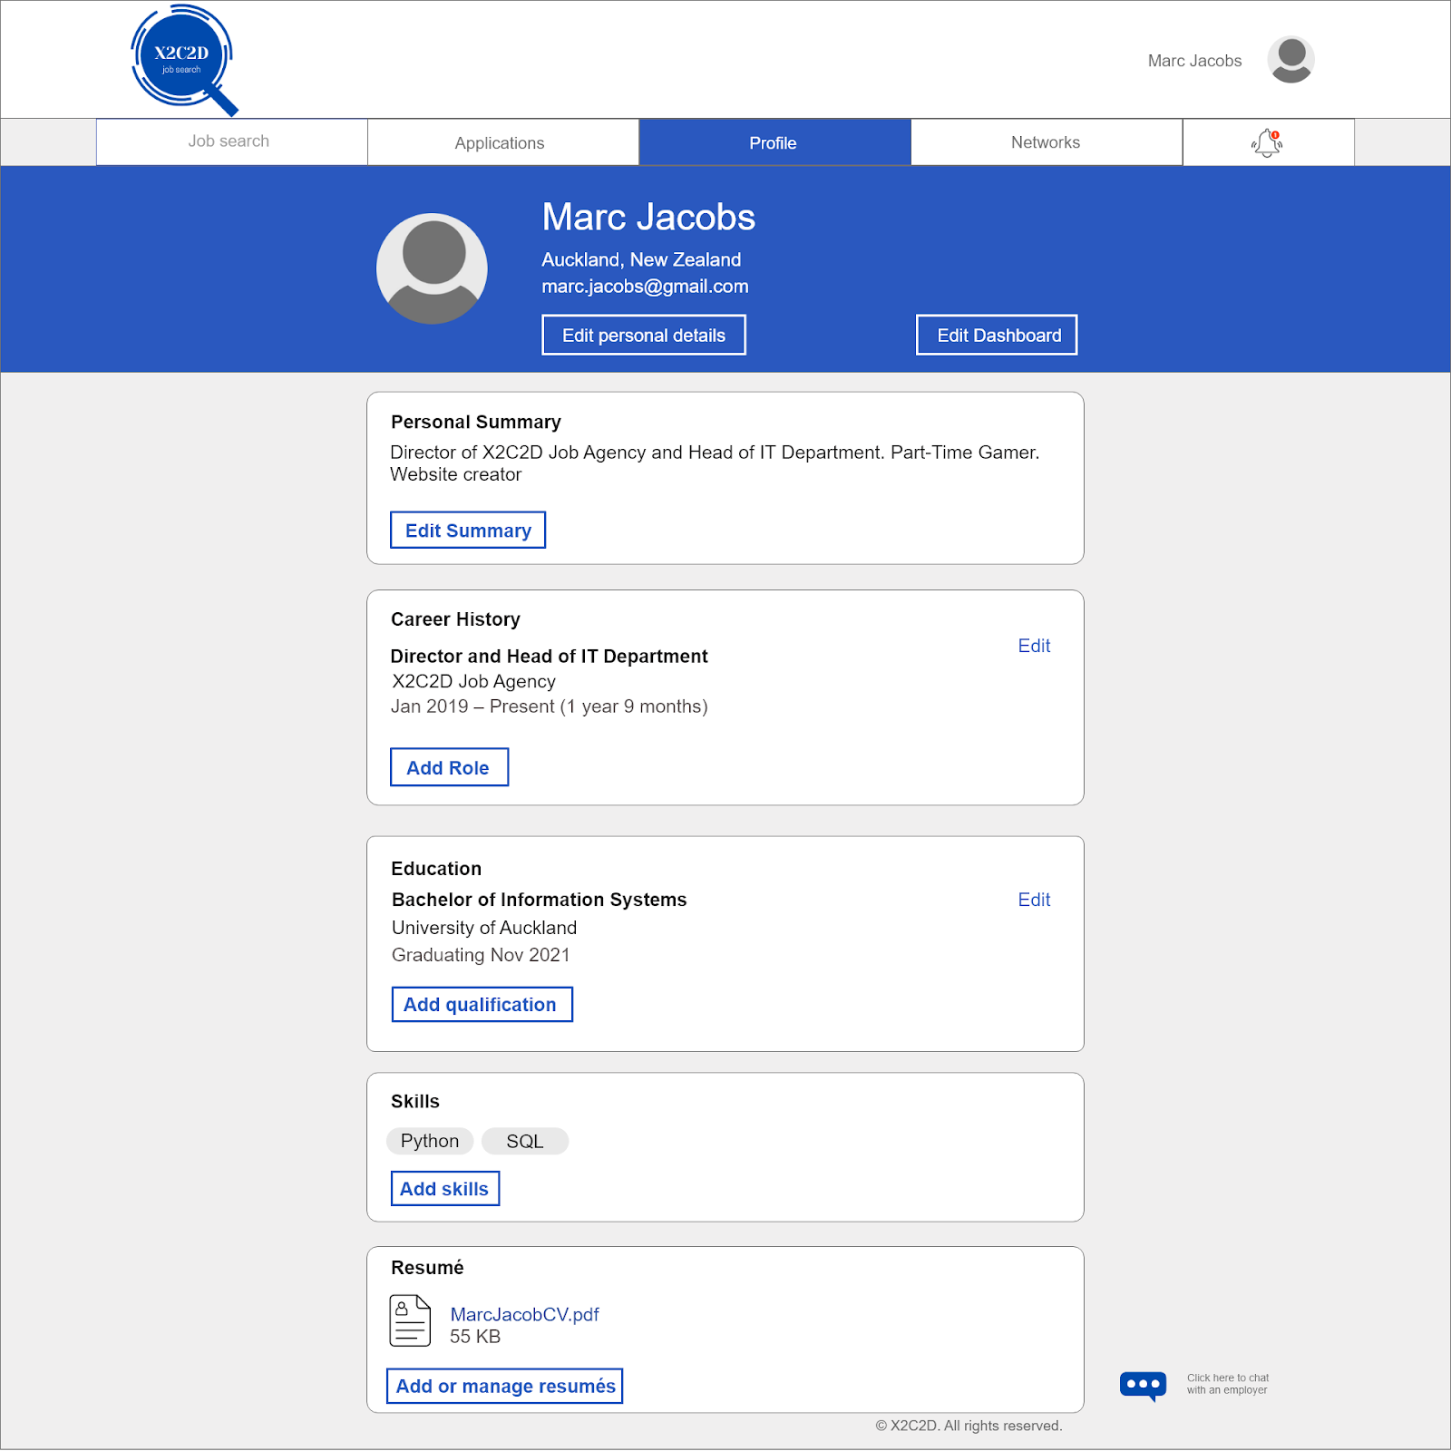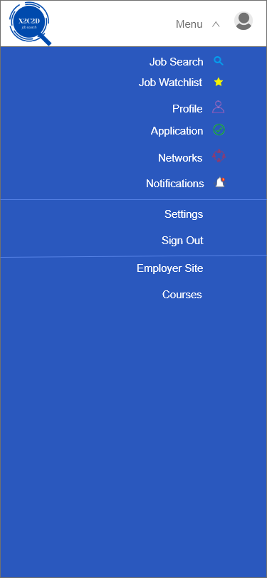

The simplicity within the menu section

The portal logo make it easier to switch between different feature